# Creating a PostProcessing Custom Cartoon Shader

* https://www.youtube.com/watch?v=mzydOmgN7mc

1. Change Material Domain to PostProcessing

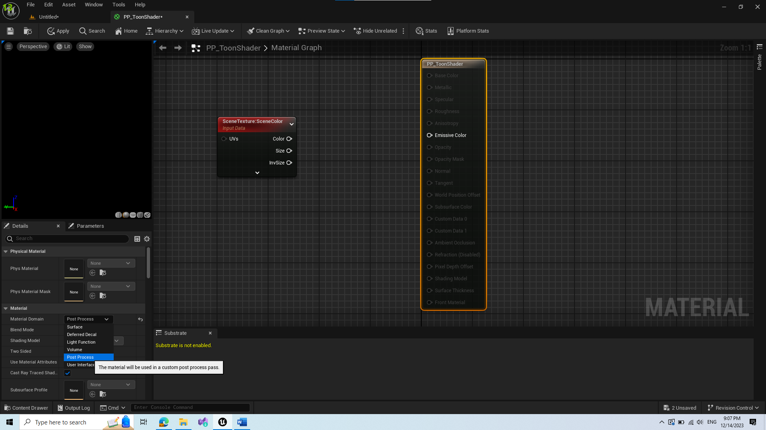

1. Add SceneTexture Node and change Id to PostProcessInput0

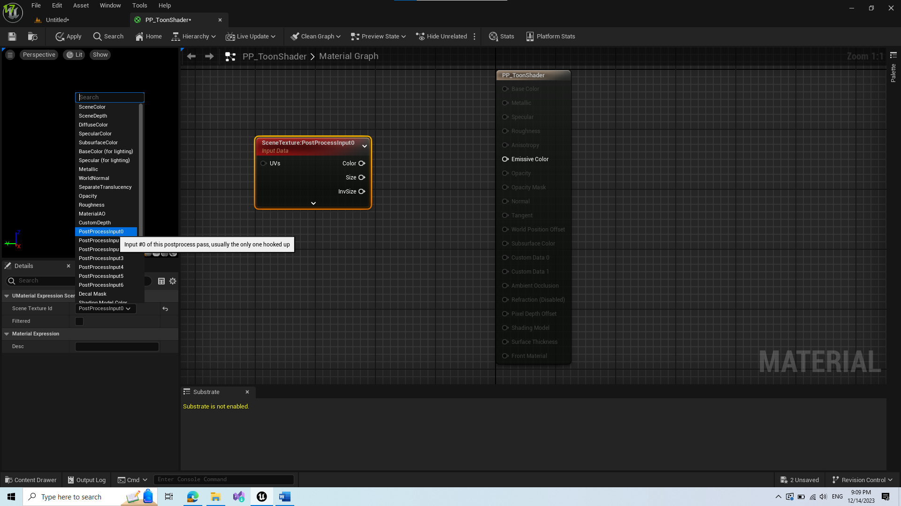

1. Add Desaturation – creates grayscale filter

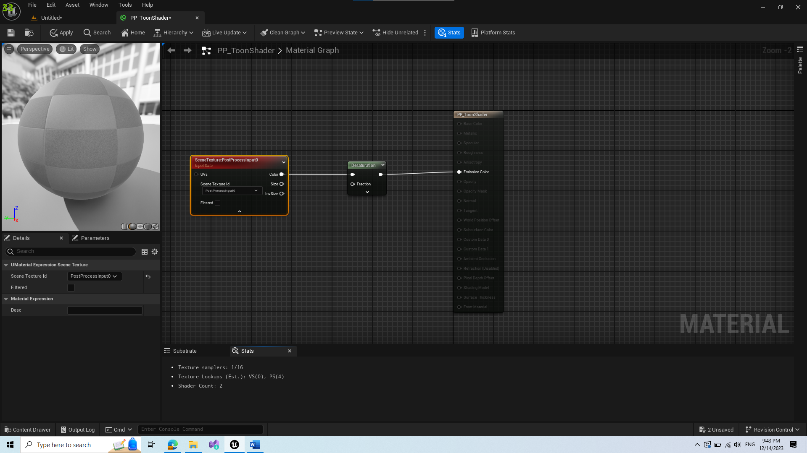

1. Change Blendable Location from After Tonemapping to Before Tonemapping

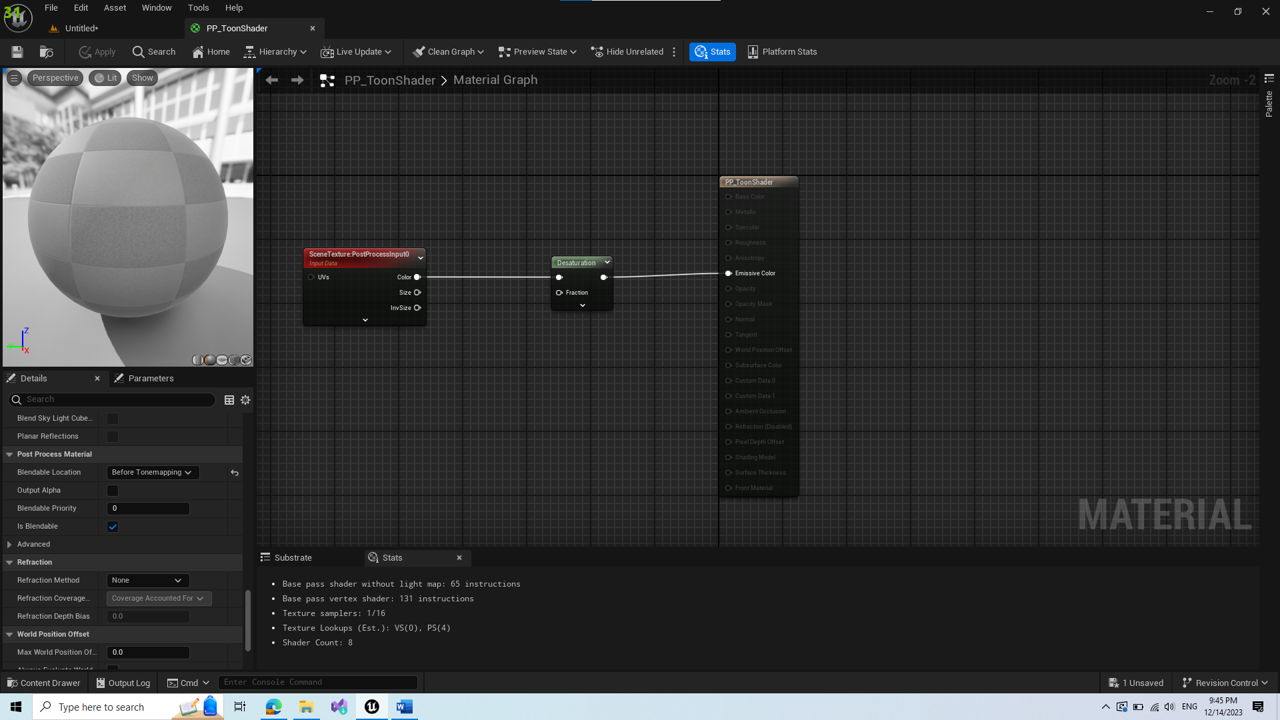

1. Save and create Material Instance from this
2. Create PostProcess Volume and add Material Instance to its rendering features (can check infinite bound to apply outside of bounding box)

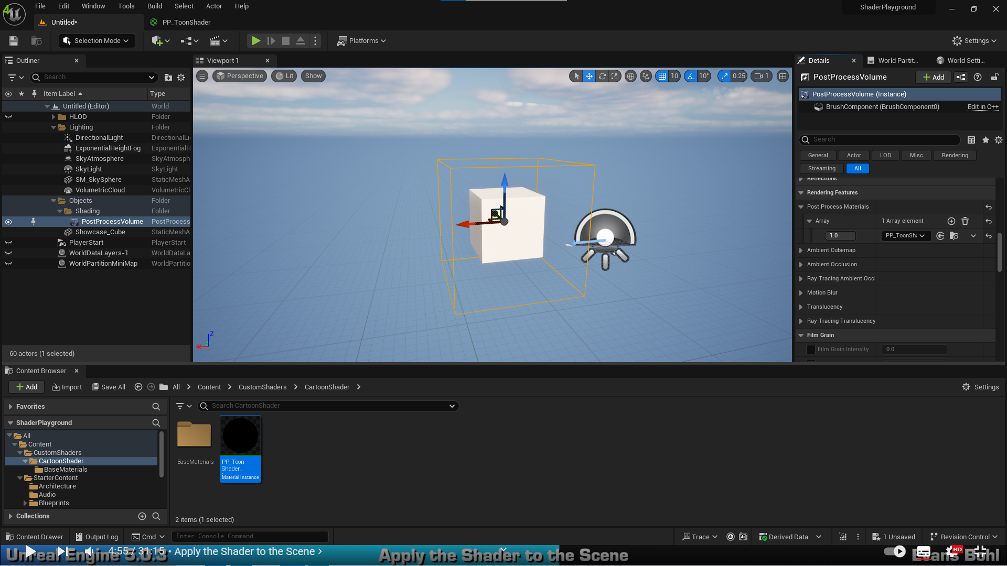

I believe this was just an introduction until this point.

1. Create a new SceneTexture and set its Scene Texture Id as BaseColor(stored in GBuffer)

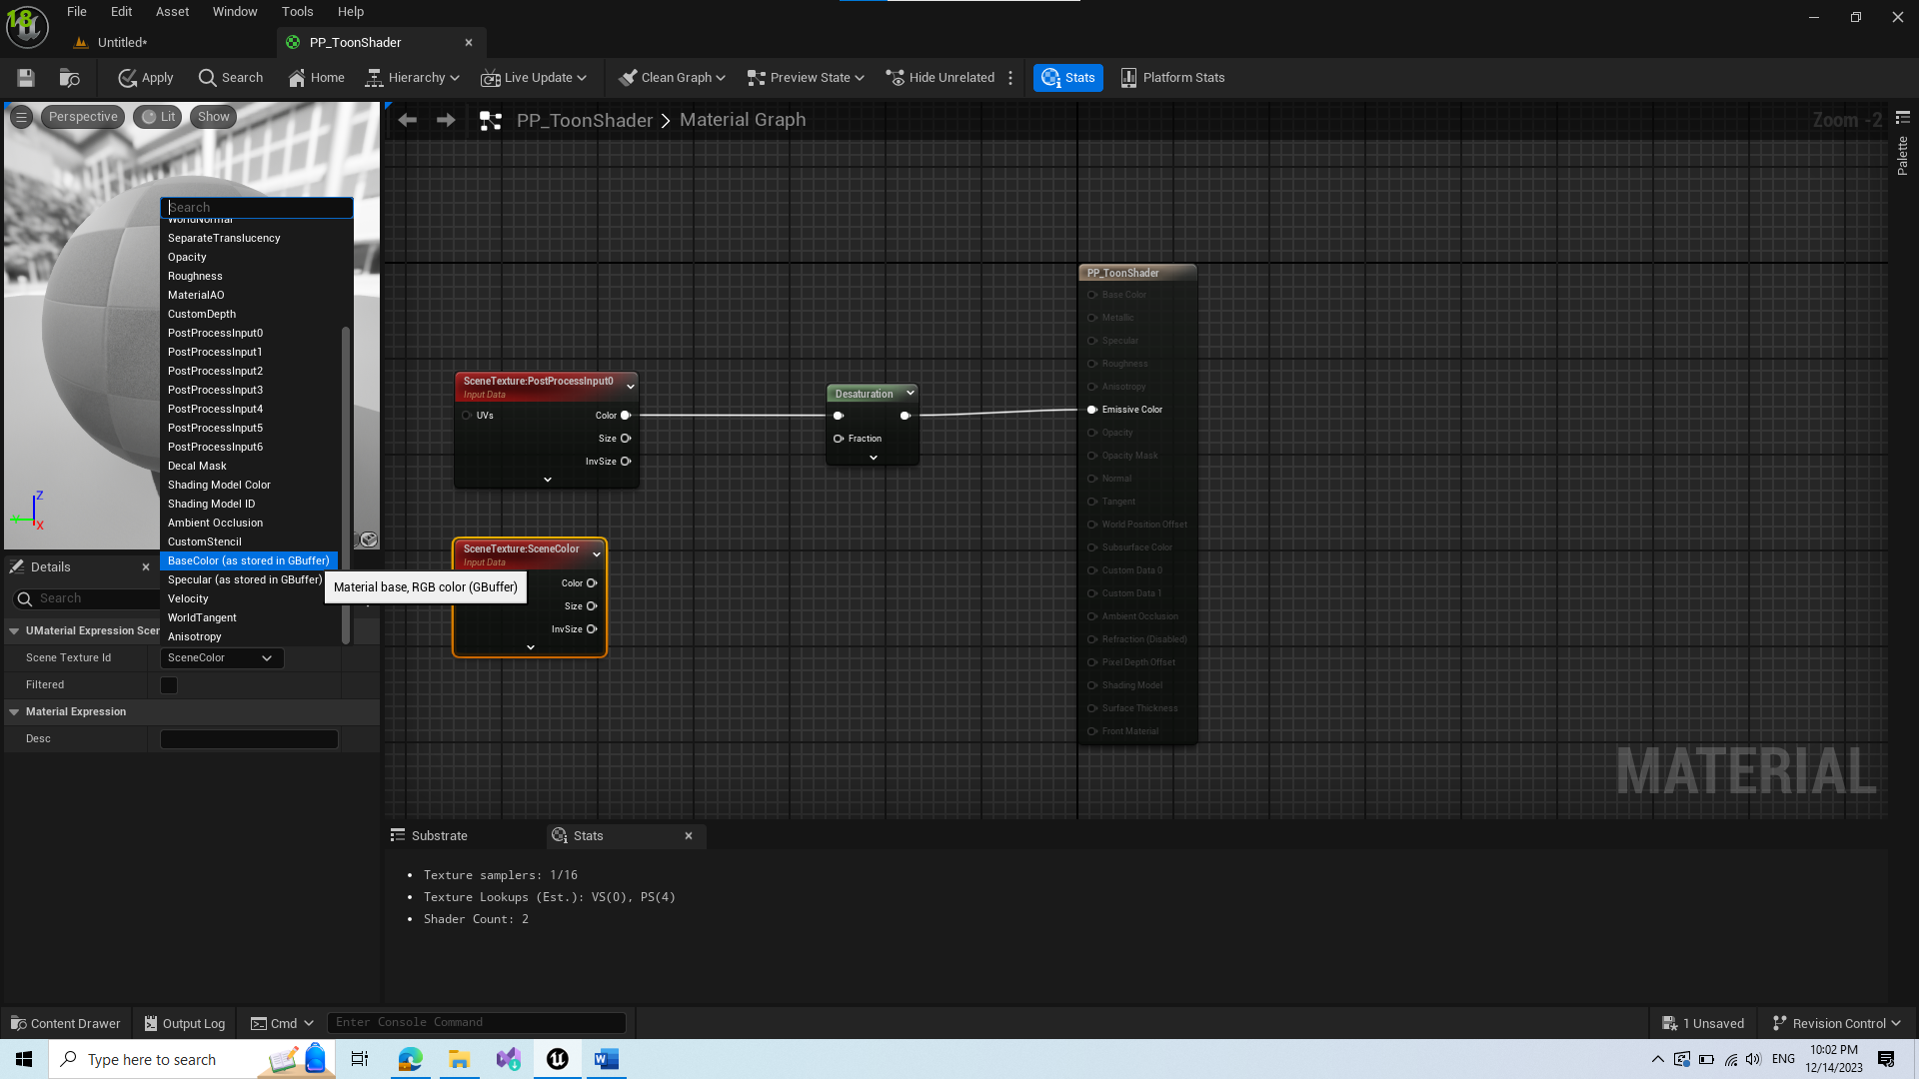

This will result in ignoring lighting buffer and will have basic colors of materials. Next we copy the desaturation and connect it to new SceneTexture.

1. Divide the upper texture with lower

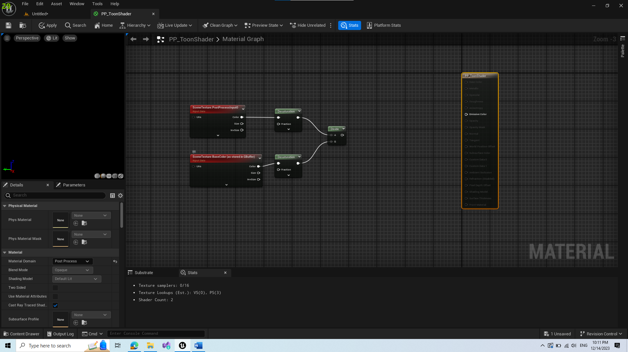

1. Add Saturate Node

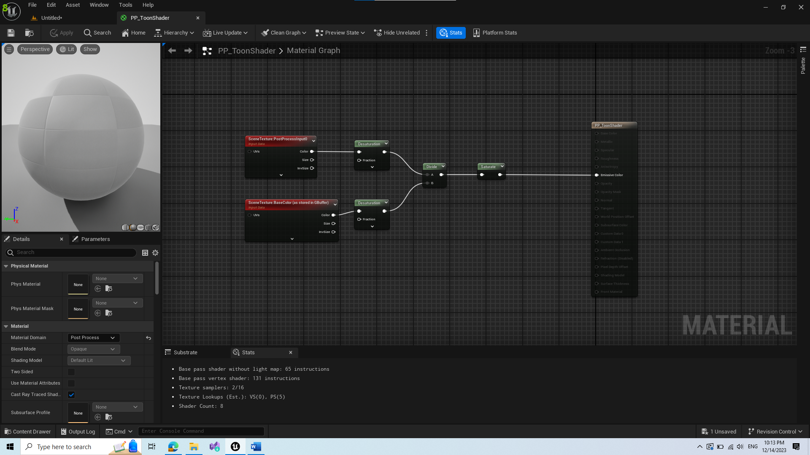

1. Add Mask and select only 1 channel(they are all the same)

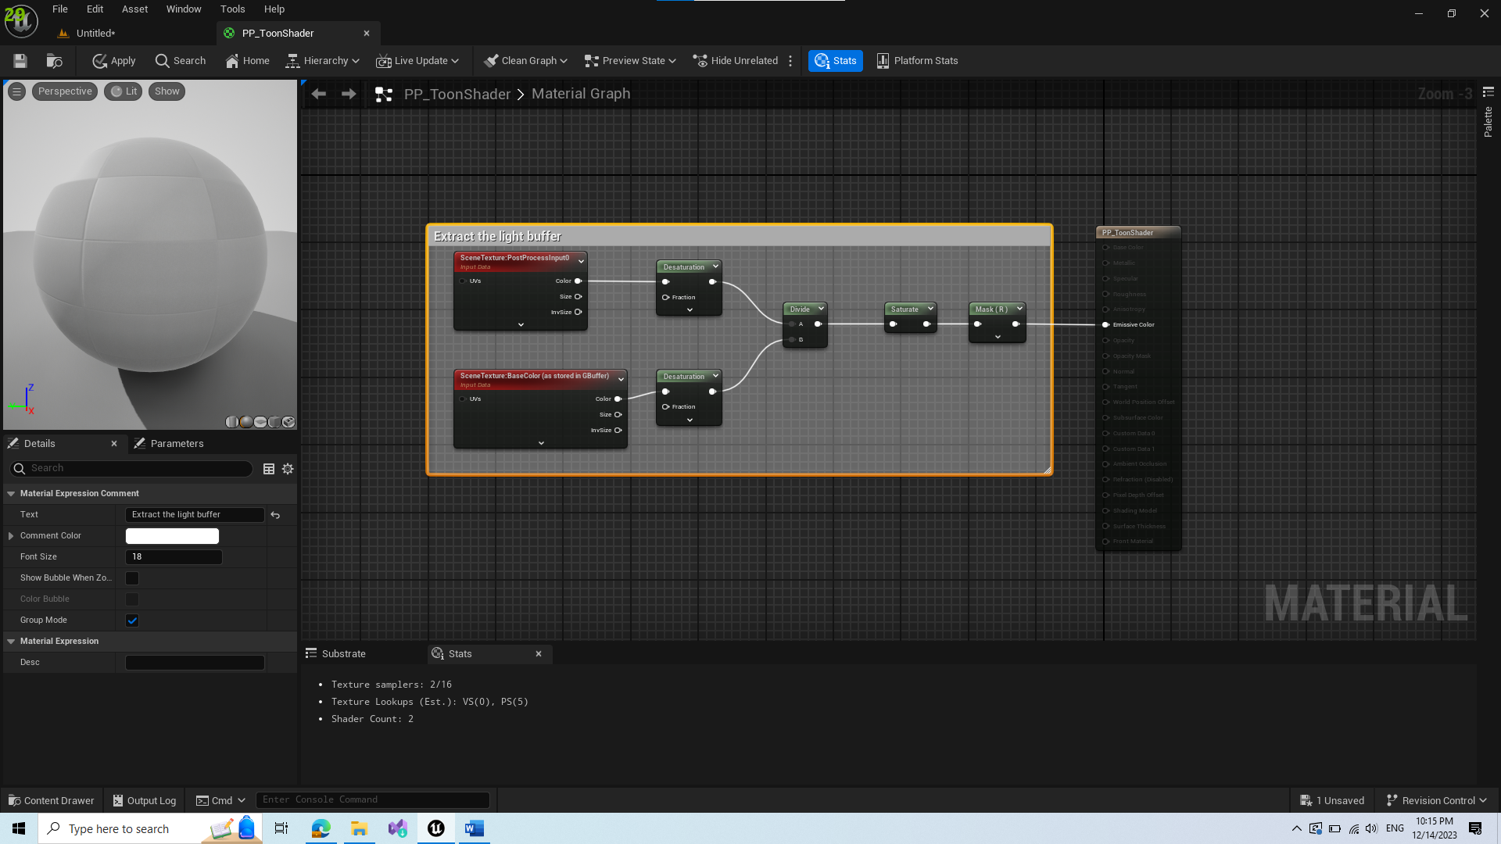

Result should be extracted light buffer, and visuals should be grayscale, 0 where there is no light, 1 where light is directly hitting the surface.

1. To have a strong transition between black and white, we add step with param 0.5. If a value for a pixel is <0.5 then it changes into 0 and becomes black, else its white. However this transition is not smooth and needs improvements.

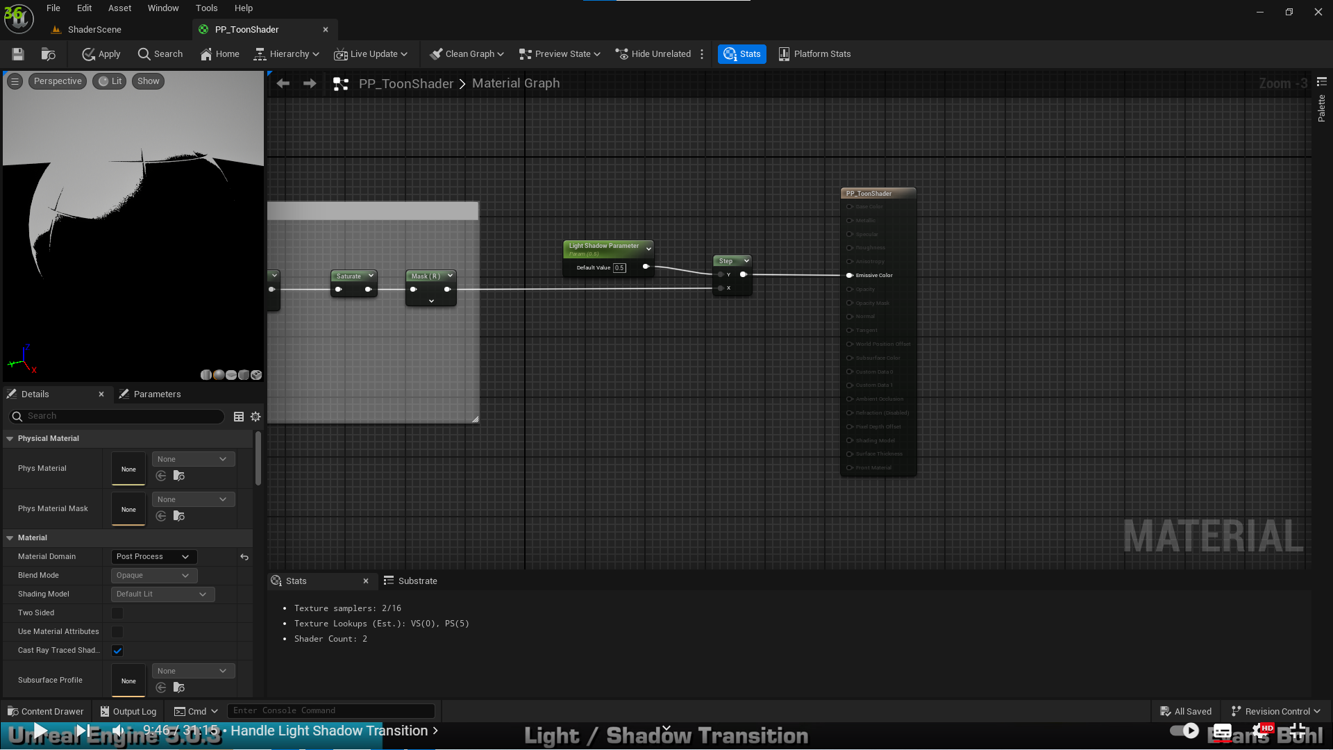

1. Creating a transition

Heres a simple drawn explanation:

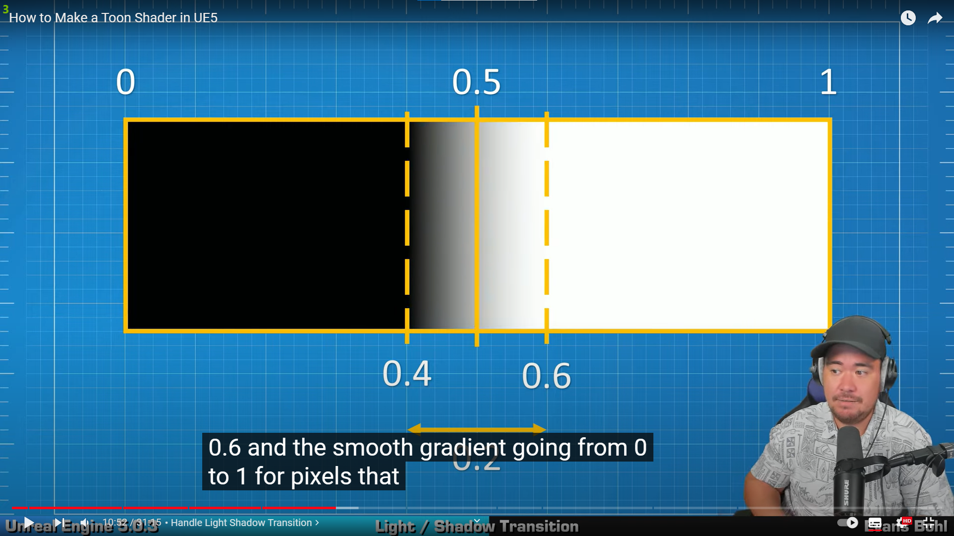

We introduce smooth step between 0.4-0.6 as represented in sketch:  
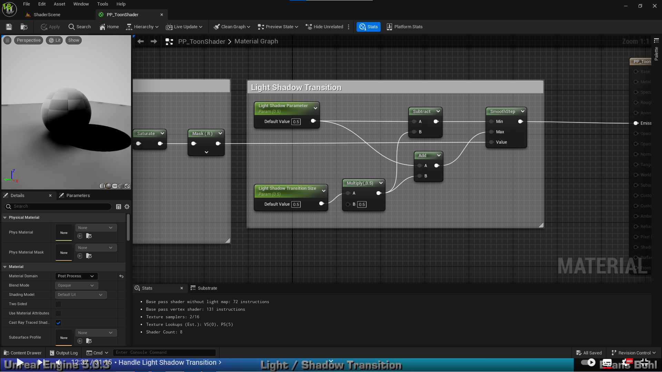

1. Adjusting colors so its not black or white but our own custom colors

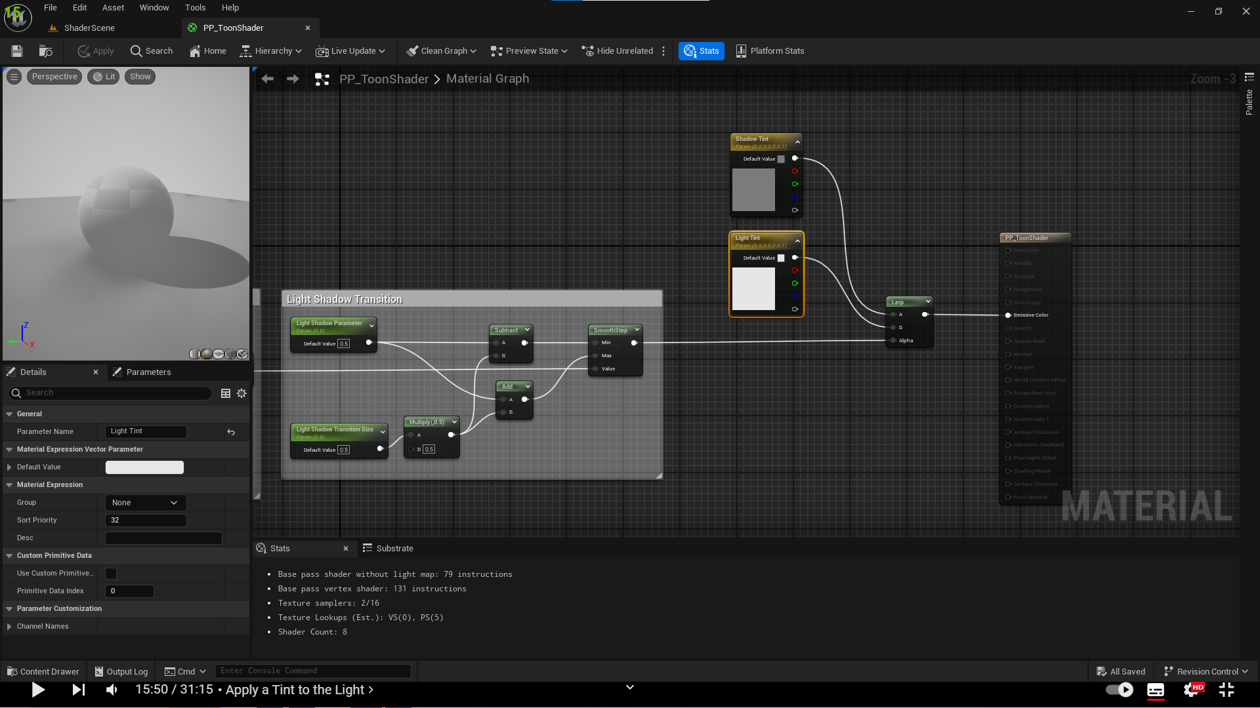

We can adjust these colors in our material instance.

1. Applying lighting with color will not change the color. For that we introduce blending between its color and tinting parameters we introduced earlier.

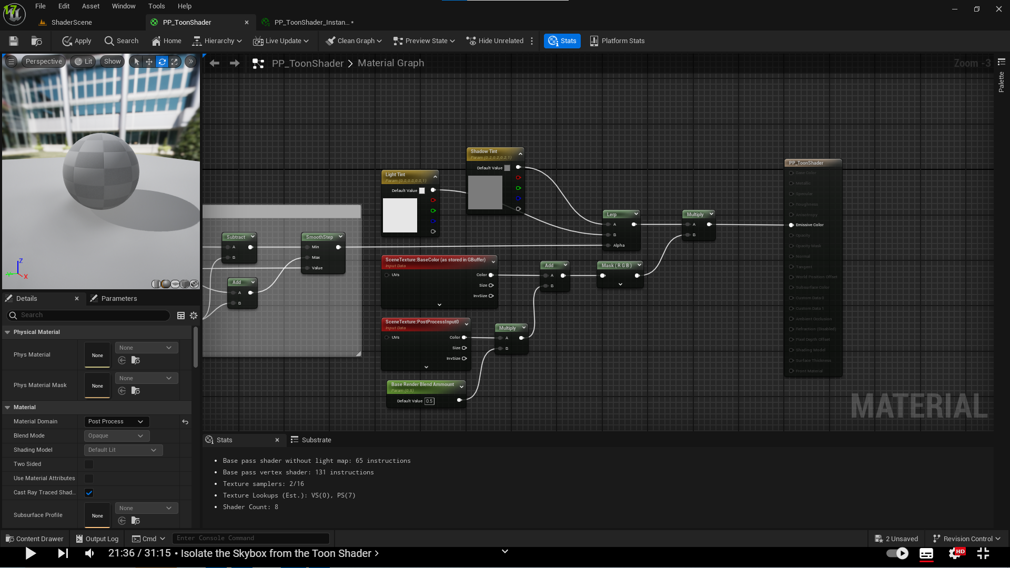

1. Define max distance for applying this effect, this way skybox for example unchanged

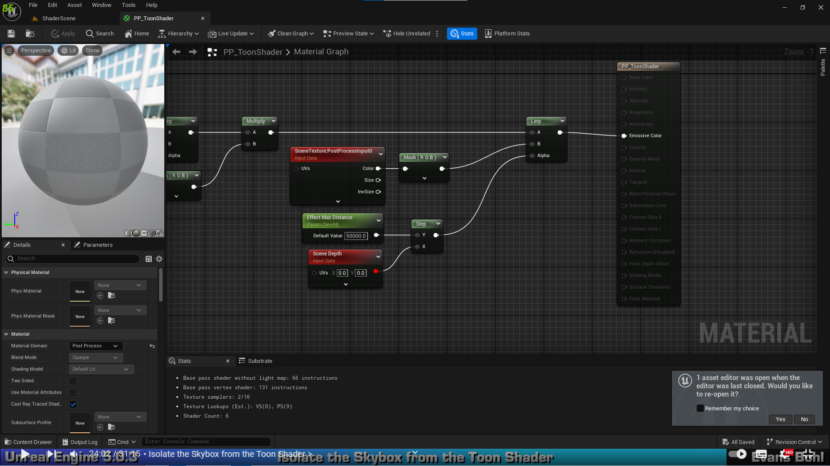

1. To apply effect to only some objects, we need to select the objects with Render CustomDepth Pass Boolean

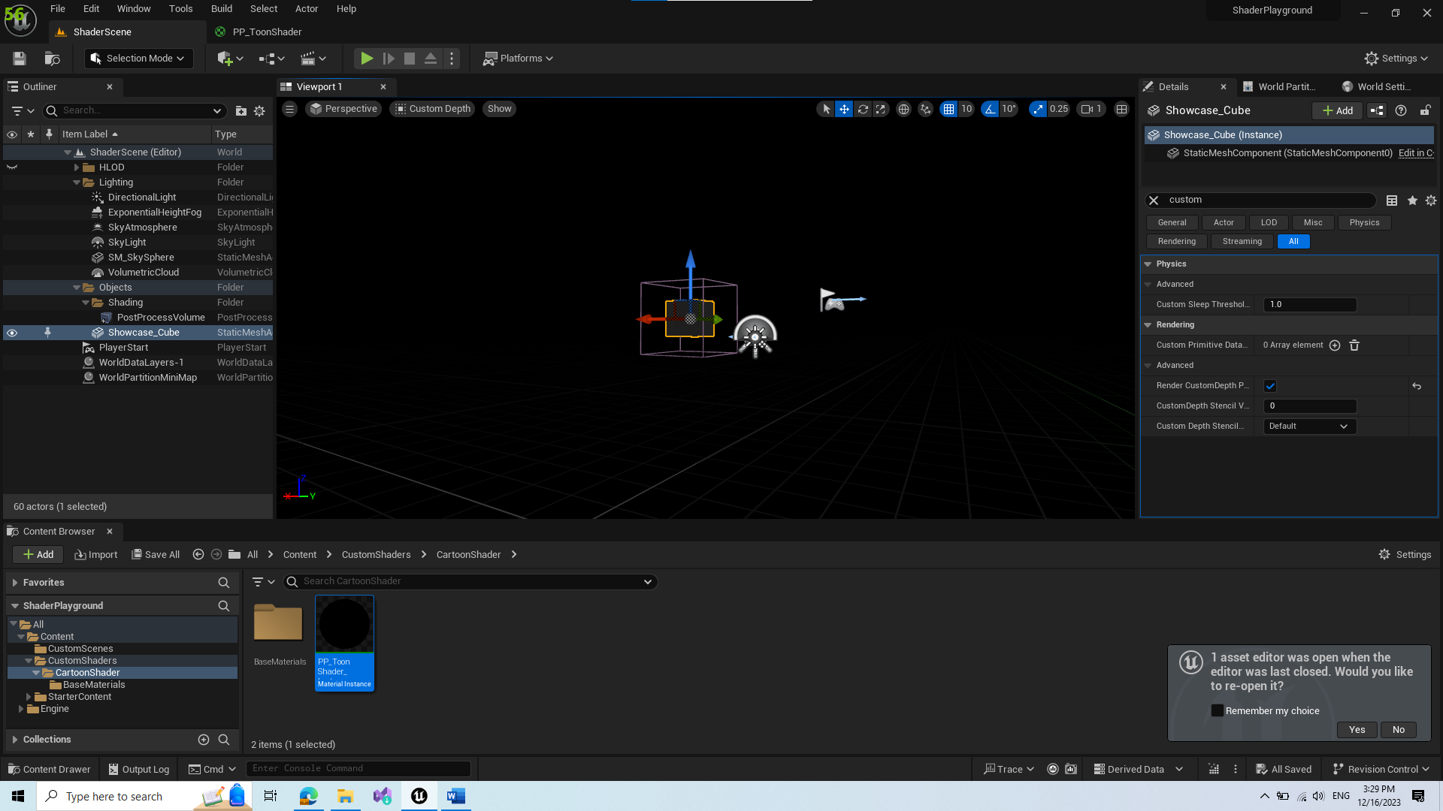

After that we need to adjust our effect to filter only selected objects

1. Now we get custom depth objects in this effect, however this results in wall hack possibilities

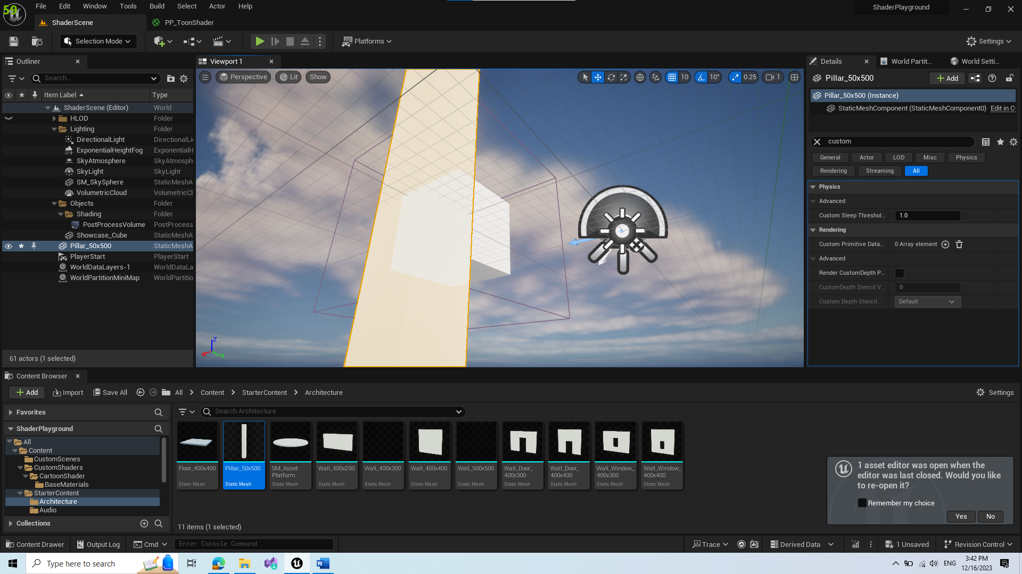

To solve this we need to adjust the effect so it checks sceneDepth if our custom depth object is 1st in camera

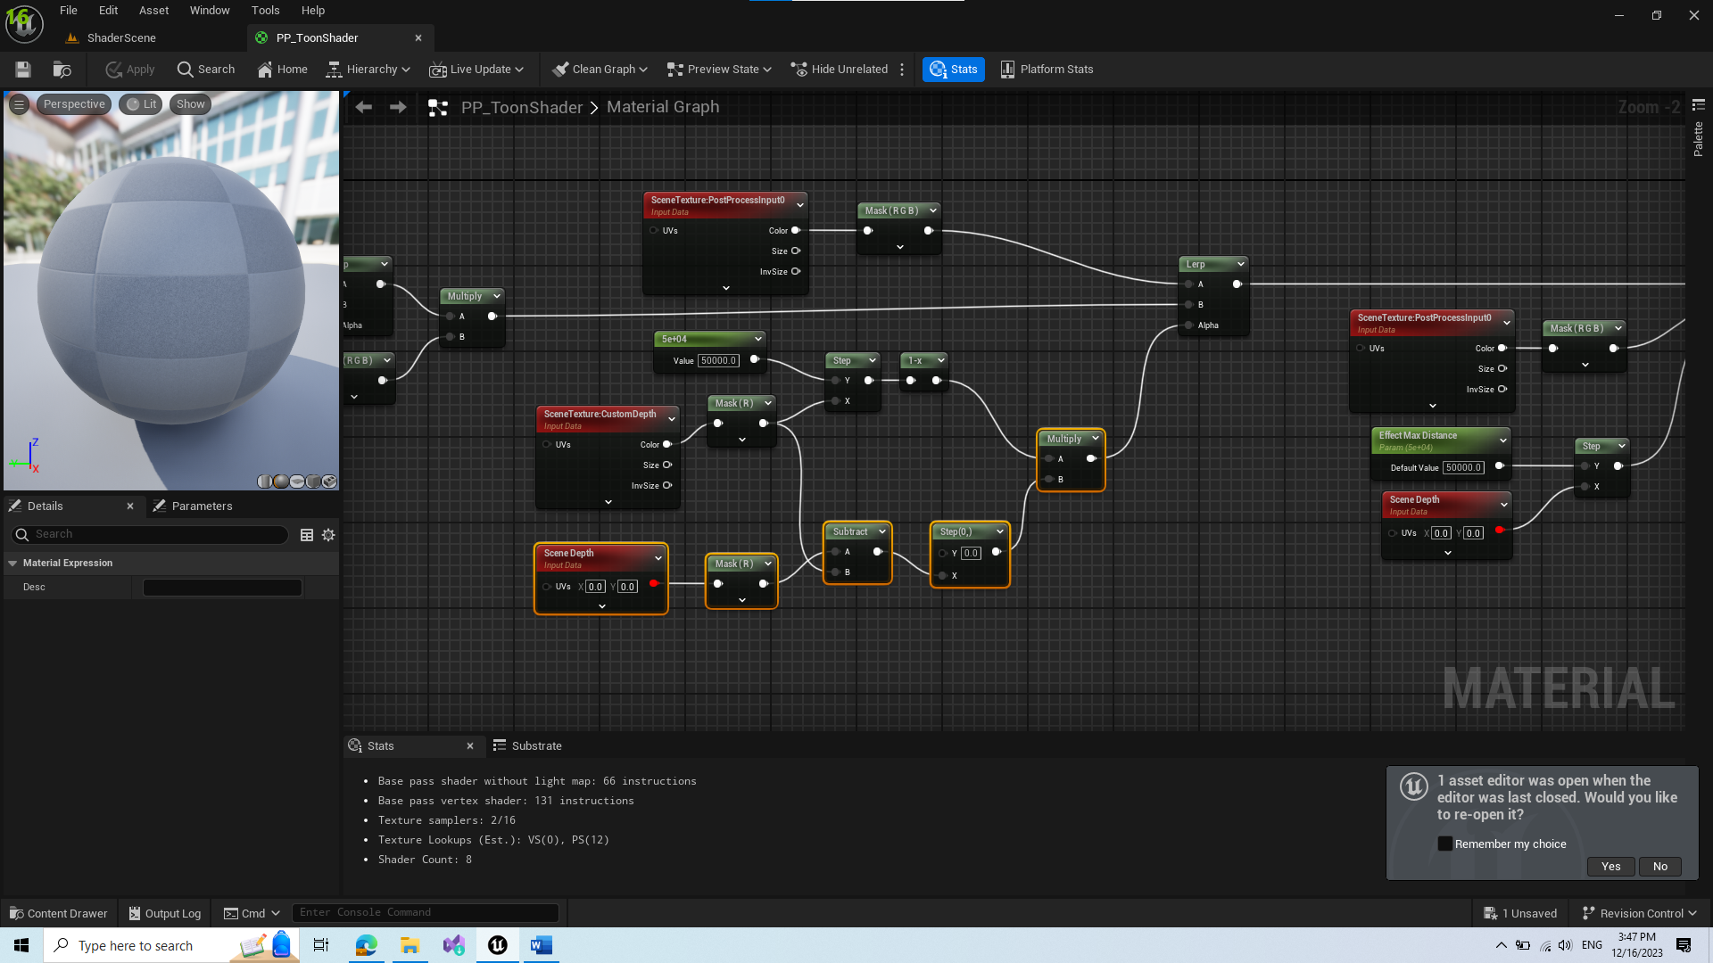

1. Create an option for enabling and disabling this

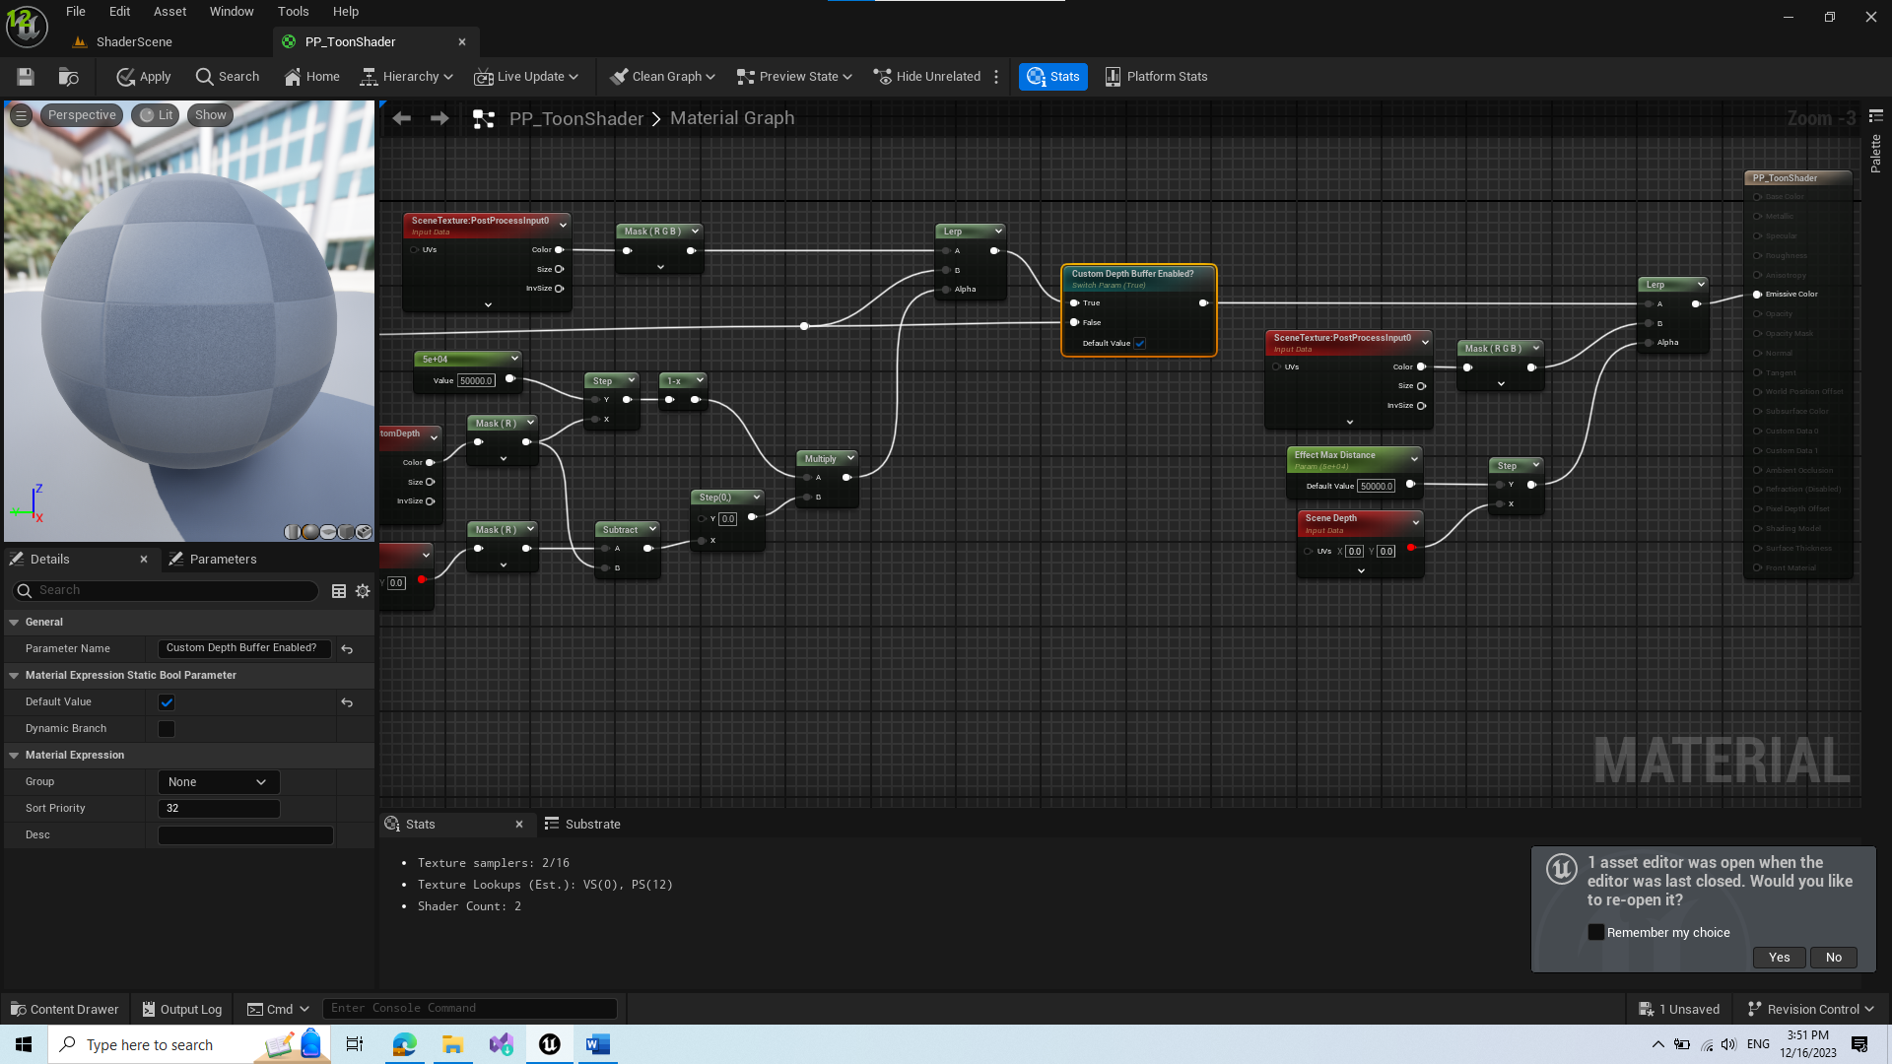

1. Create option to enabling custom depth wallhack

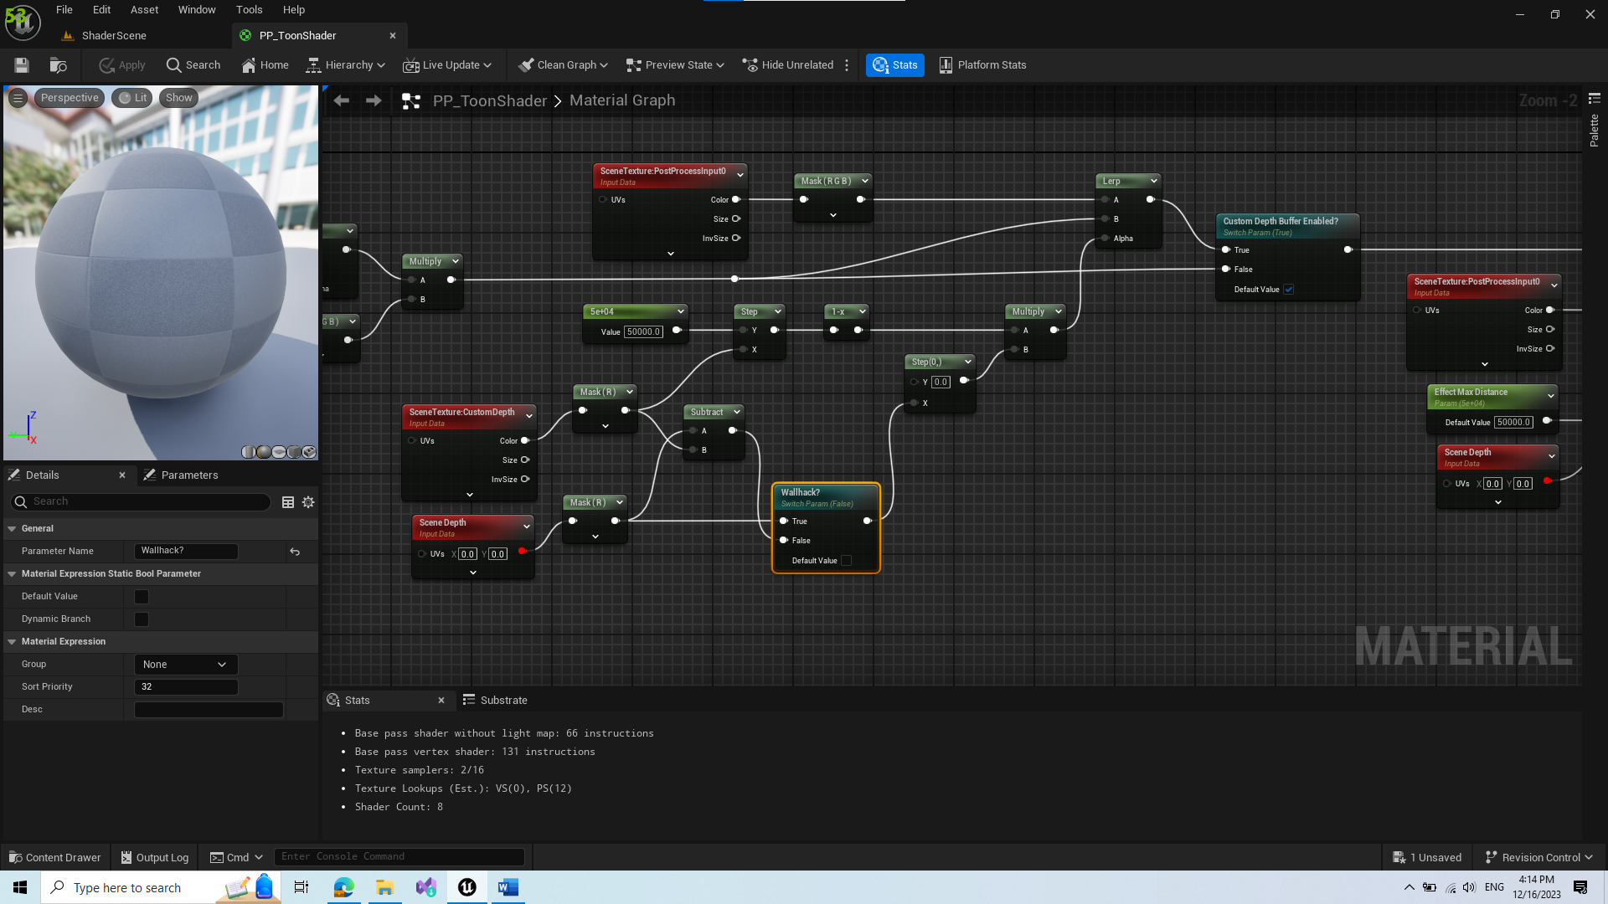

## Transform Cartoon Shader from BP to C++

TODO

# Create Custom Outline Shader

<https://www.youtube.com/watch?v=9KvUfnrHcqM&list=PLHbittBAlUdn3hh9ScZiKIH1L-53419qo&index=11>

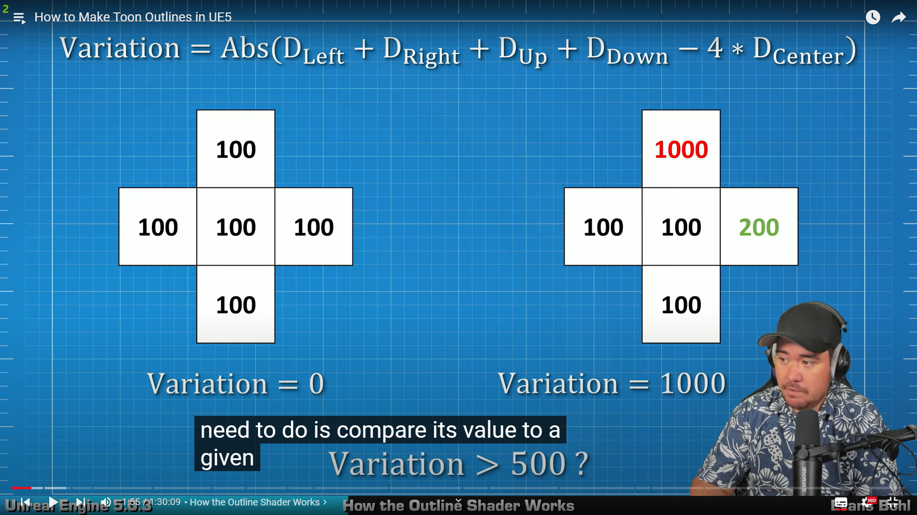

* This is broad explanation what the shader does

1. Create Base PP_OutlineShader

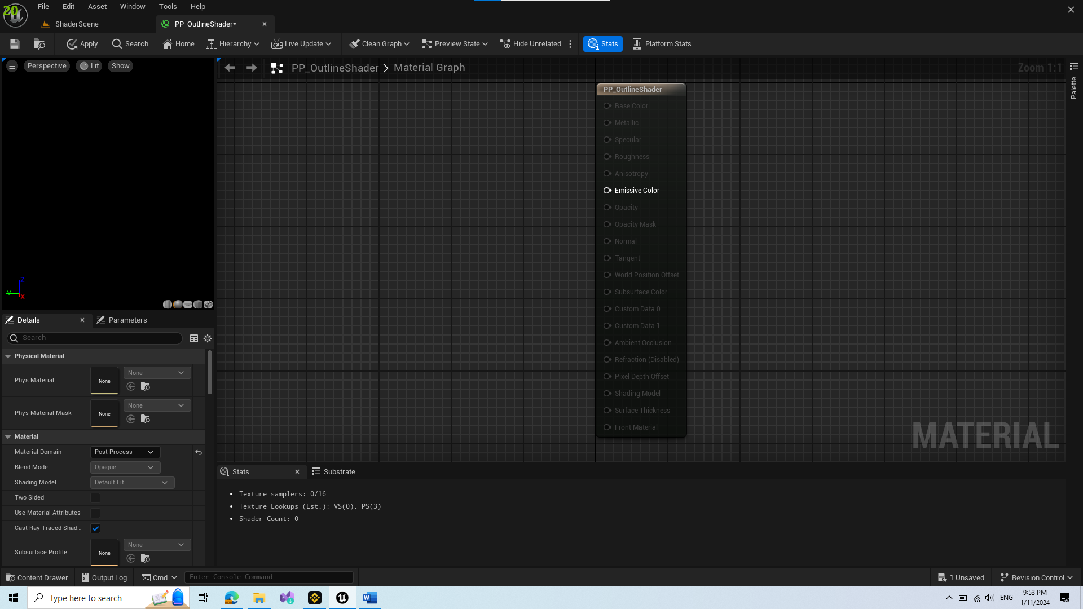

* Change Material Domain into PostProcess
* BlendableLocation into Before Mapping (otherwise there might be visual shaking bugs)

1. Create PostProcessVolume and Cube for showcasing, assign instance of shader to PP

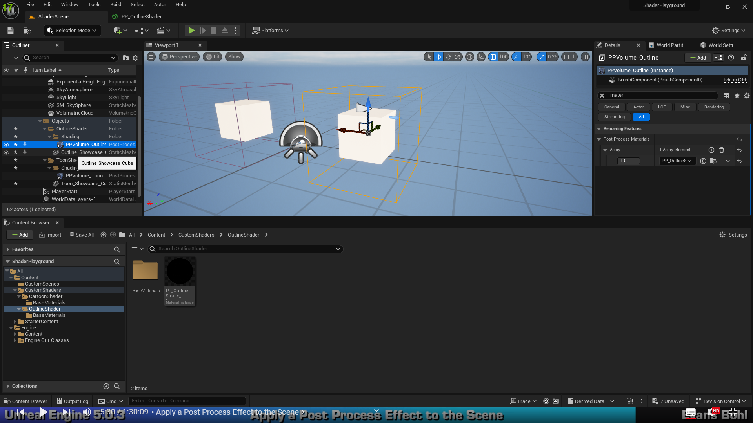

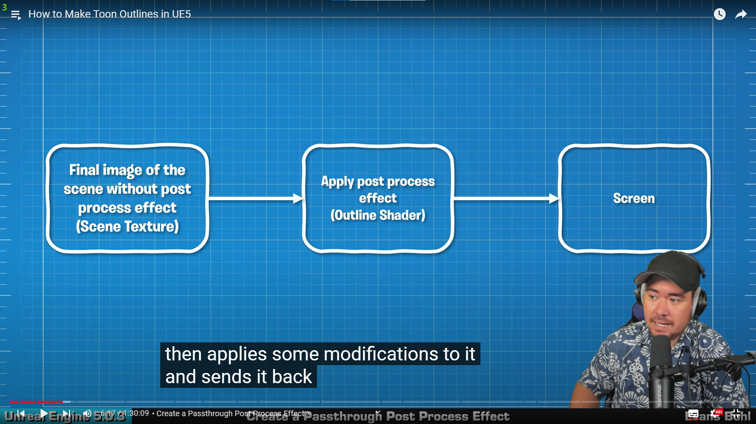

* This is just a simple explanation of how ue5 applies post processing

1. Add sceneTexture node and change id to PostProcessInput0

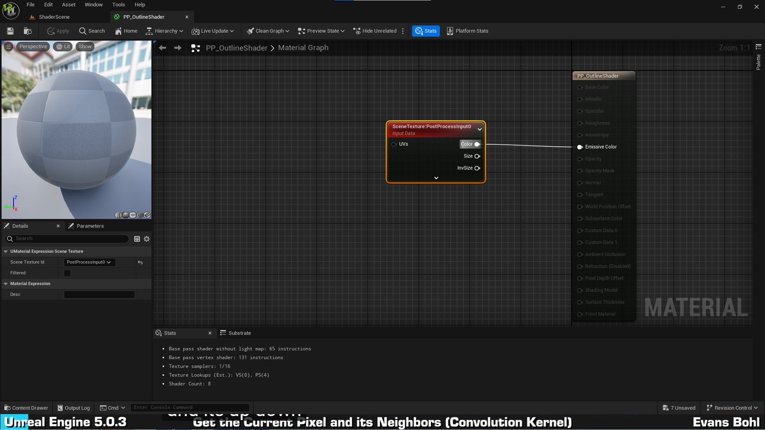

1. Create Material Function for Image Convolution Kernel

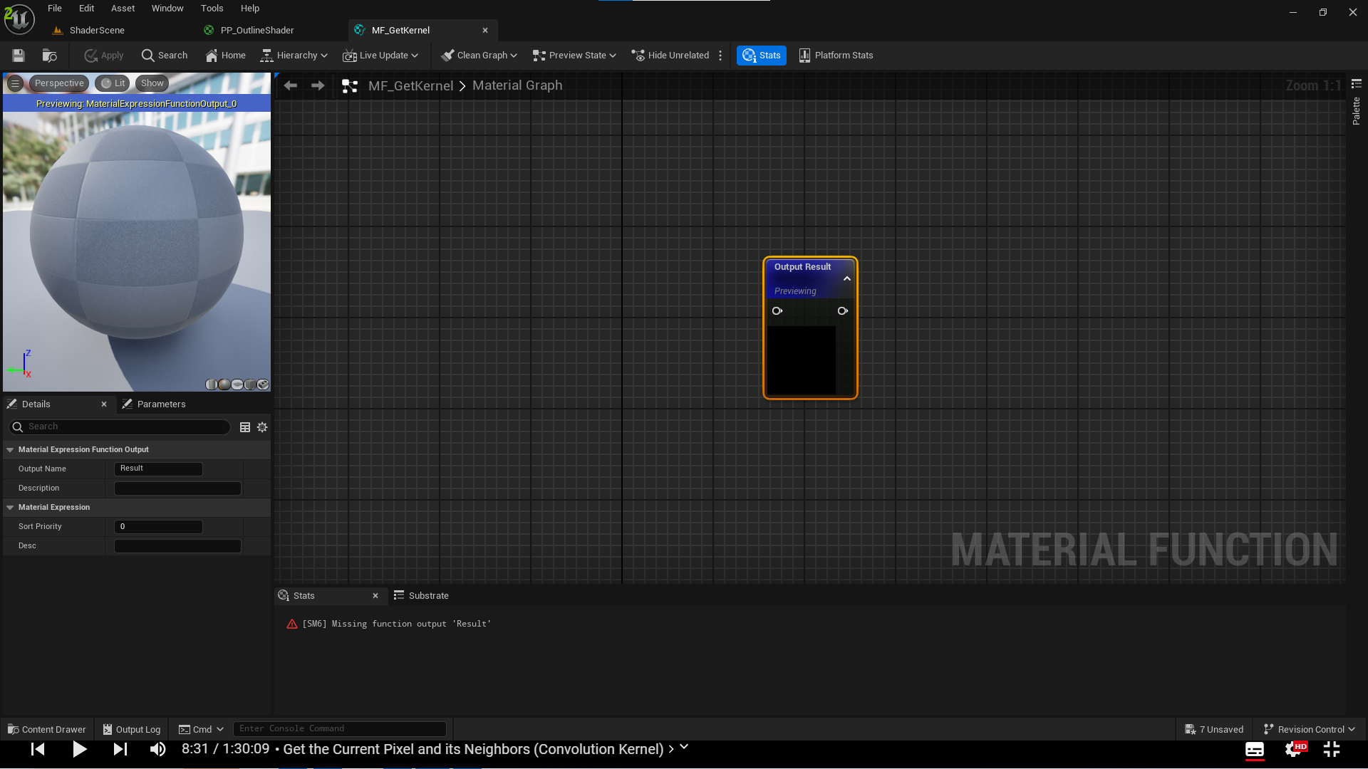

* Duplicate existing node, it should represent edge pixels of our center pixel

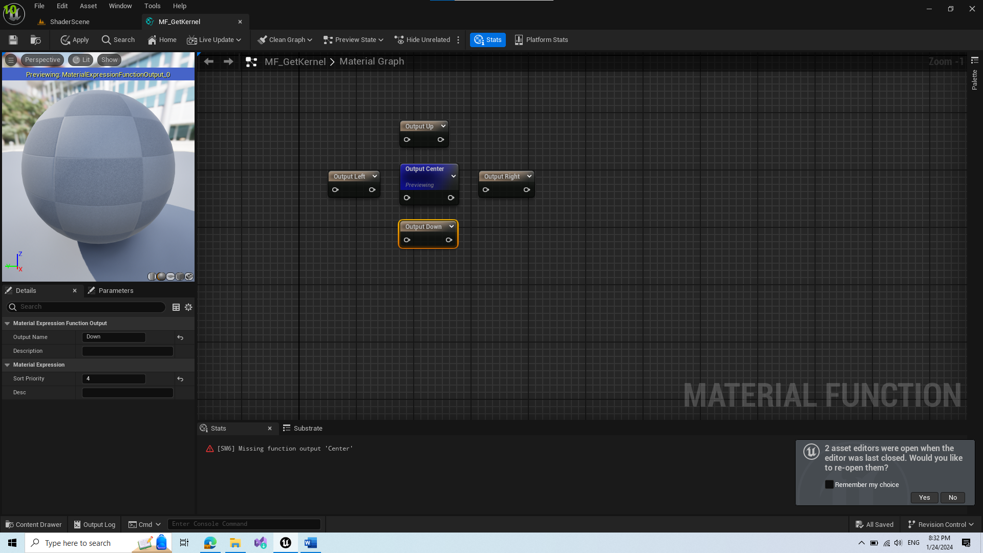

* Create horizontal offset per pixel for left and right pixel adjustments

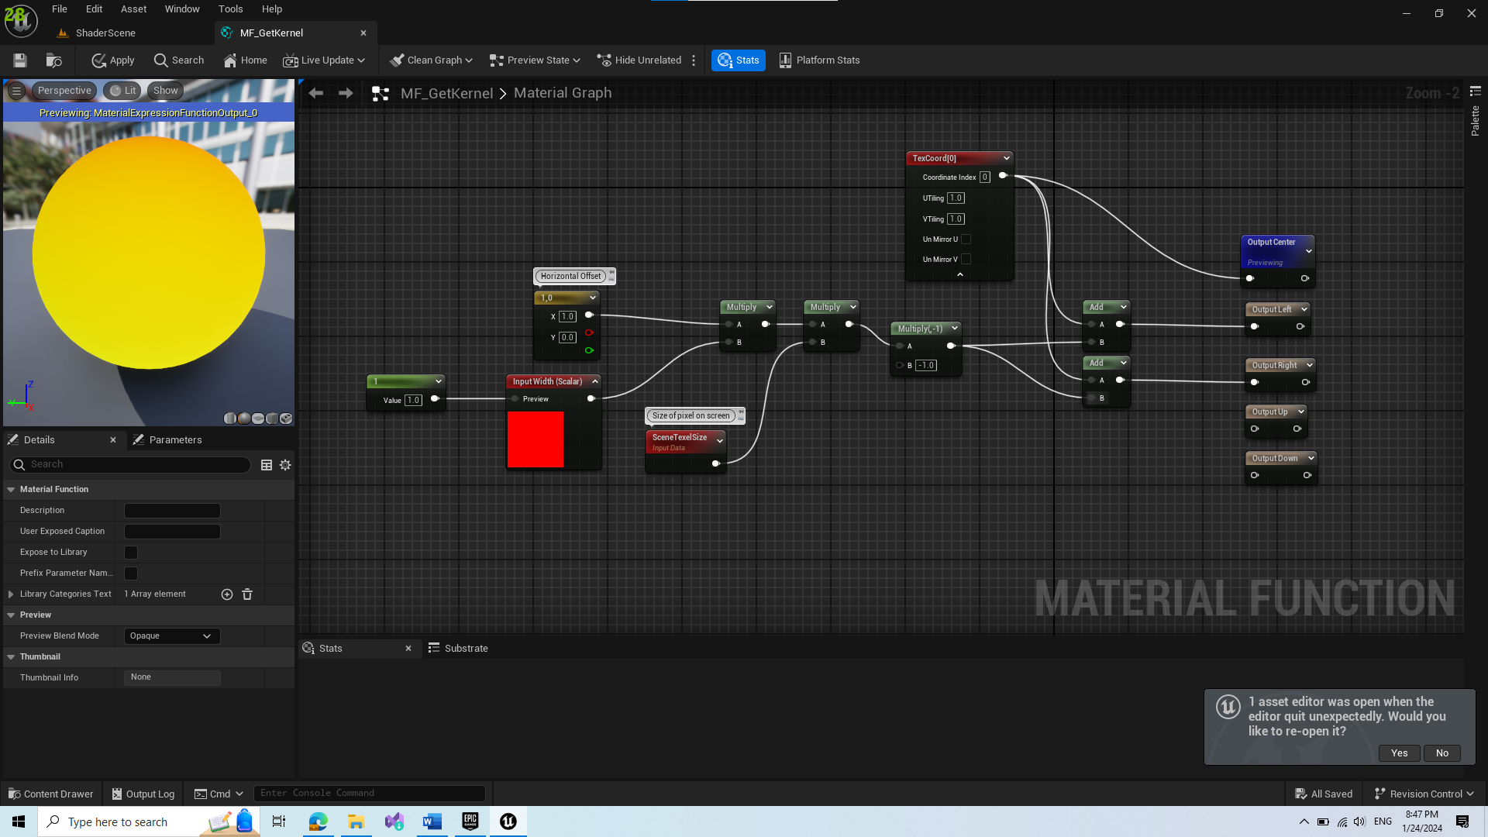

* Repeat similar for vertical offset and pixels up and down

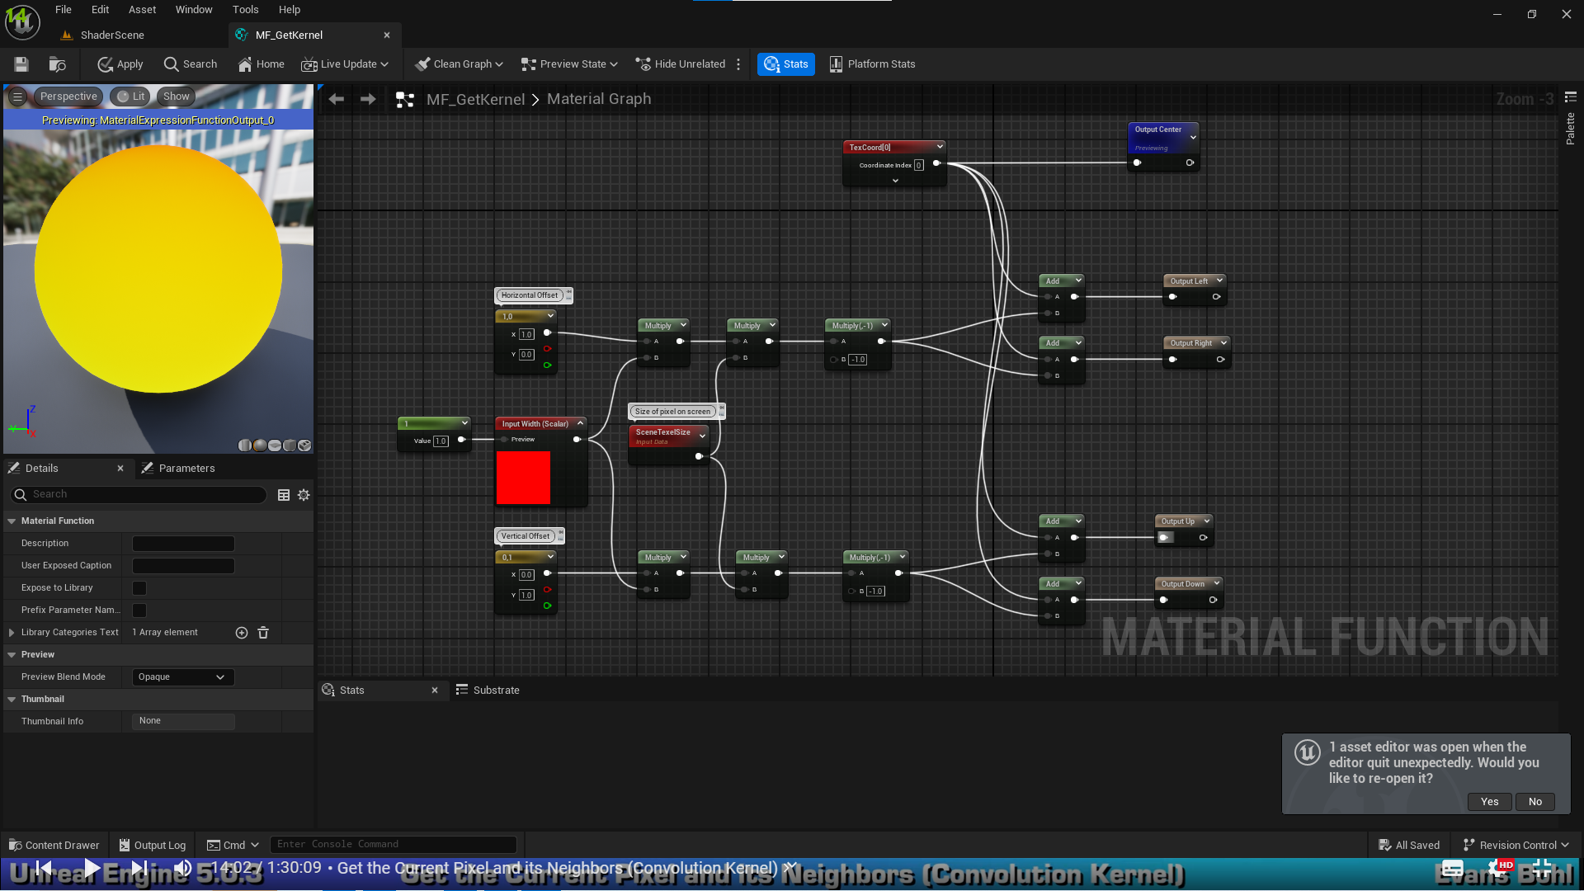

With this, Convolution Kernel is done.

1. Create new Material Function for Edge Detection & Depth

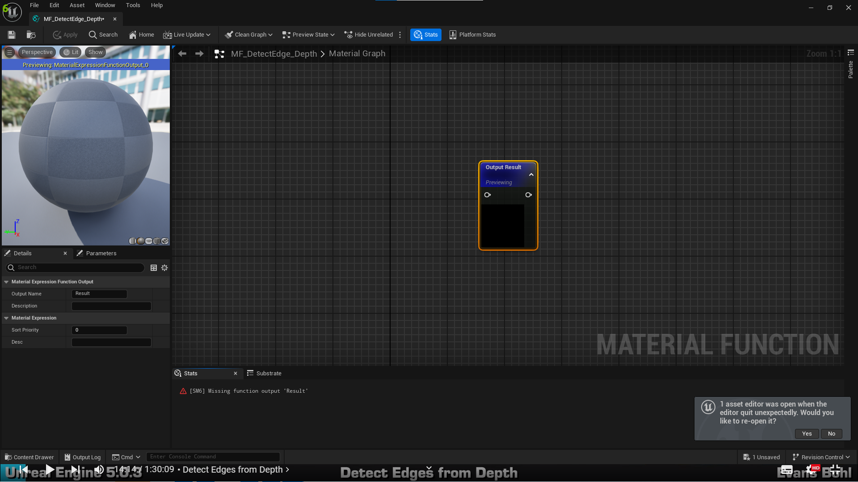

Return 1 if pixel is on edge 0 if its not

* Create 2 inputs, 1 for defining thickness, 1 for defining threshold. Then get Convolution Kernel created earlier

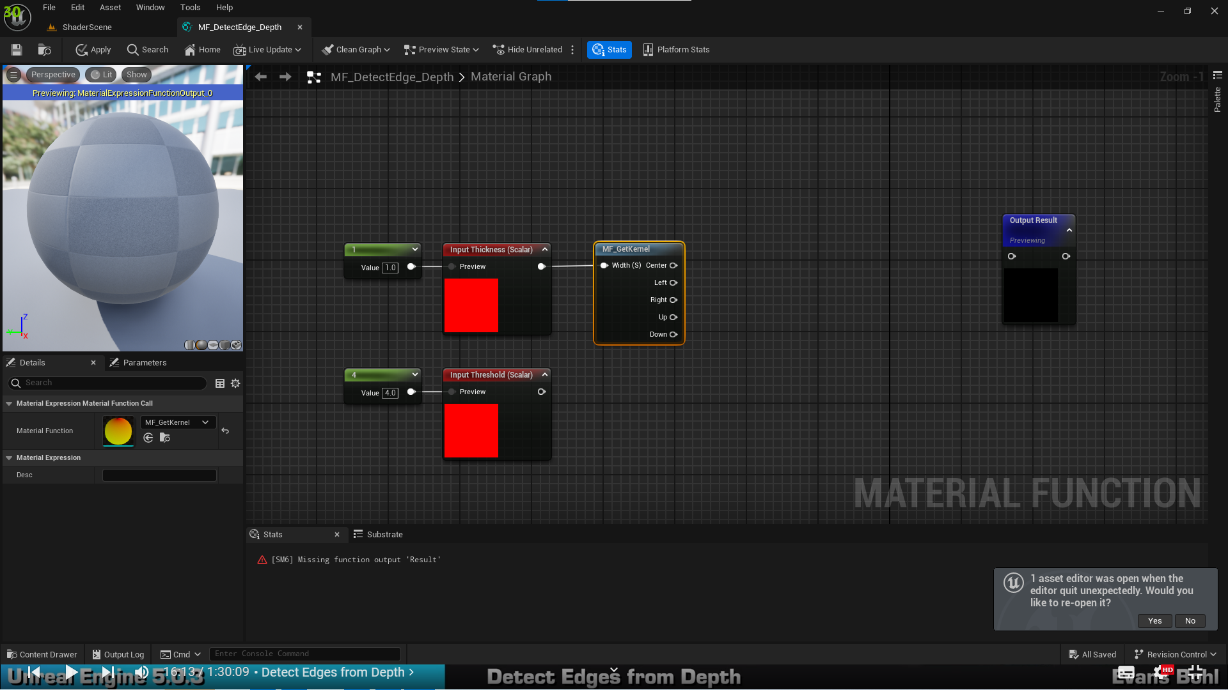

* Get scene depth to represent adjacent pixels and calculate if outlines are applied. Calculations should represent graph matrix shown in images above. Make both switch parameters true by default.

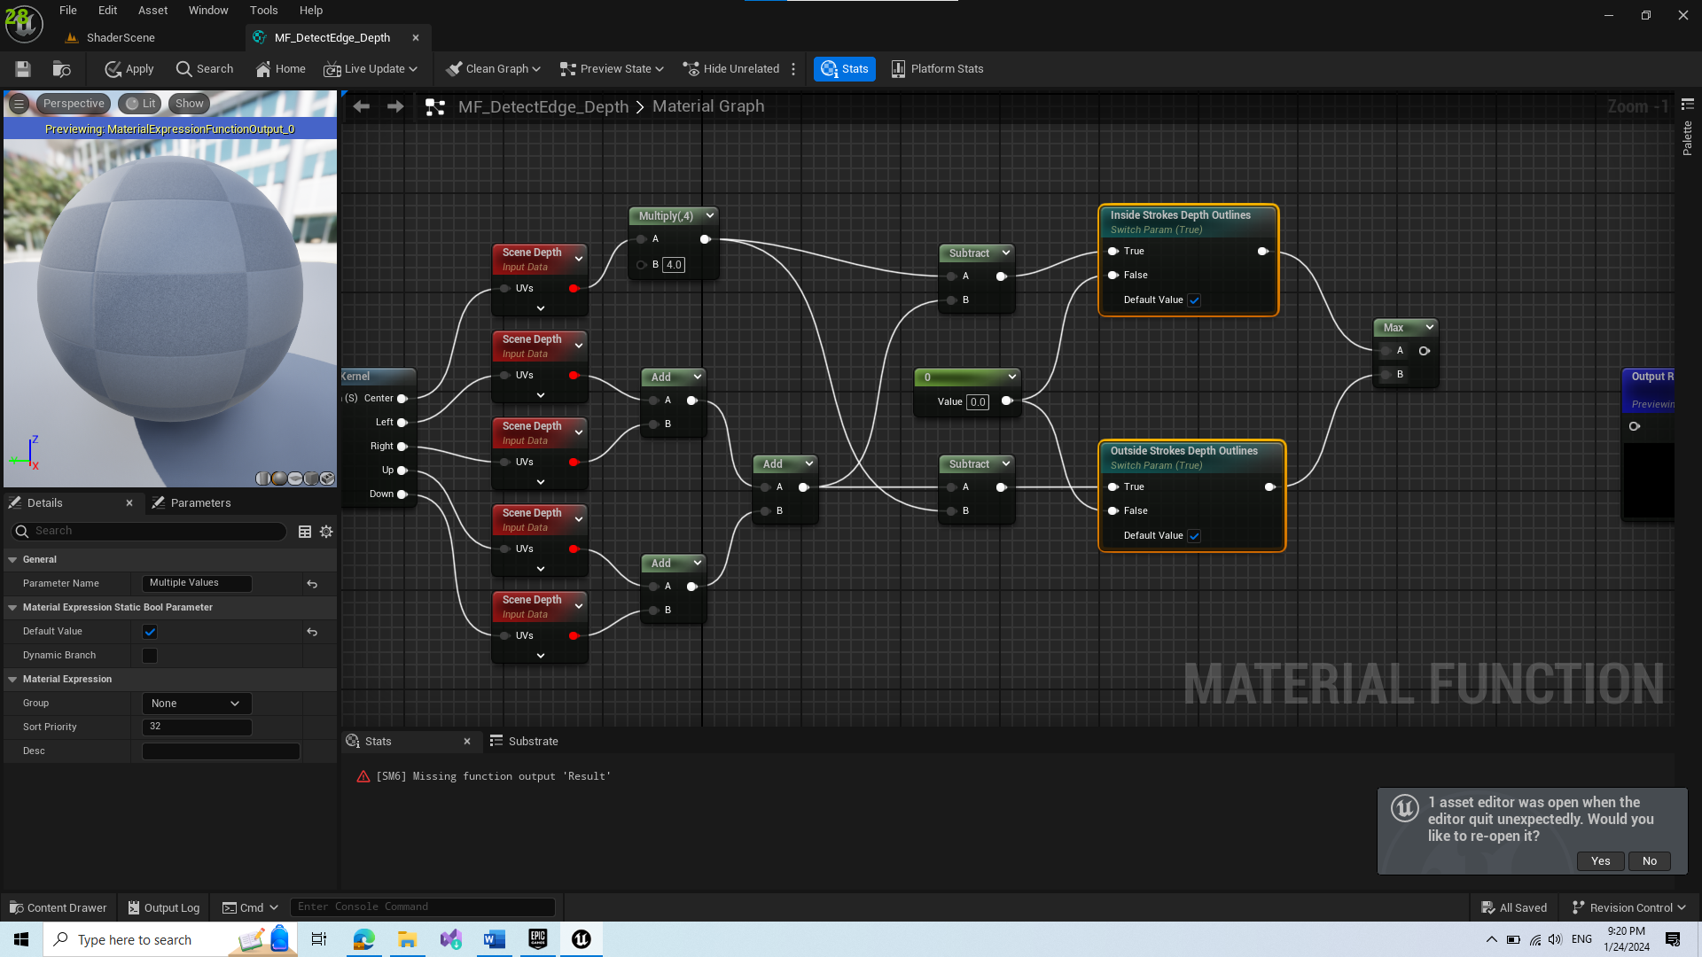

* Compare it with the threshold

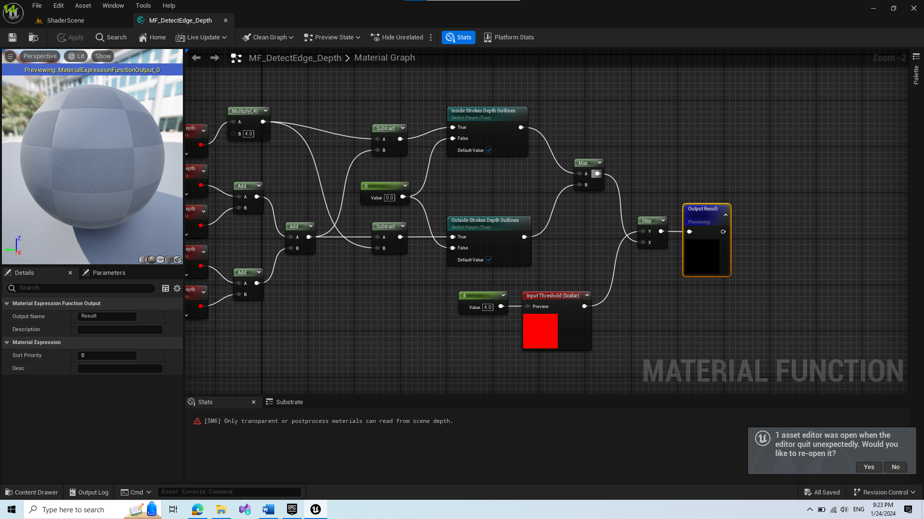

1. Apply DO Material function to Shader

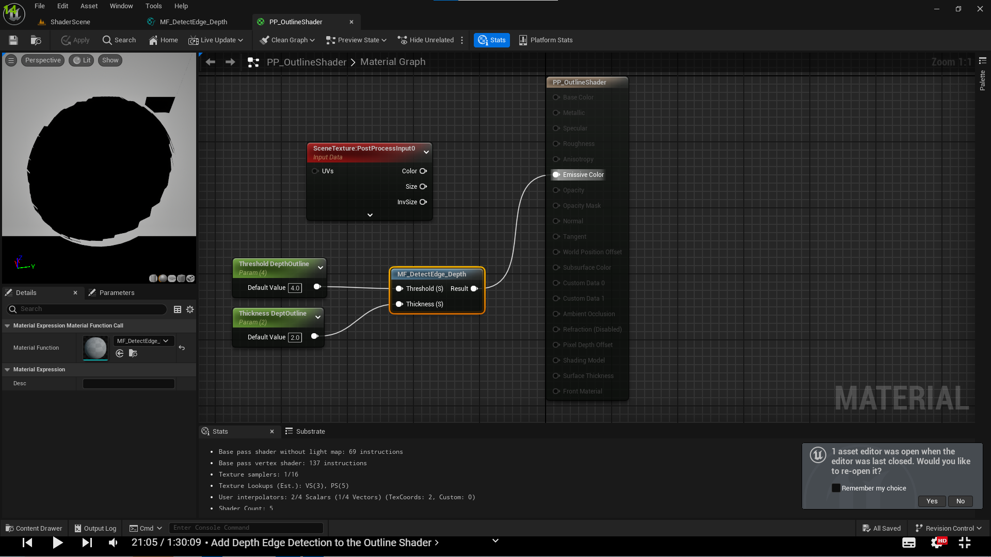

* However we see visual bug so we need to find the issue

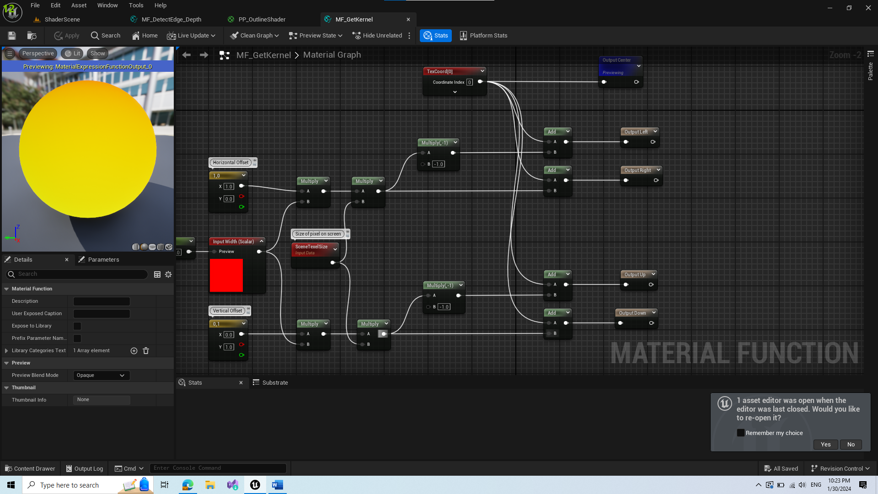

* Problem was in multiplication and add nodes

Result:

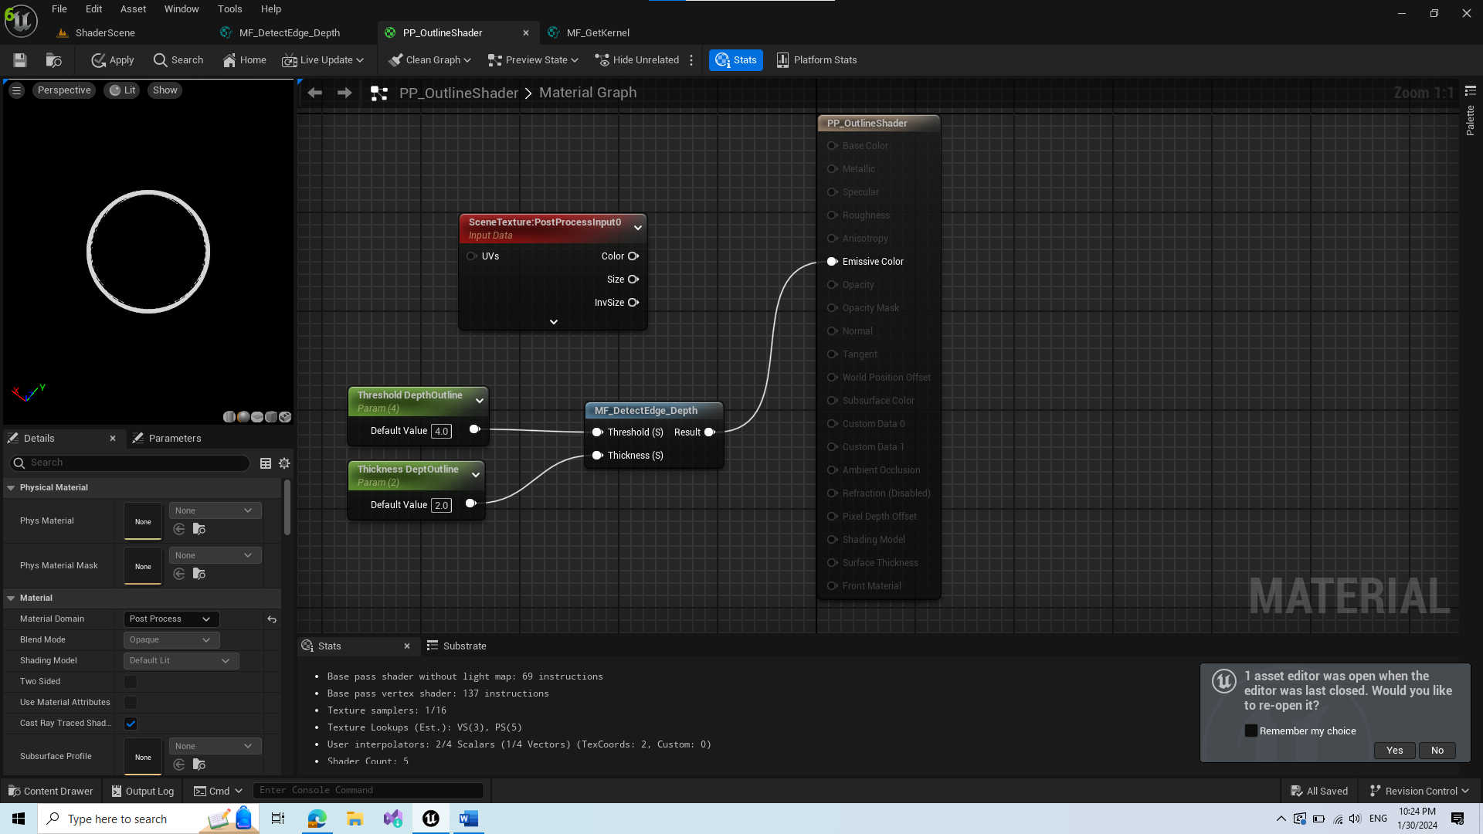

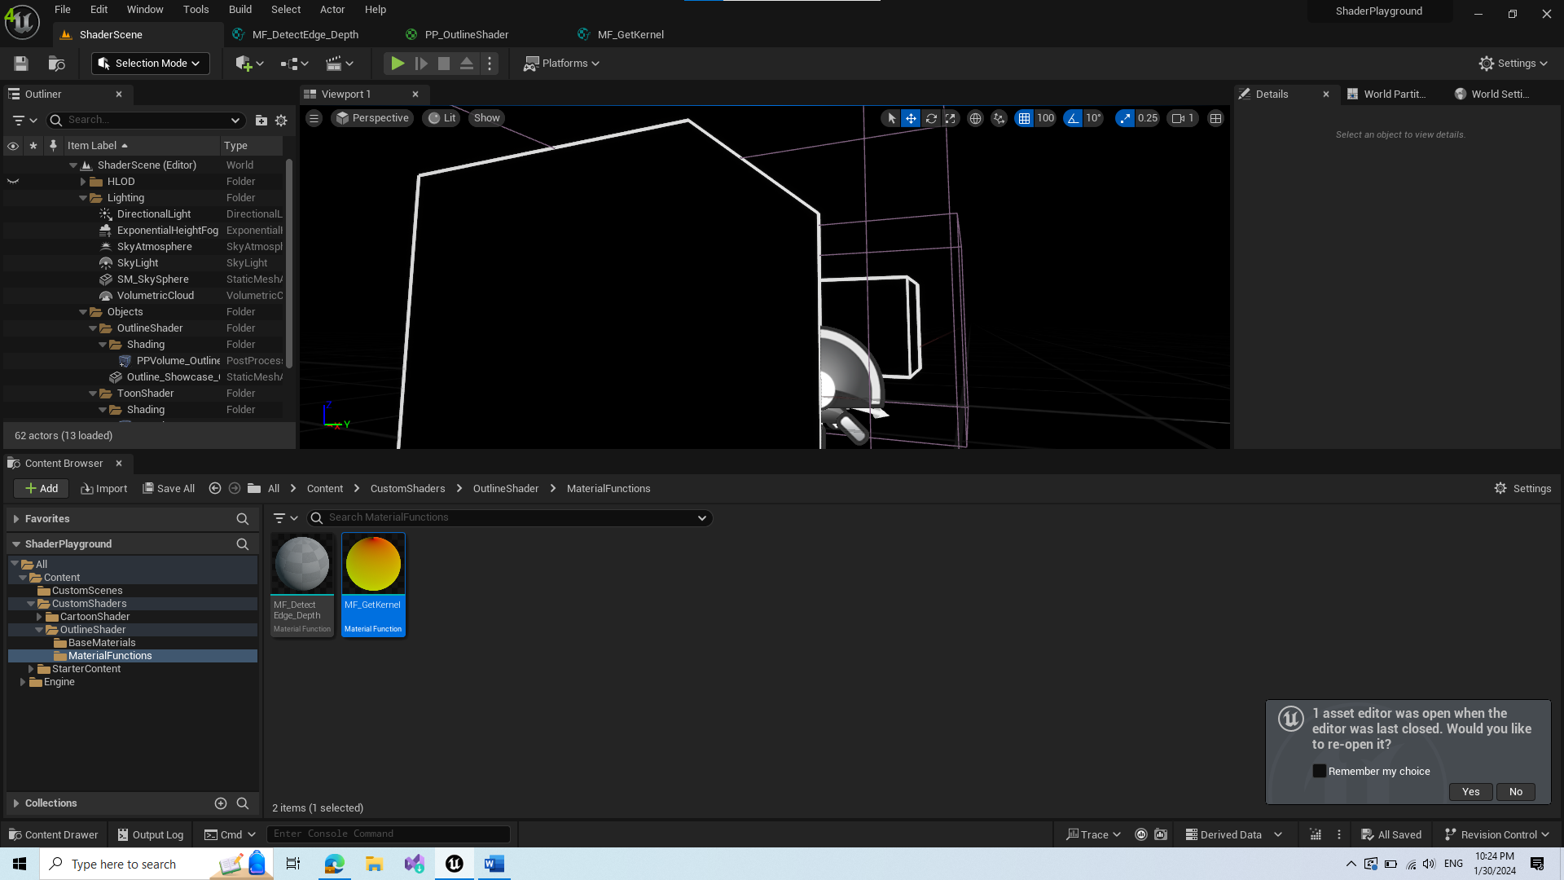

1. Bring back scene color

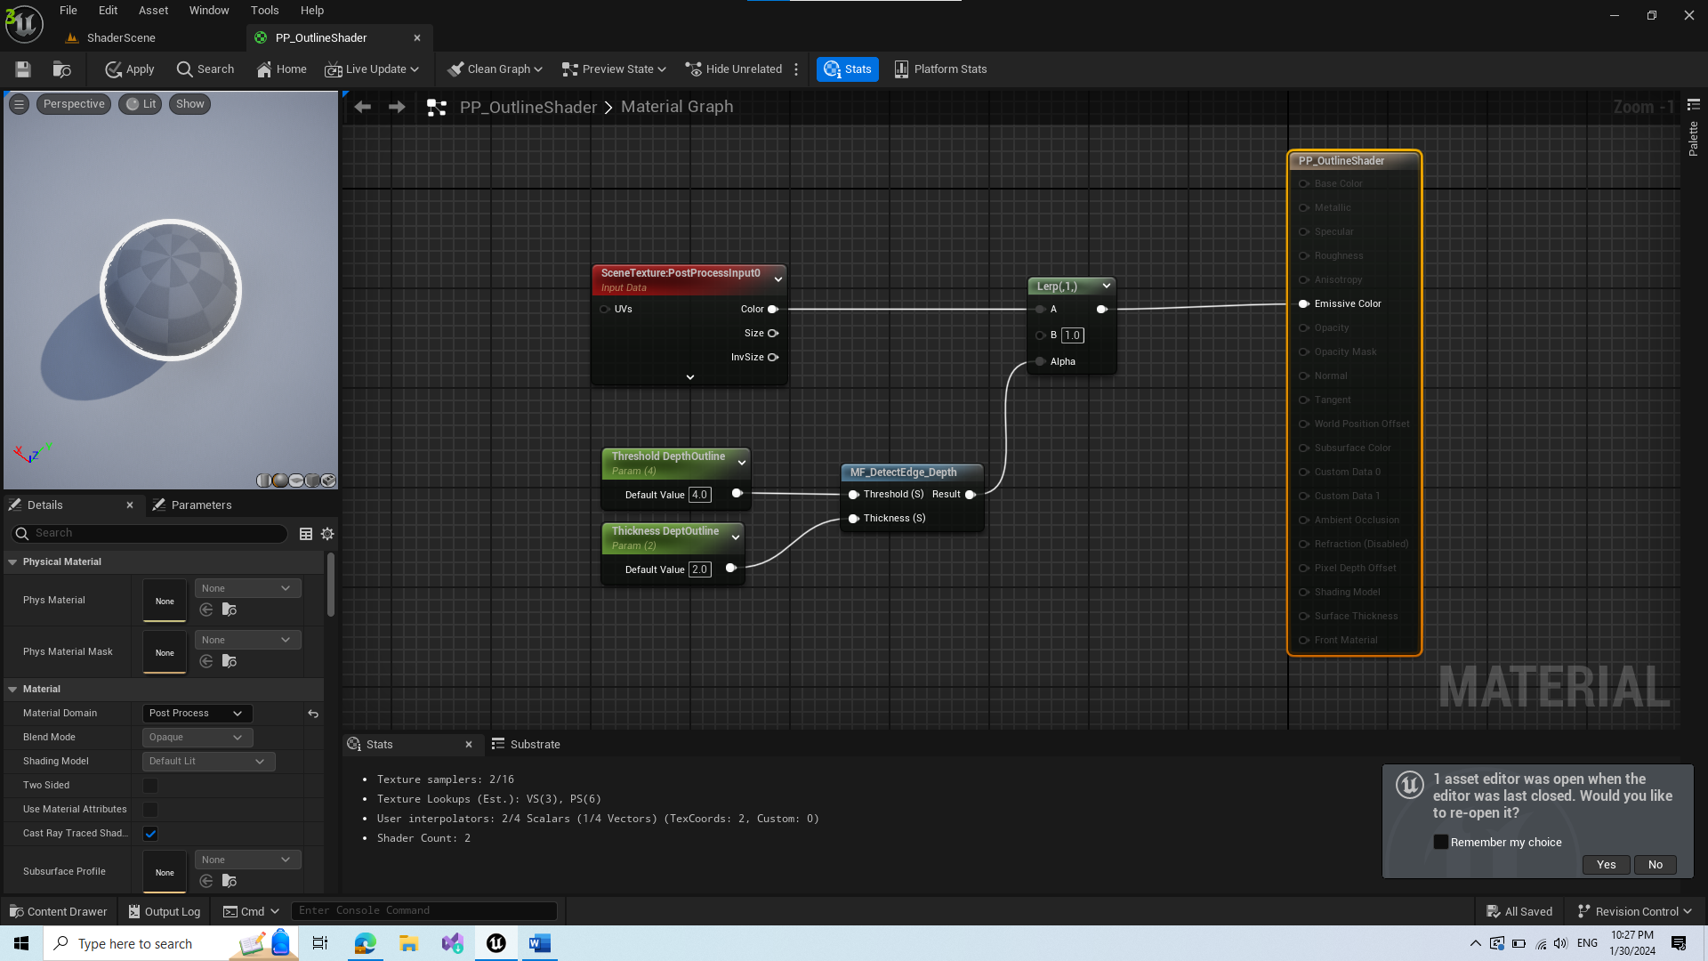

* We put our material function into alpha, which results in 0(transparency) if our material function calculation returns 0, meaning no edge detected or 1 for edges
* If you want to change color of outline, plug it in b of lerp

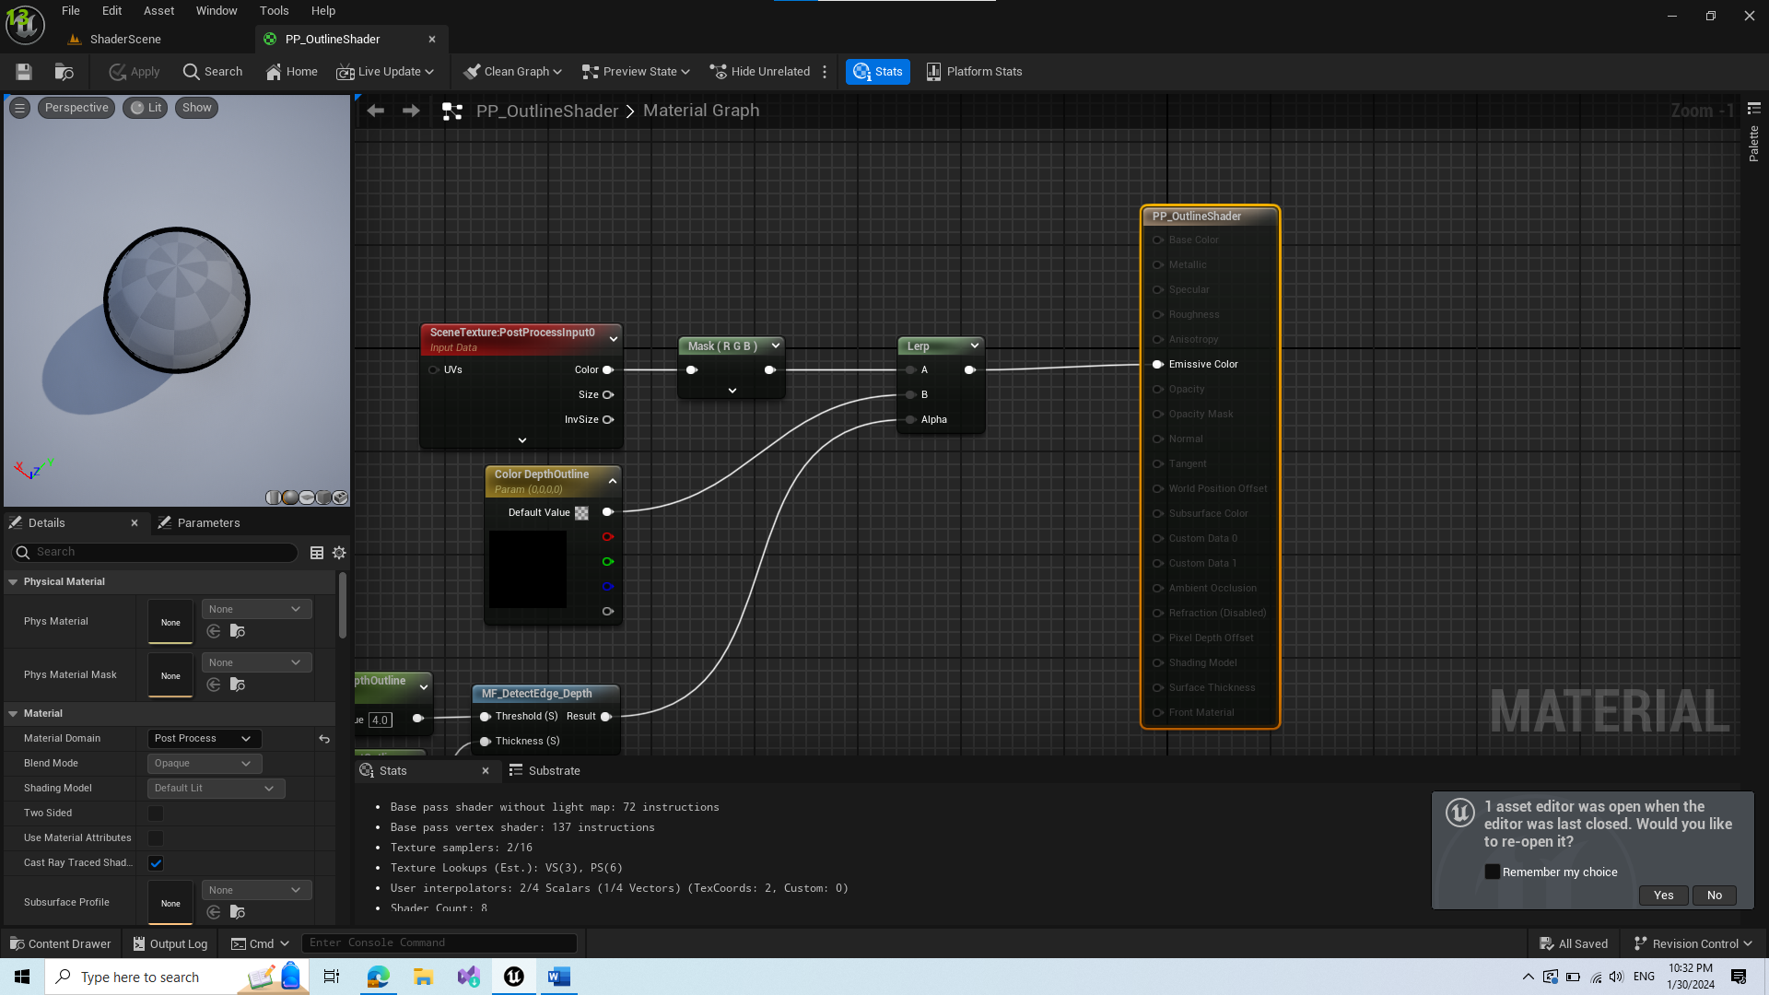

1. Create a new Material function for detecting normal

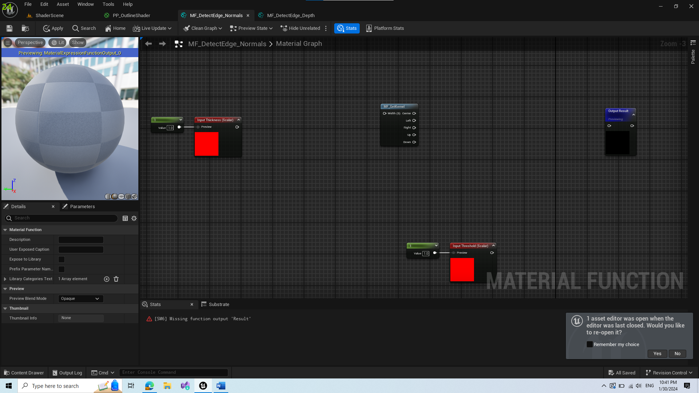

* Since its using similar calculations as detect edges depth material function, we copied Input scalars for thickness and threshold

1. Add SceneTexture node and change scene texture id to World Normal

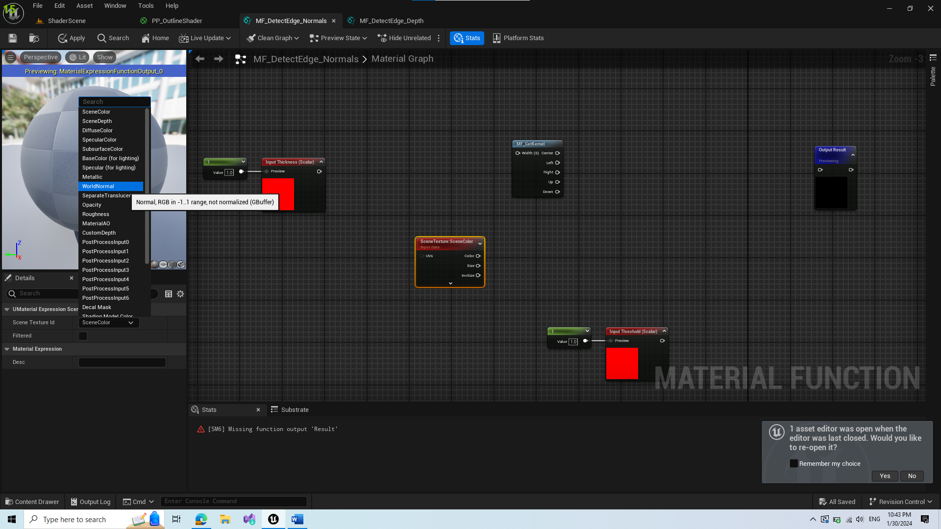

1. Duplicate them for adjacent pixels

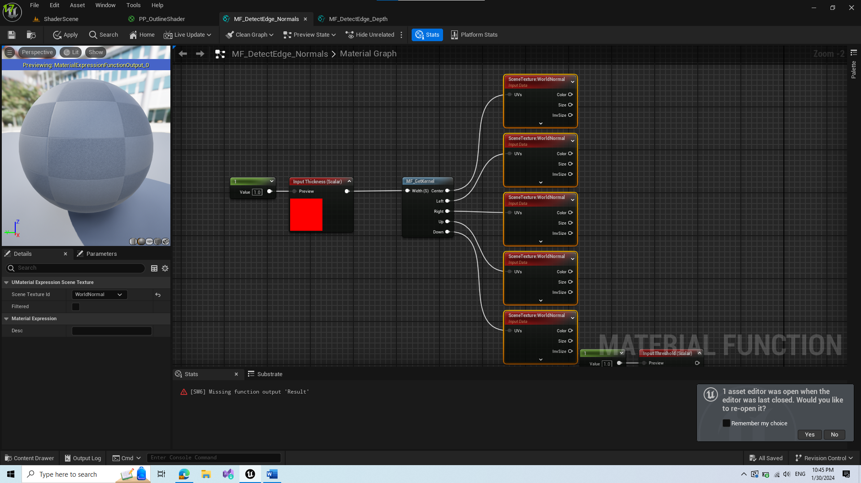

1. Calculate distance between center and rest of the normal (Utility -> Distance)

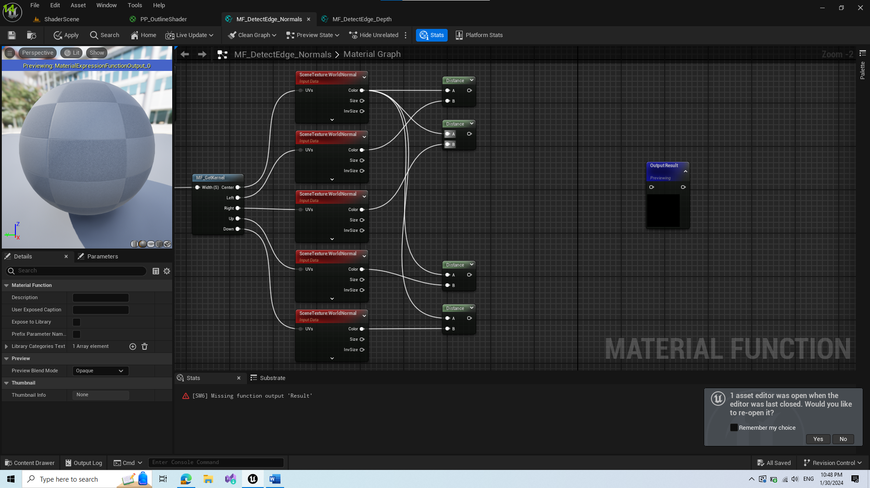

1. Add the distances together and compare them to threshold parameter for output as step

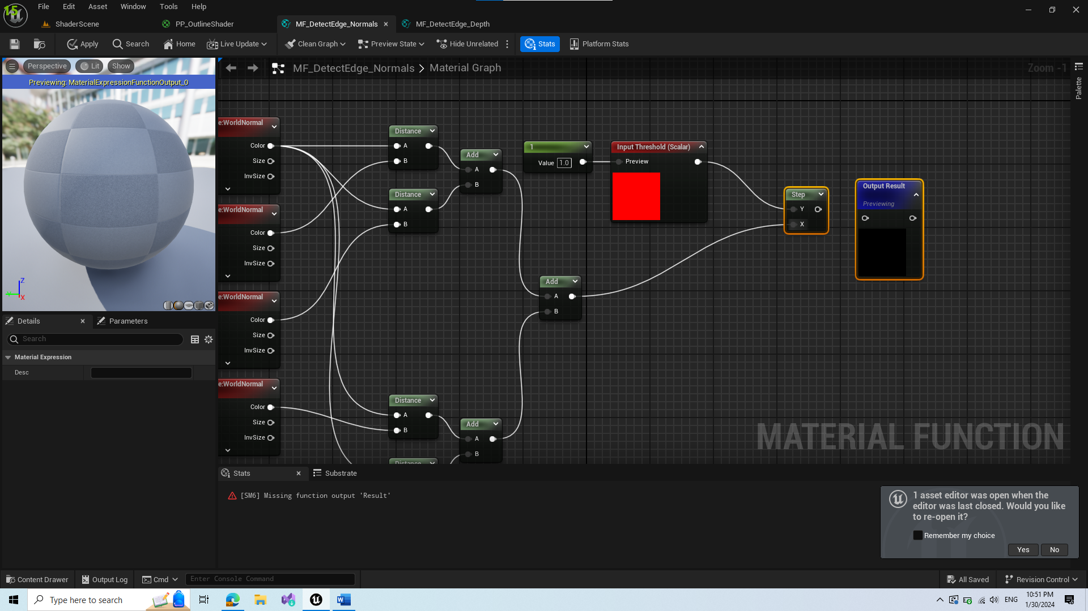

1. Combine it in shader

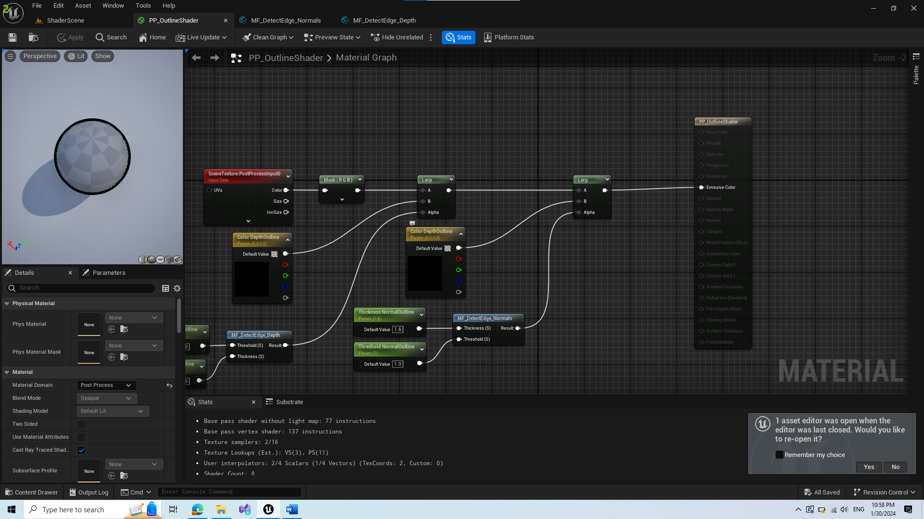

1. To get rid of visual bugs at certain angles, we create new Material Function MF_DepthTghresholdModulation_GrazingAngle

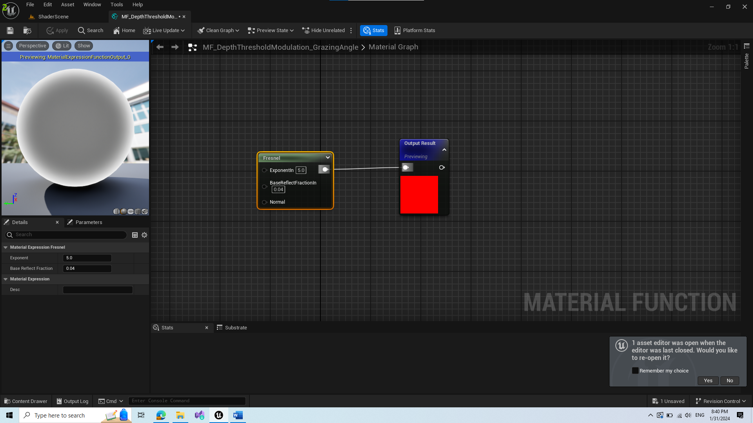

For that we will use Fresnel node. It works like this:

* If the surface looks directly at the camera it returns 0
* The more the surface normal is perpendicular to the camera it gets closer to the 1

1. Add math to material function

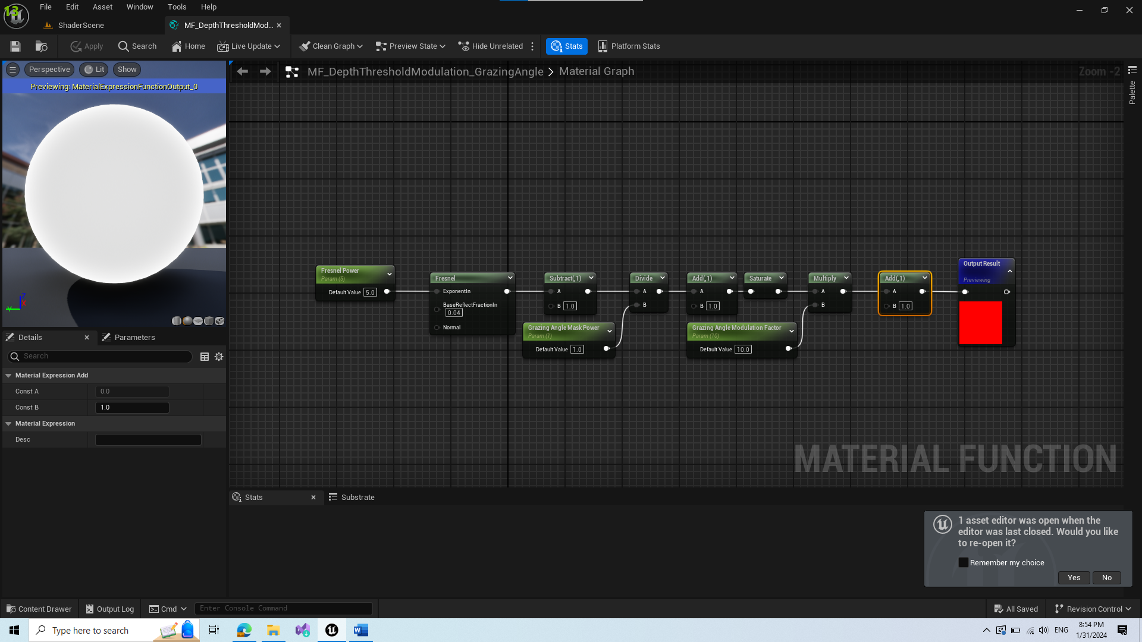

* Here we provide a smoother transition of color

1. Add the GrazingAngleModulation material function to shader with custom switch param

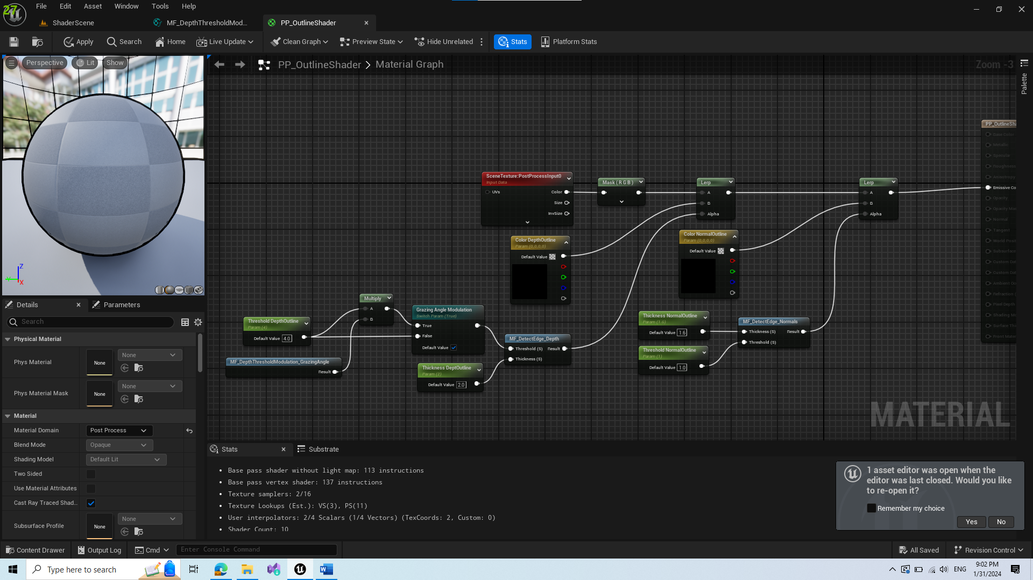

* If the problems with “shadows” on map still occur, adjust numbers in Shader Instance

1. Next bug is thickness of far away objects, for this we create new Material Function

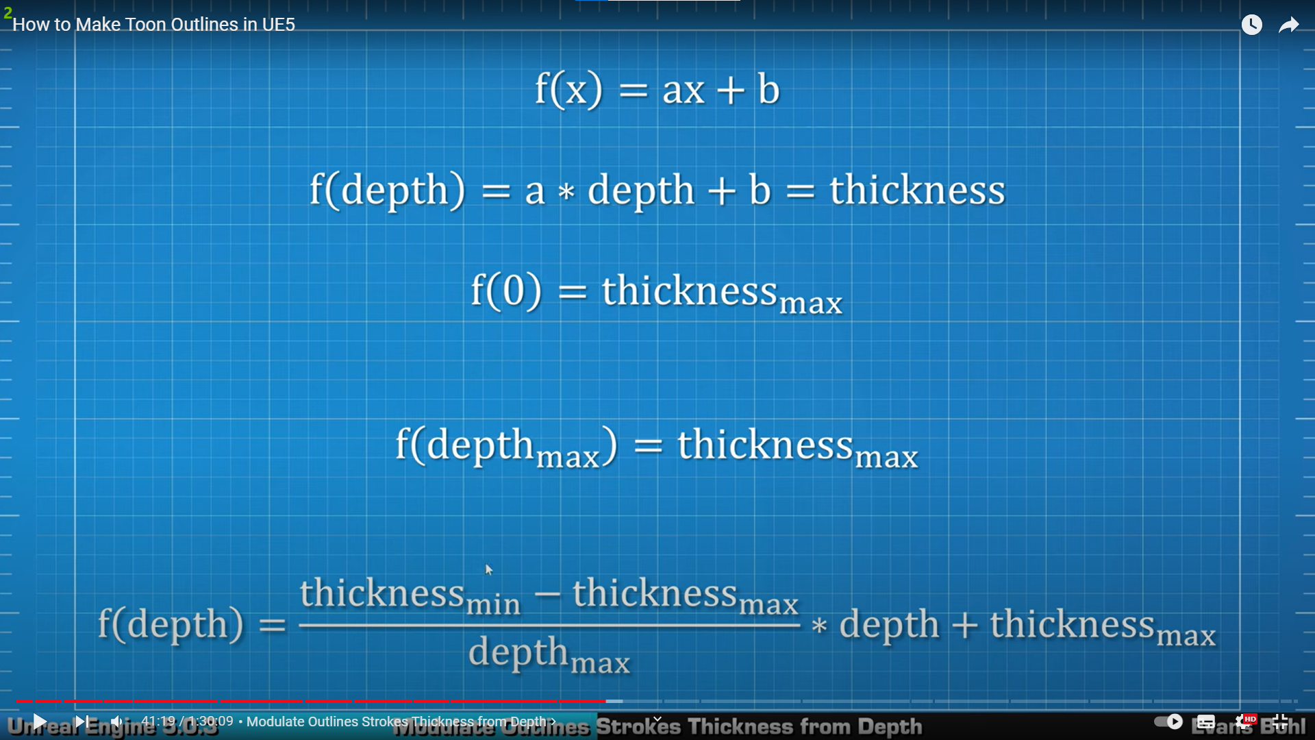

* For this, we follow the shown function and create parameters in our new material function

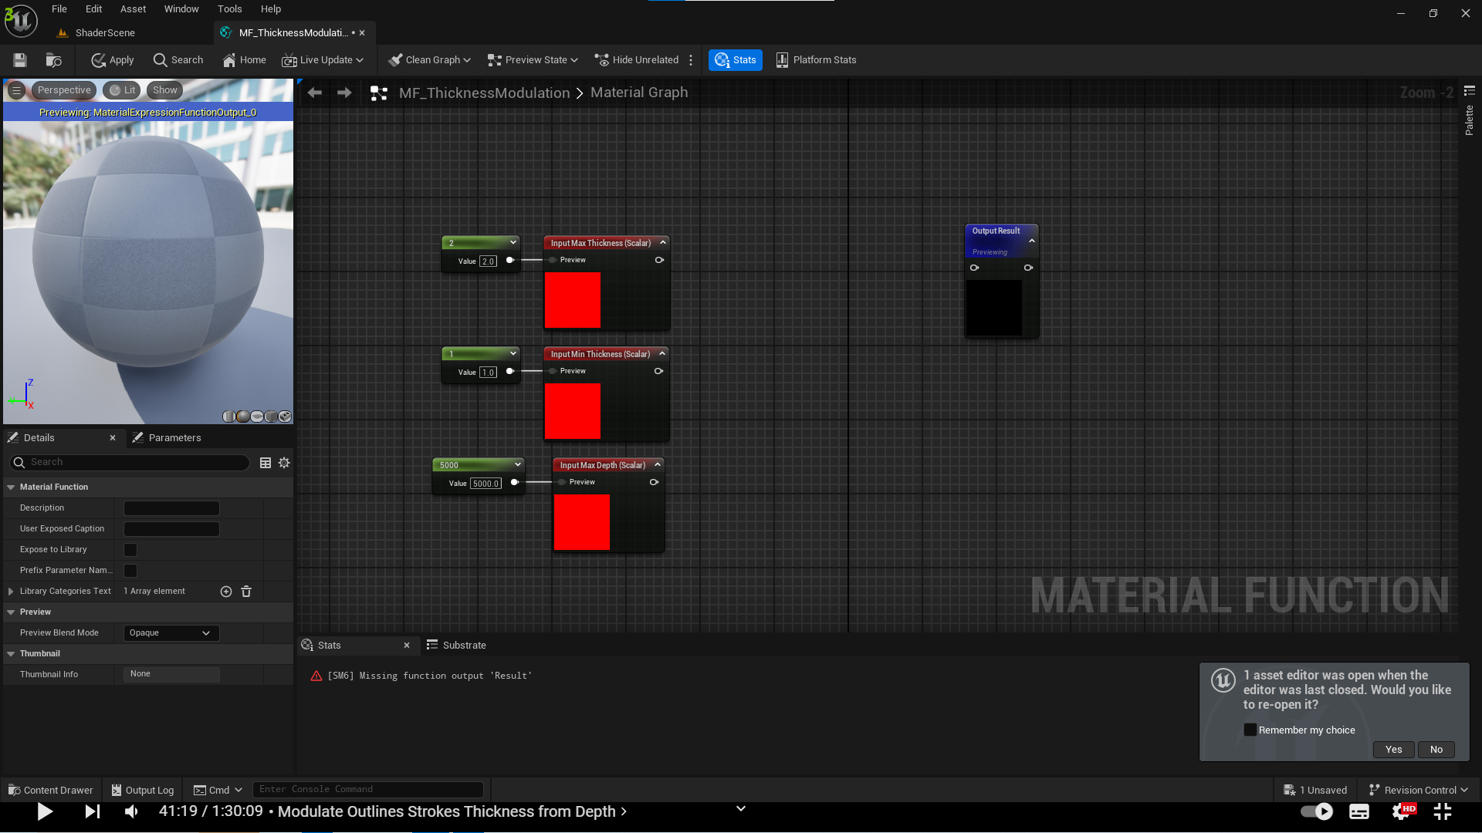

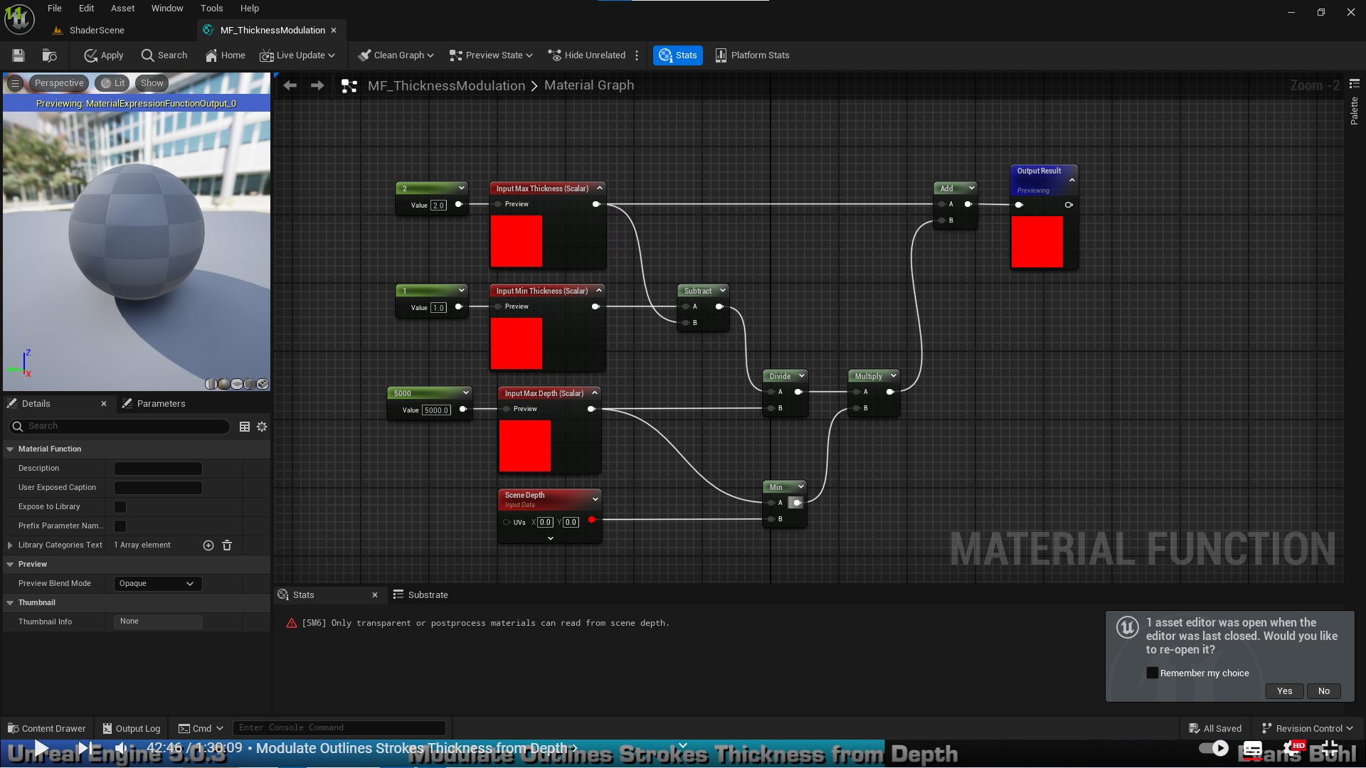

1. Add new Material Function to our shader

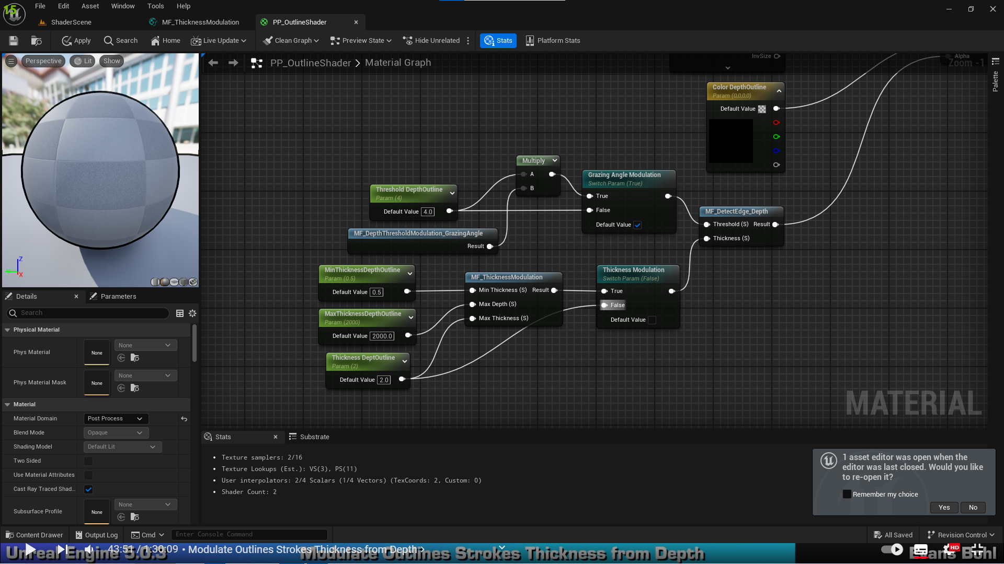

* Repeat for Normal edges

1. Fix bug with inconsistent edge thickness and inconsistent edge on round surfaces

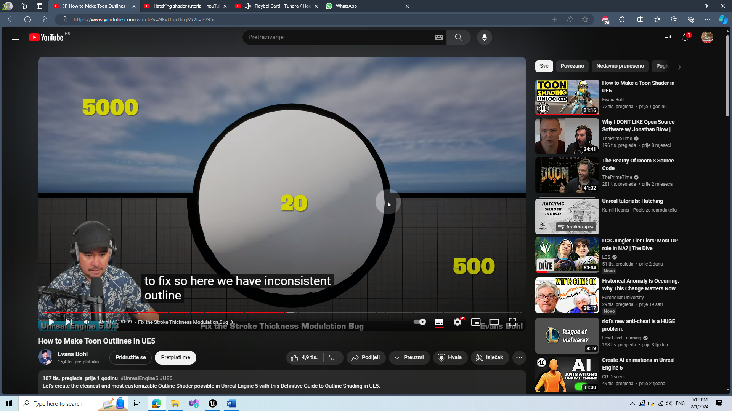

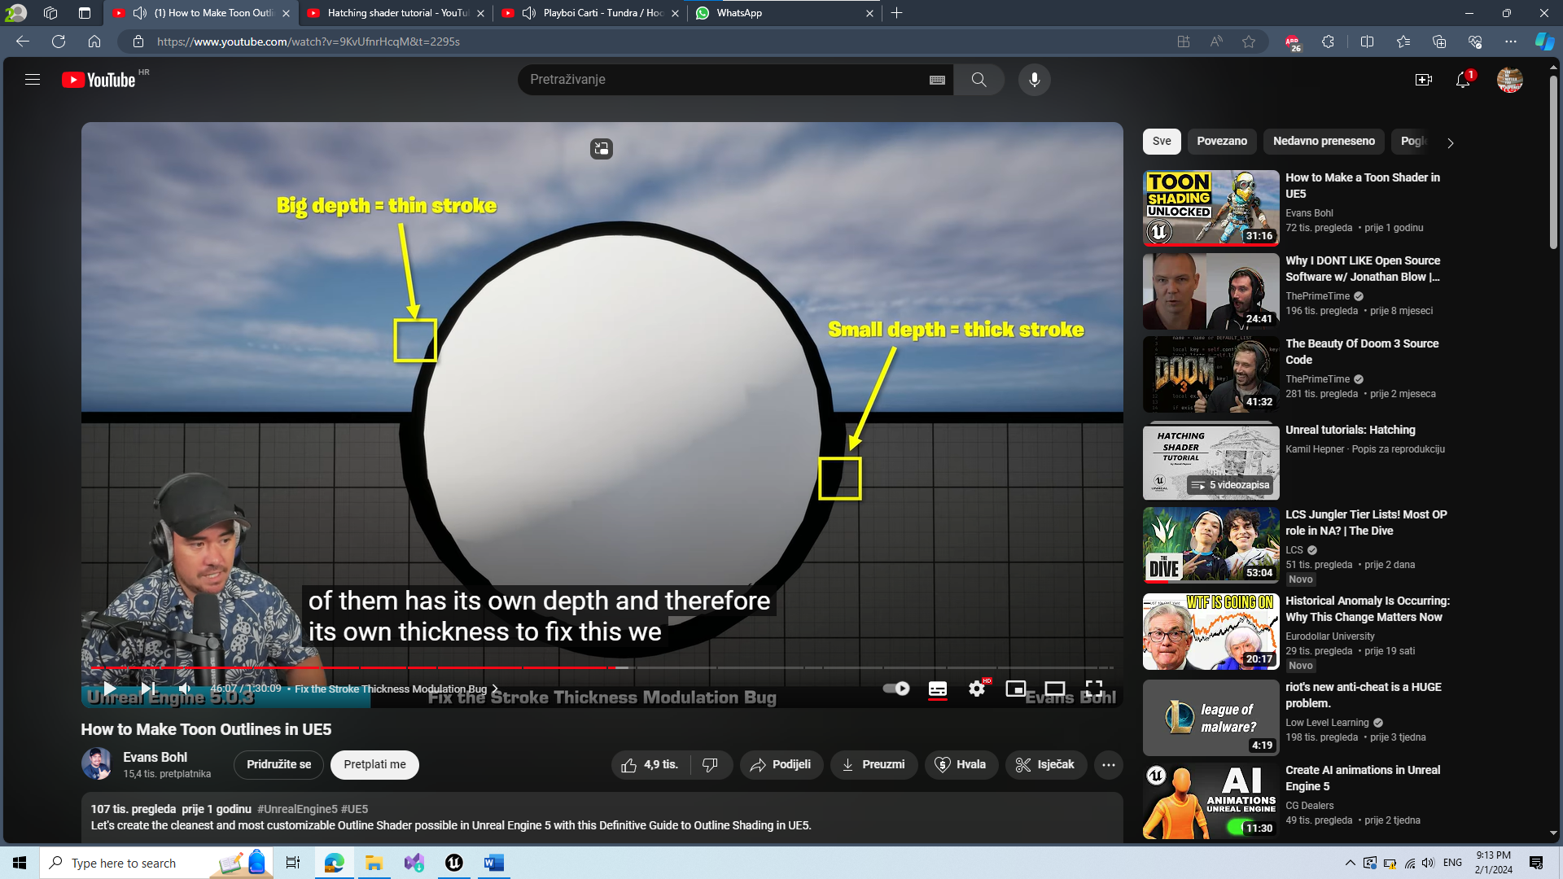

* Fix with convolution kernel and with finding closest pixel

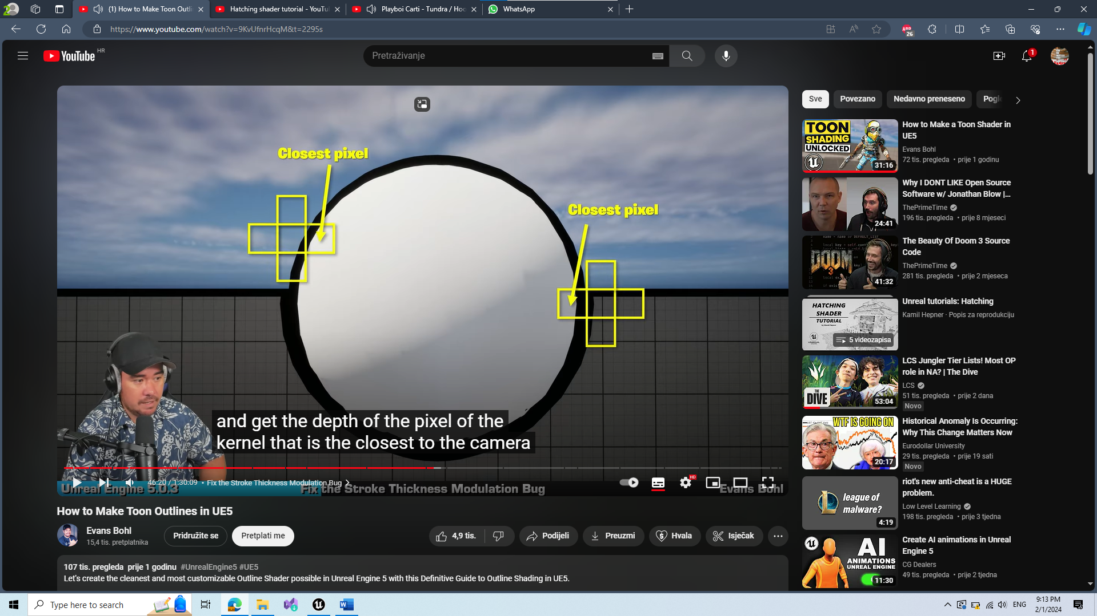

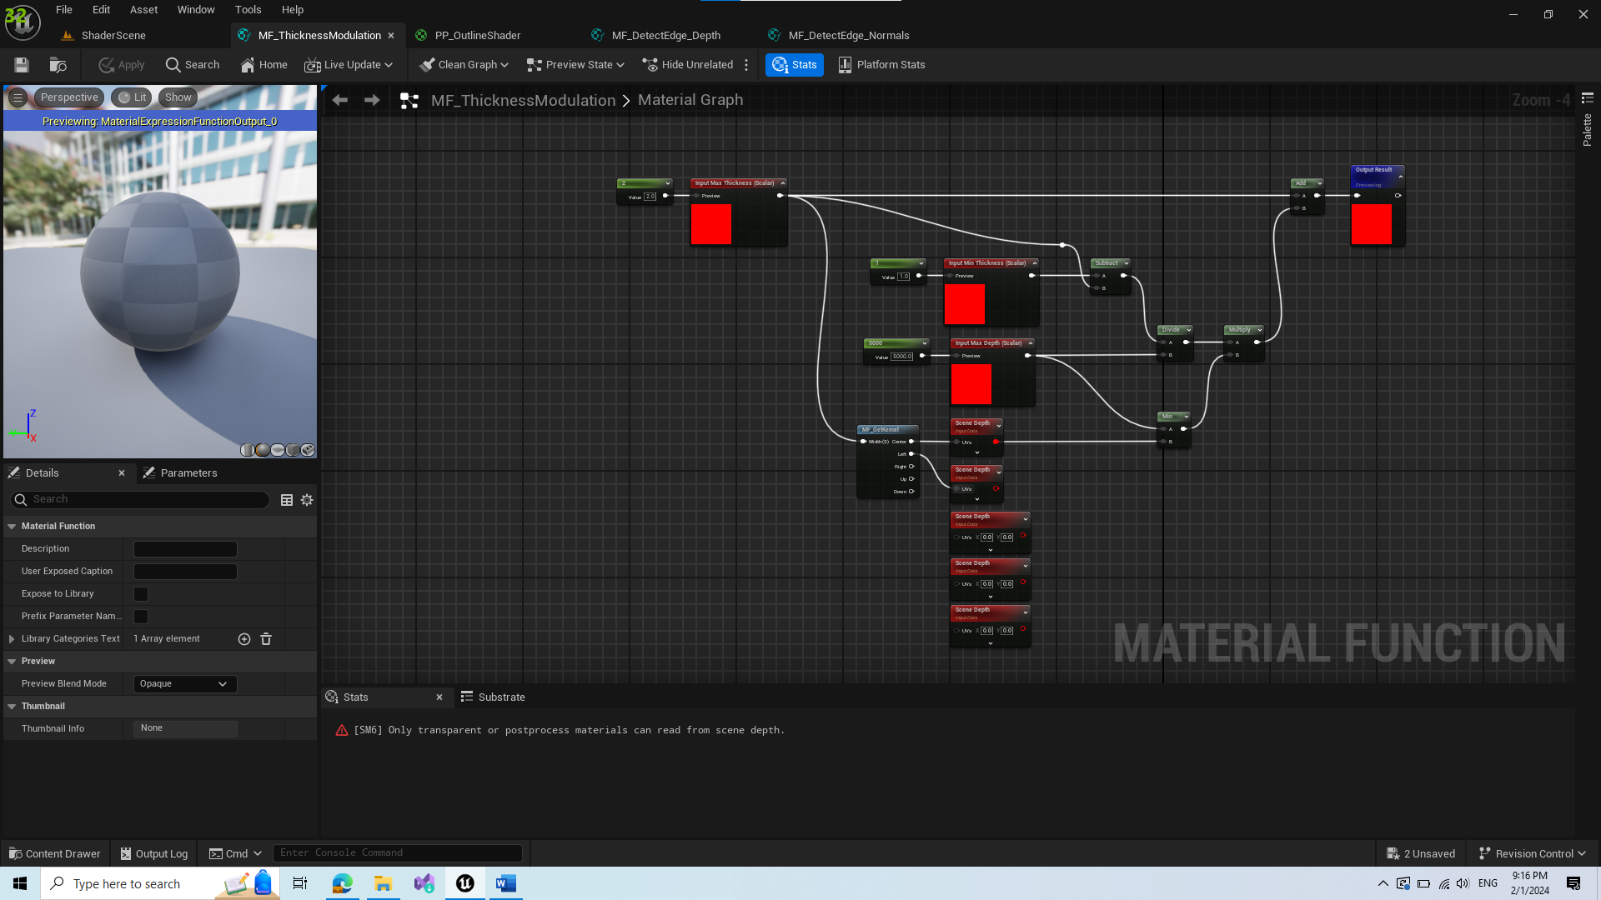

* Here we need to find the min pixel depth from scene depth nodes

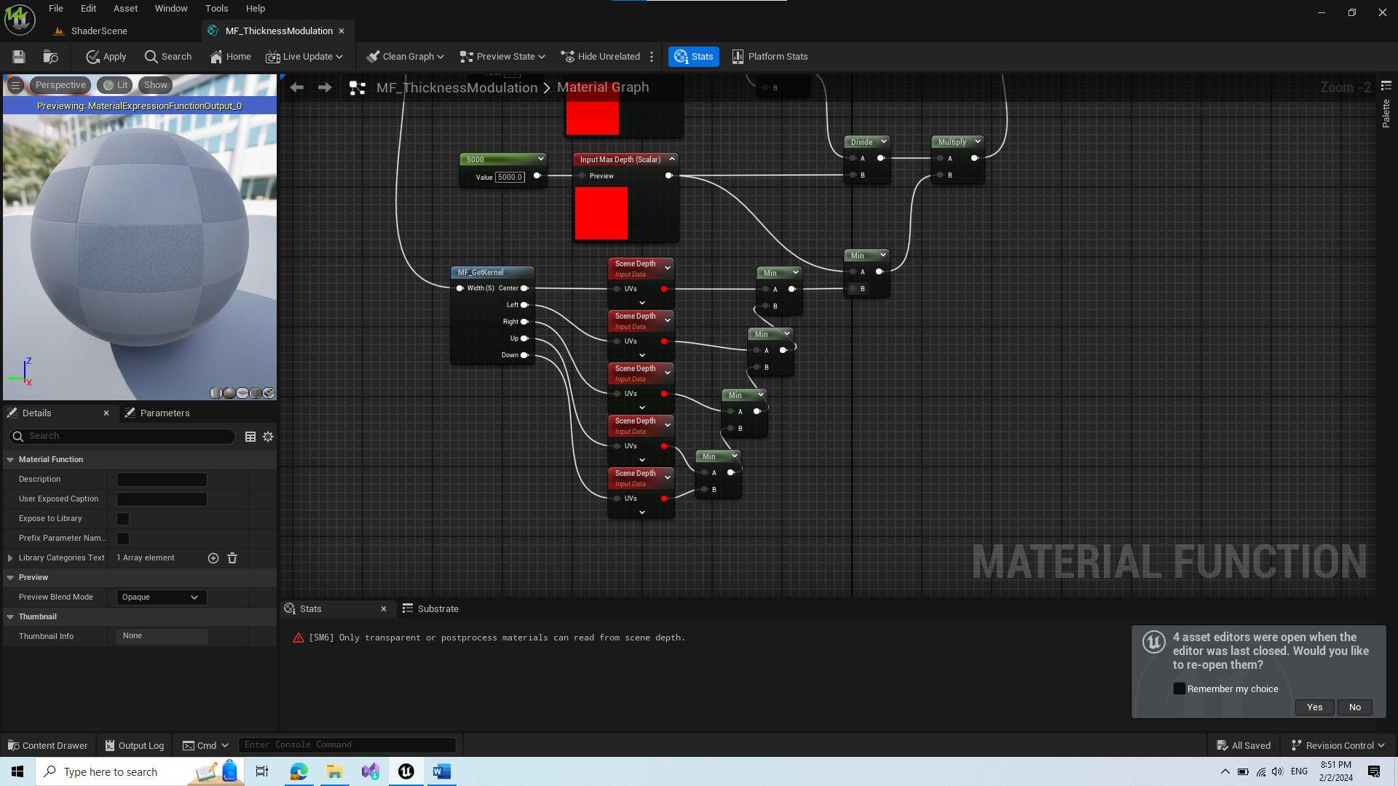

1. Next step is optional, it is added if we do not wont to outline objects that are far away from camera. For example objects far away in sky. We sometimes want to outline everything, but this is still a step that is good to go through just in case. For this we create new Material Function.

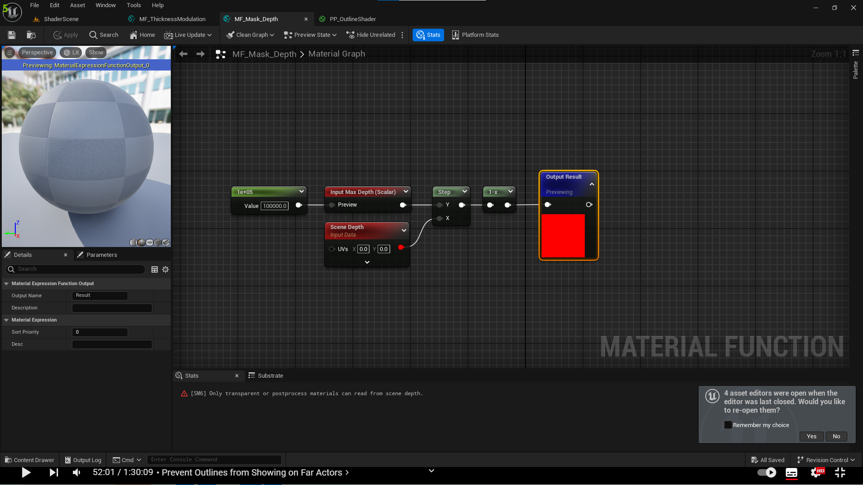

1. Apply the material function in our shader

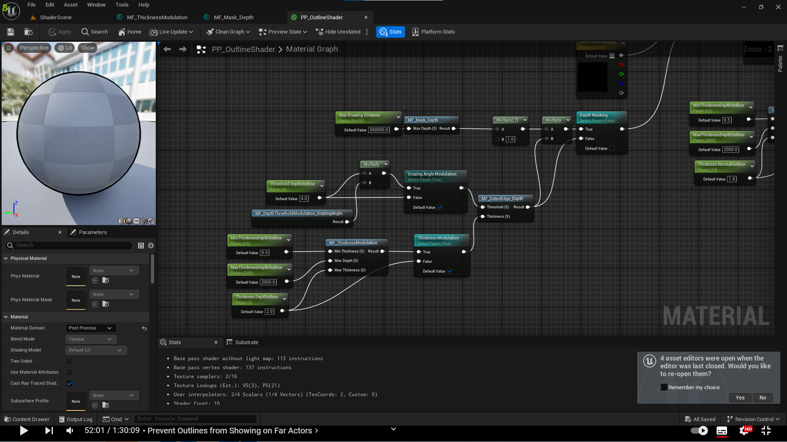

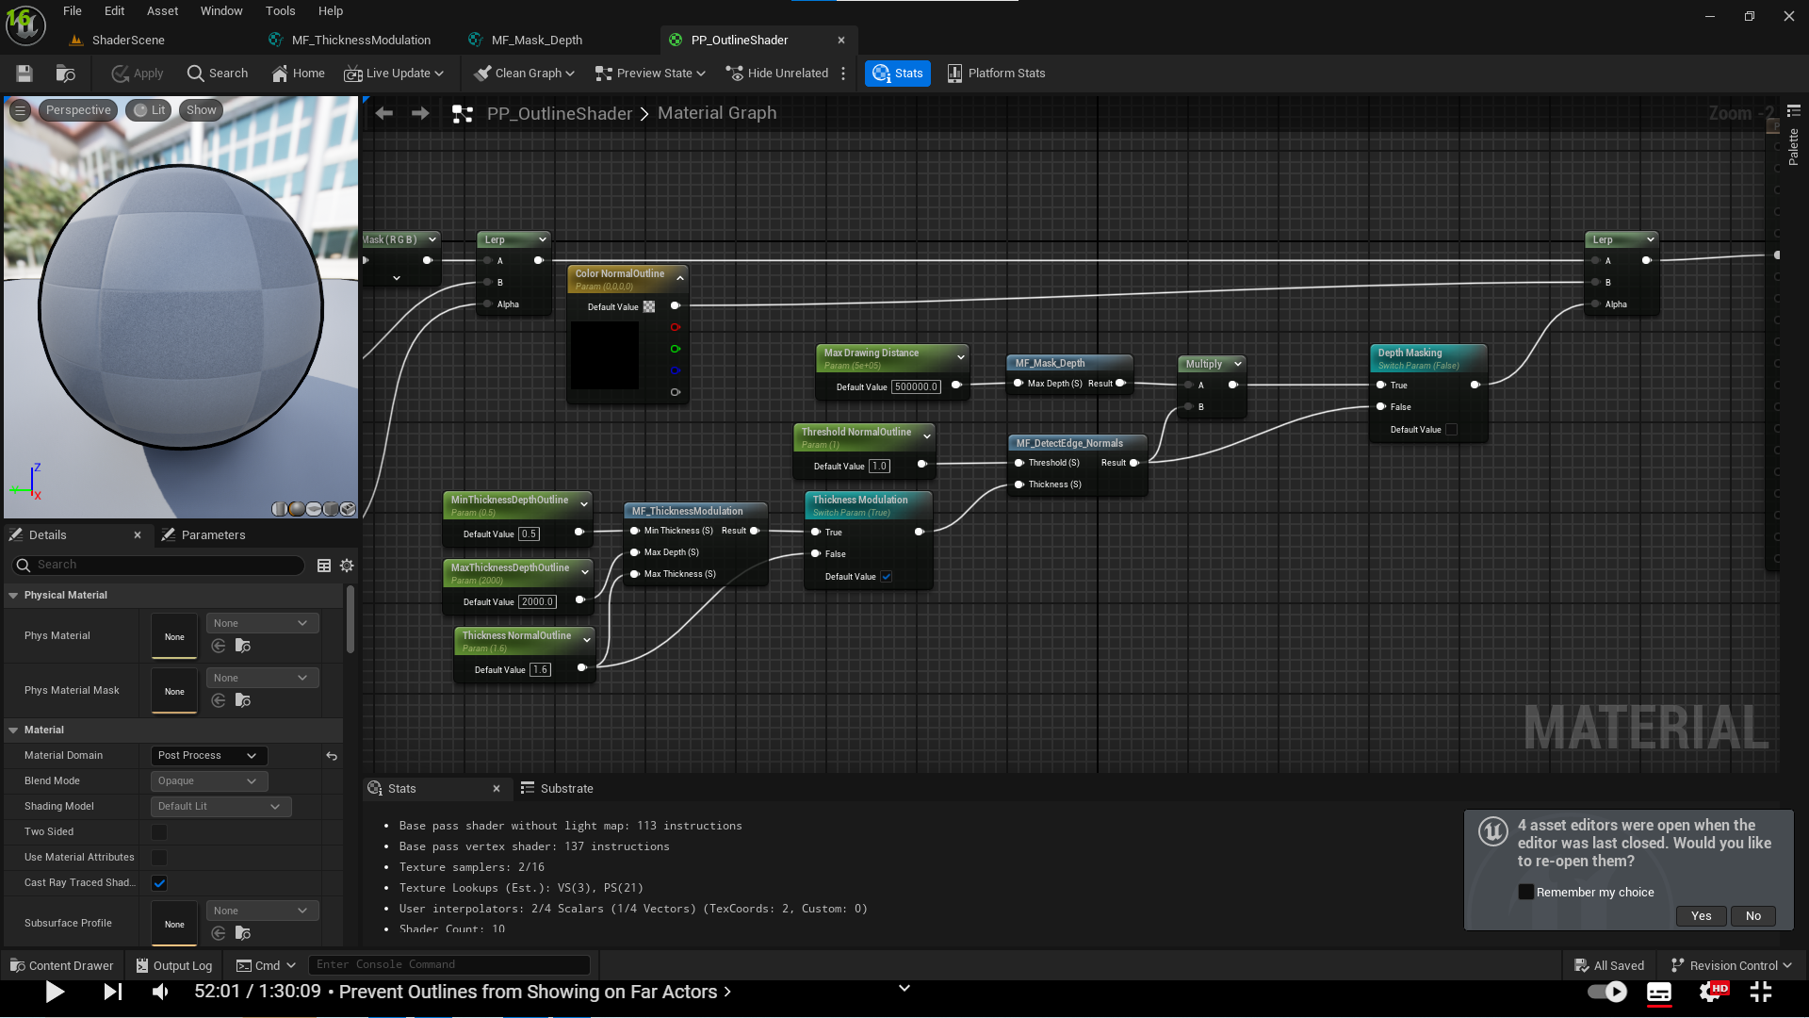

1. This results in a small bug explained in image drawing below

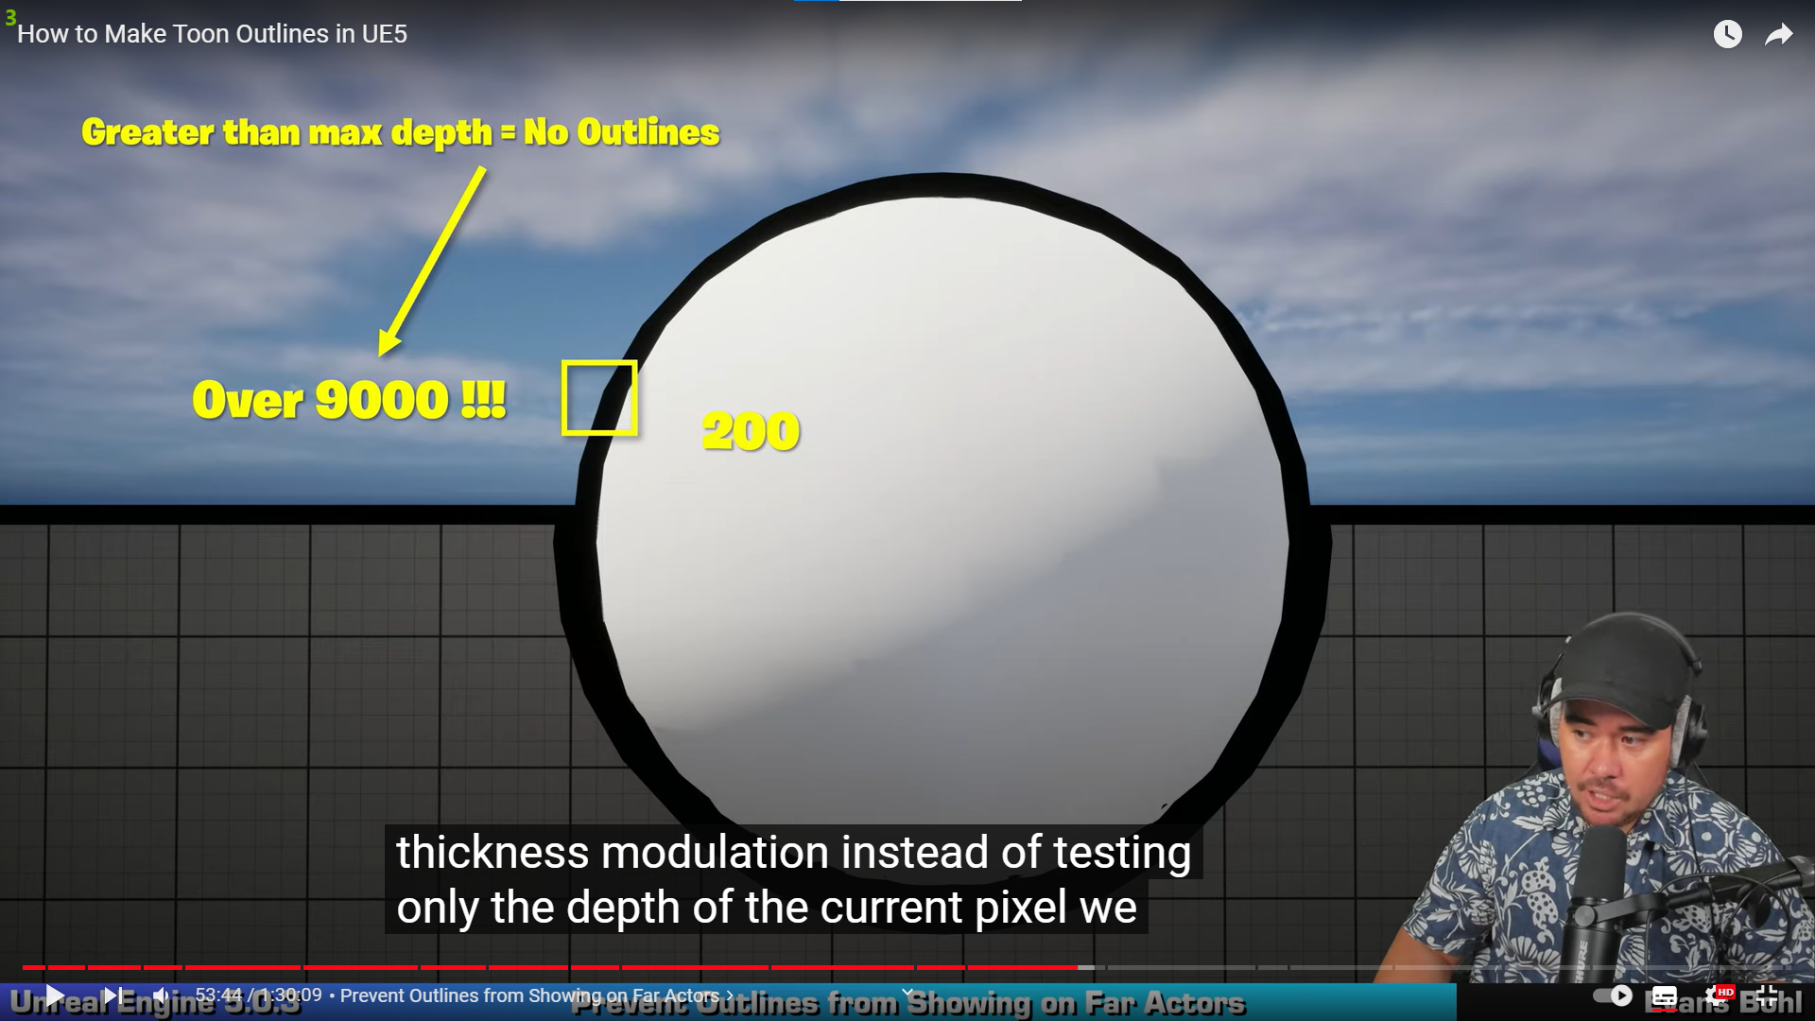

* To solve this problem, we will test the depth of neigbour pixels
* Copy the scene depth pixel min finder method from Thickness Modulation Material Function and paste it into Mask Depth Material Function instead of Scene Depth node that is added earlier

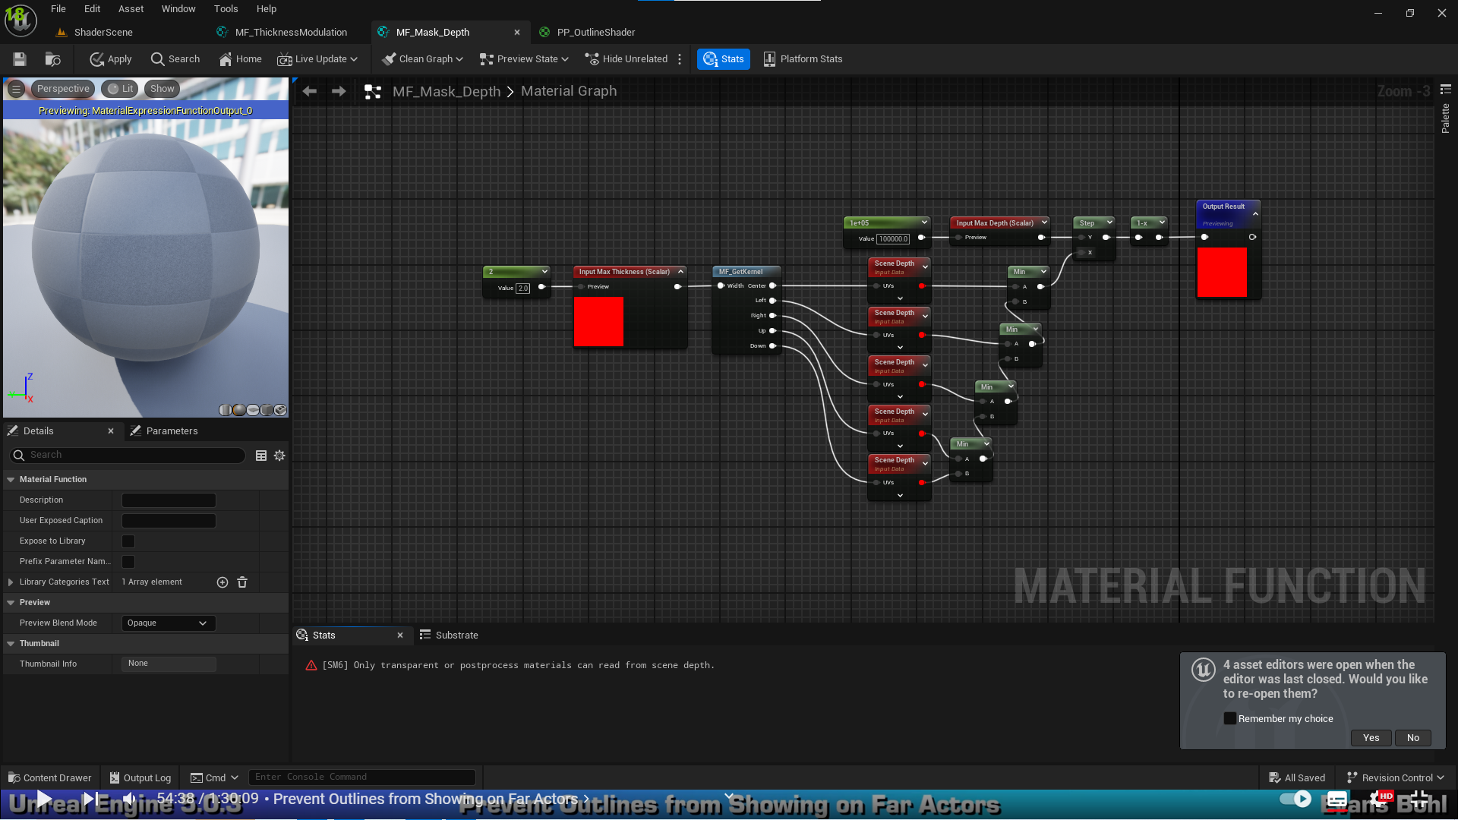

* Since we added an inp[ut to our Mask Depth Material Function we need to send a parameter to it in our shader

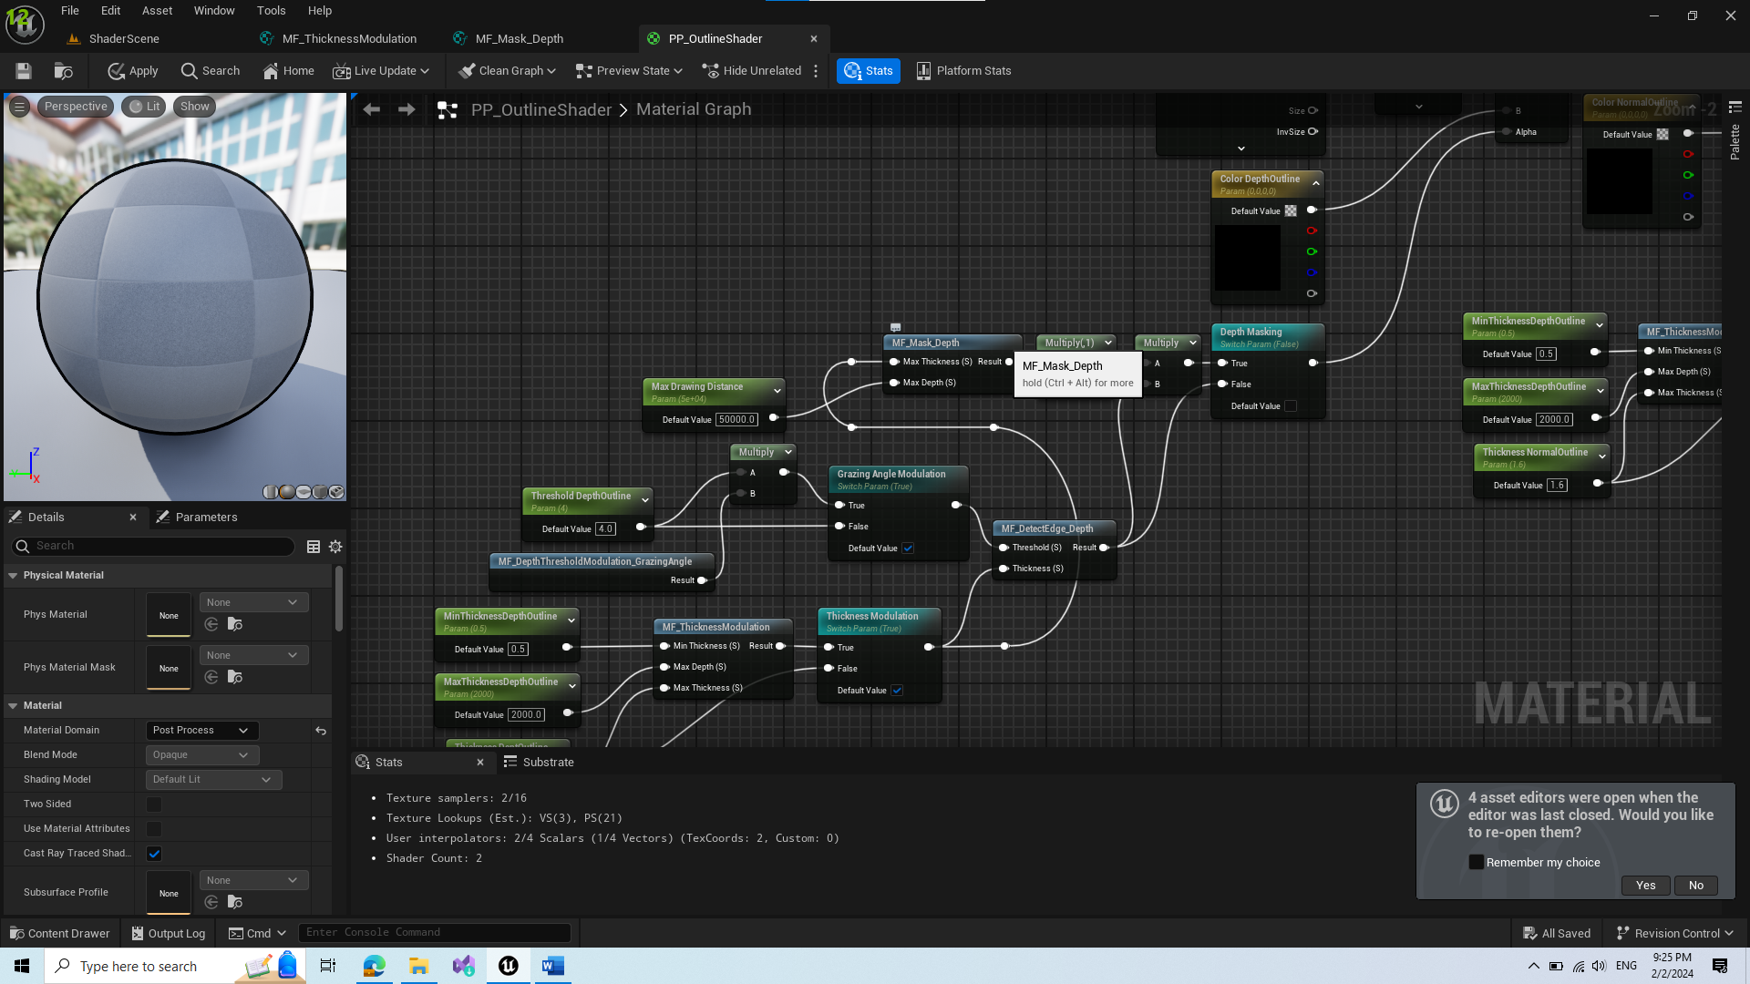

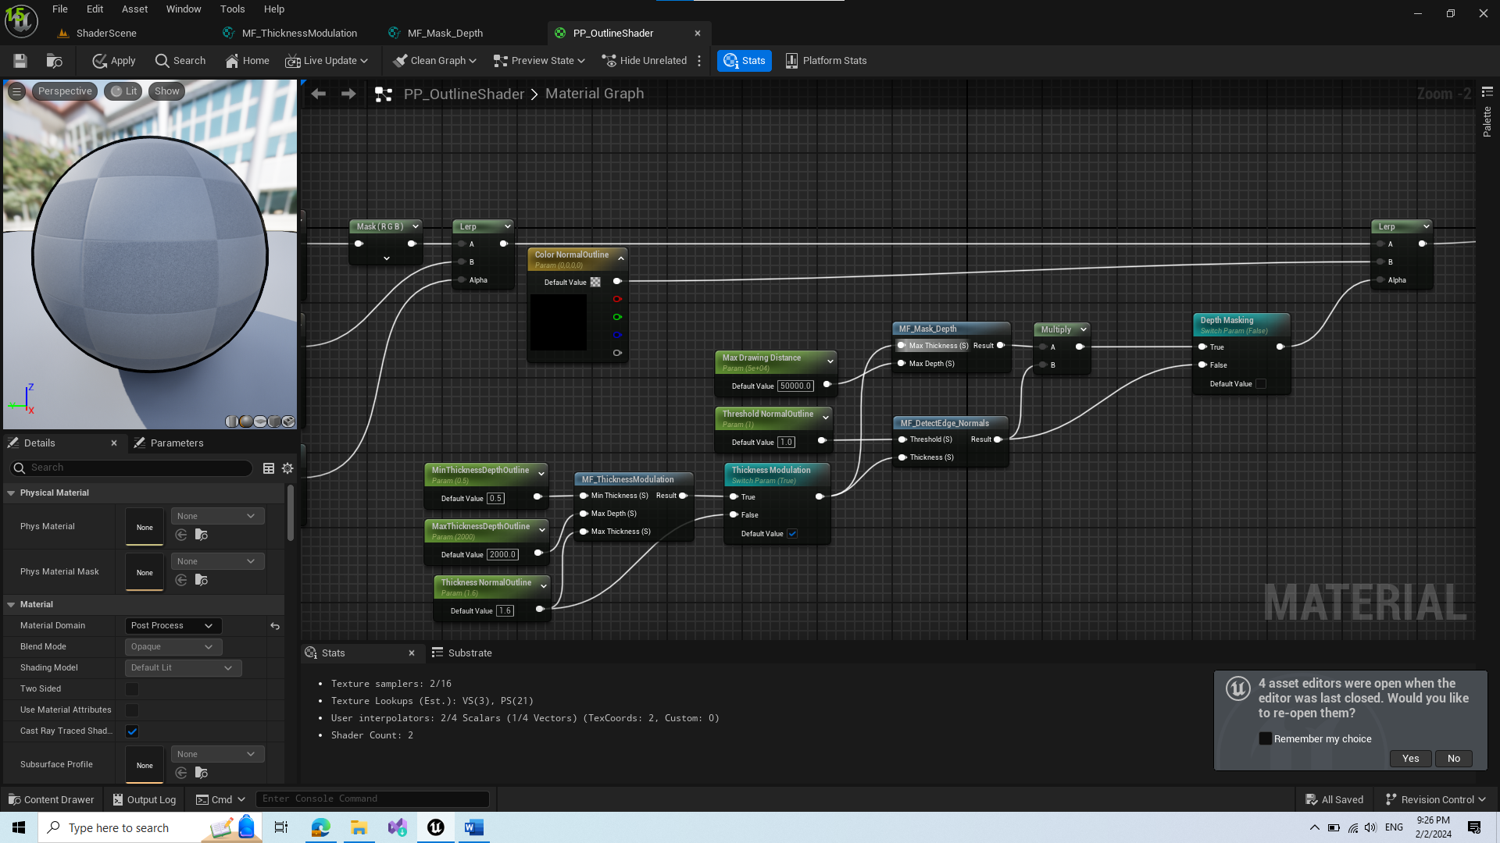

1. New functionality – Custom Depth Buffer

* We can view what objects are added to custom depth buffer by changing the view

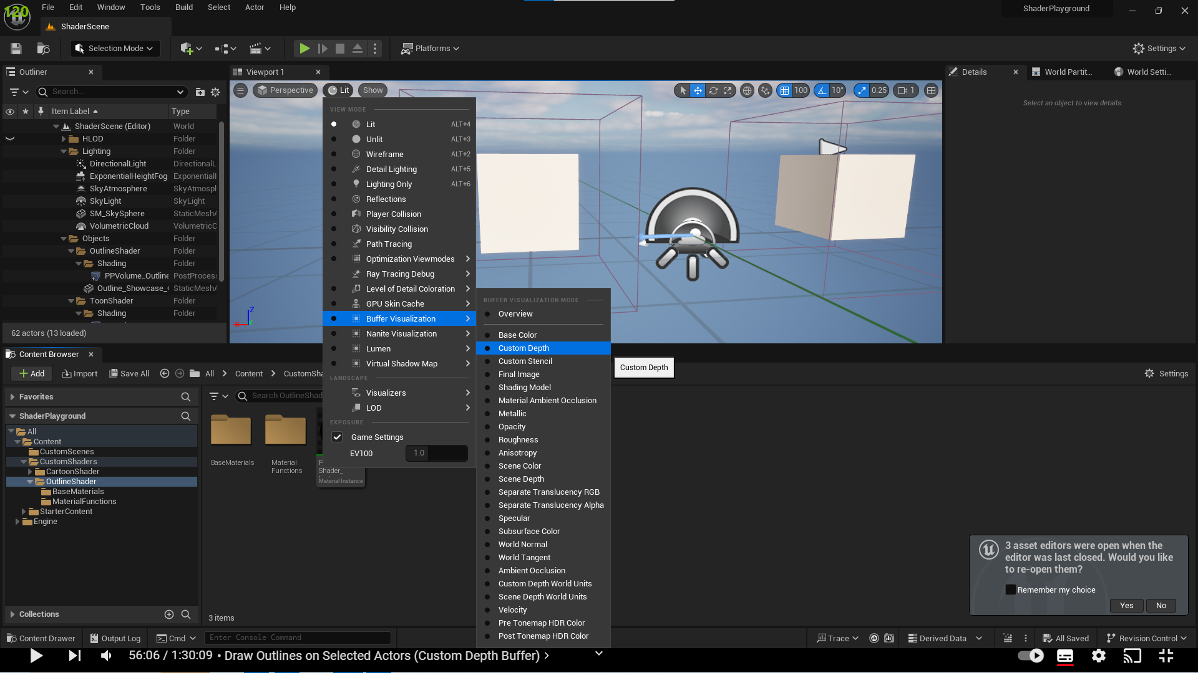

* Add object to custom depth buffer by selecting render custom pass option. The object turns slightly grey

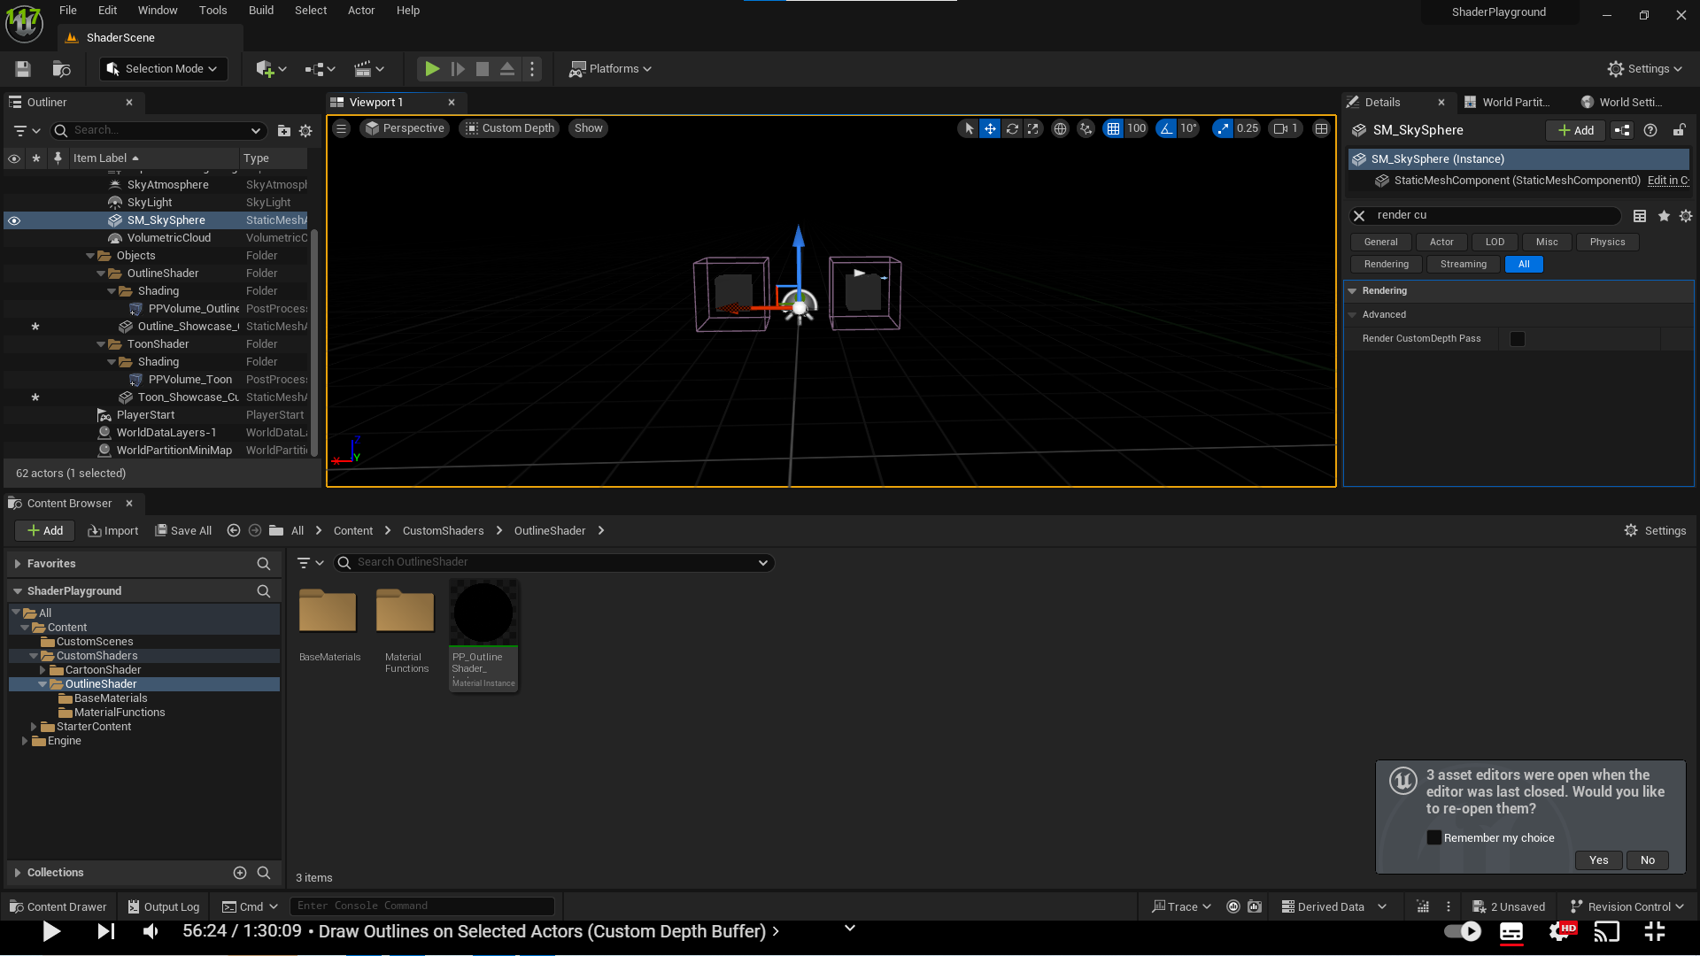

1. Create new Material Function Mask Custom Depth and copy paste nodes from Mask Depth Material Function

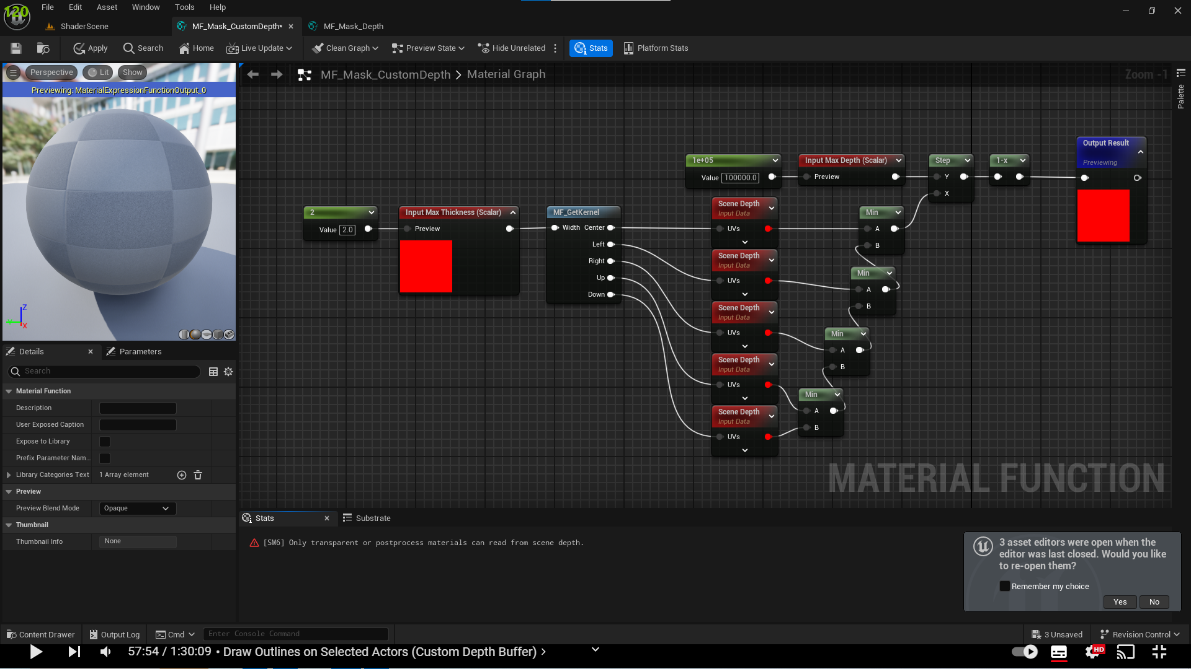

1. Switch SceneDepth nodes with Scene Texture node

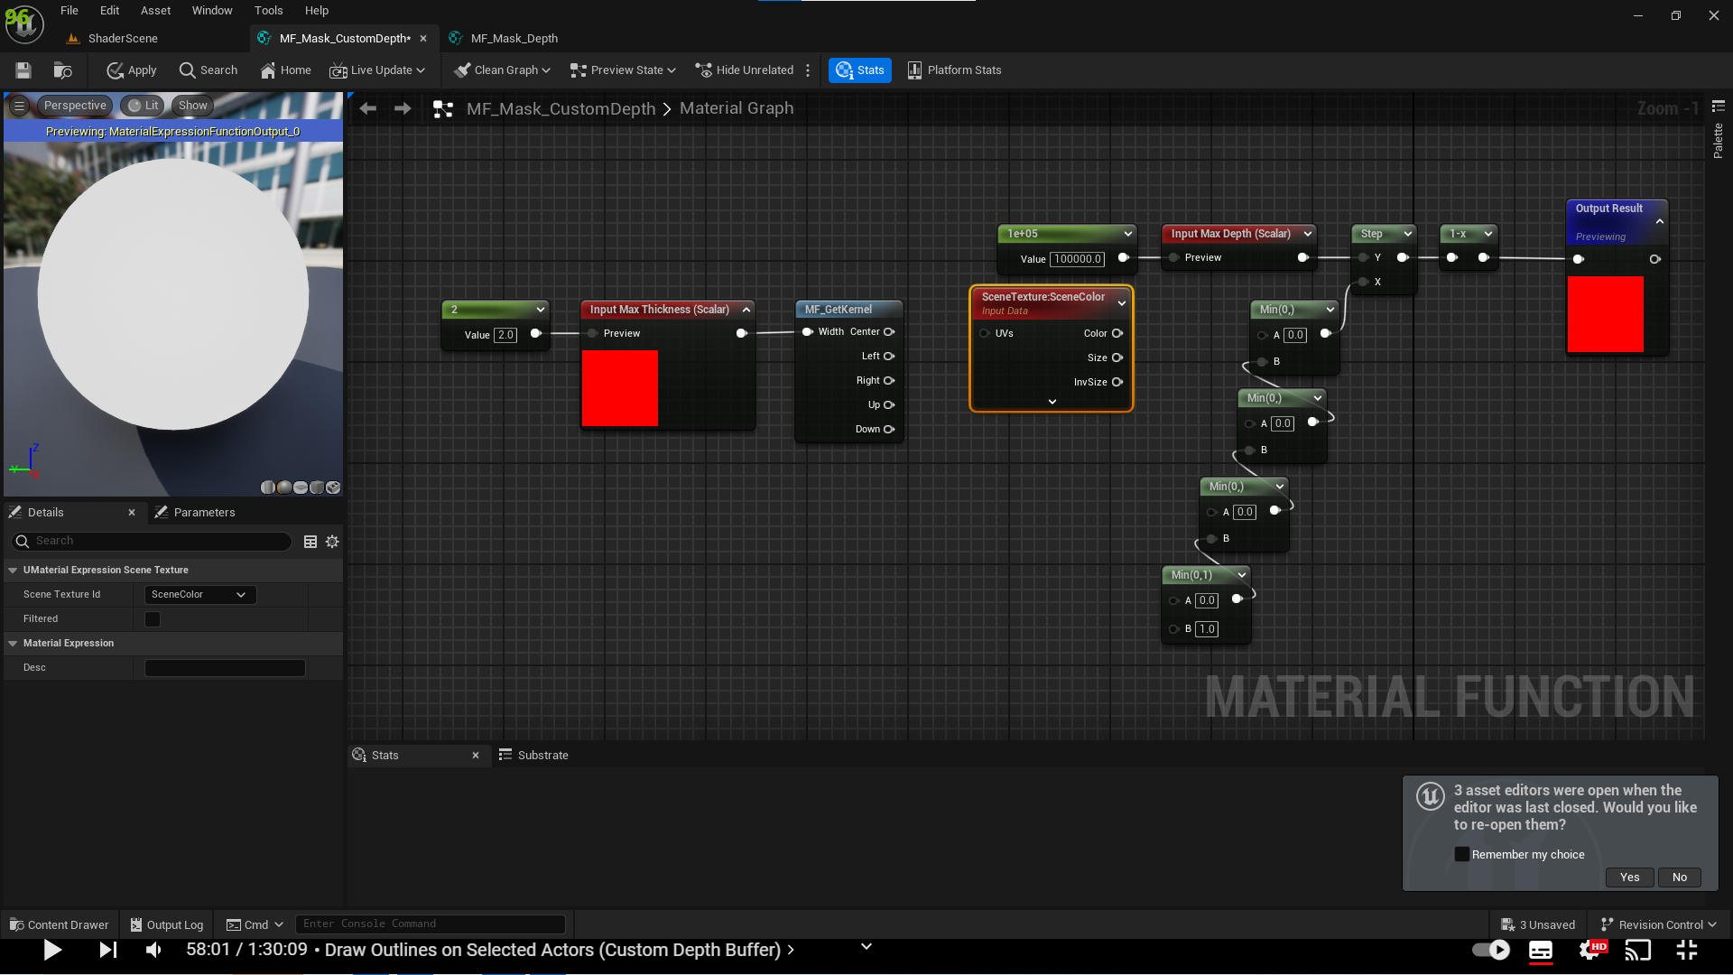

* Change its scene texture id to Custom Depth

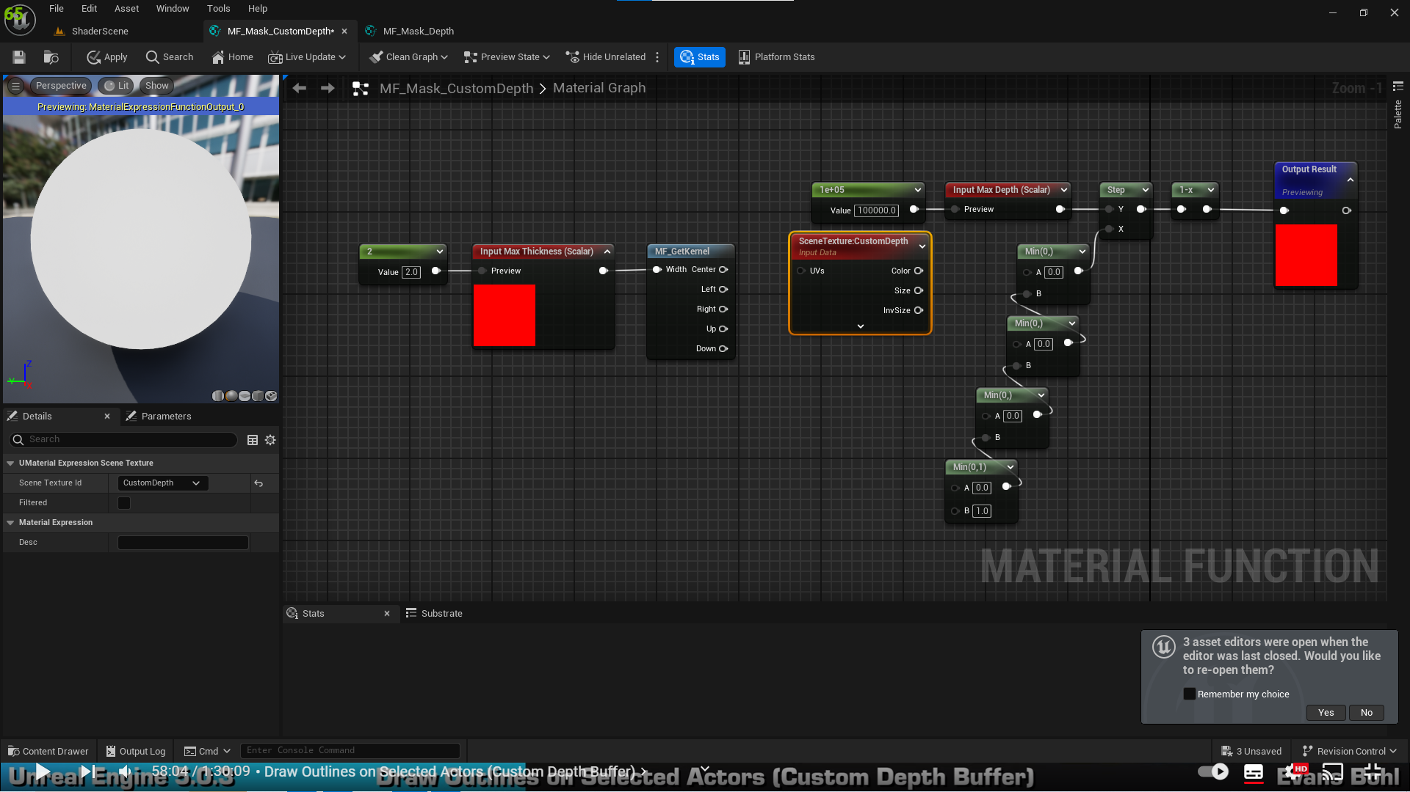

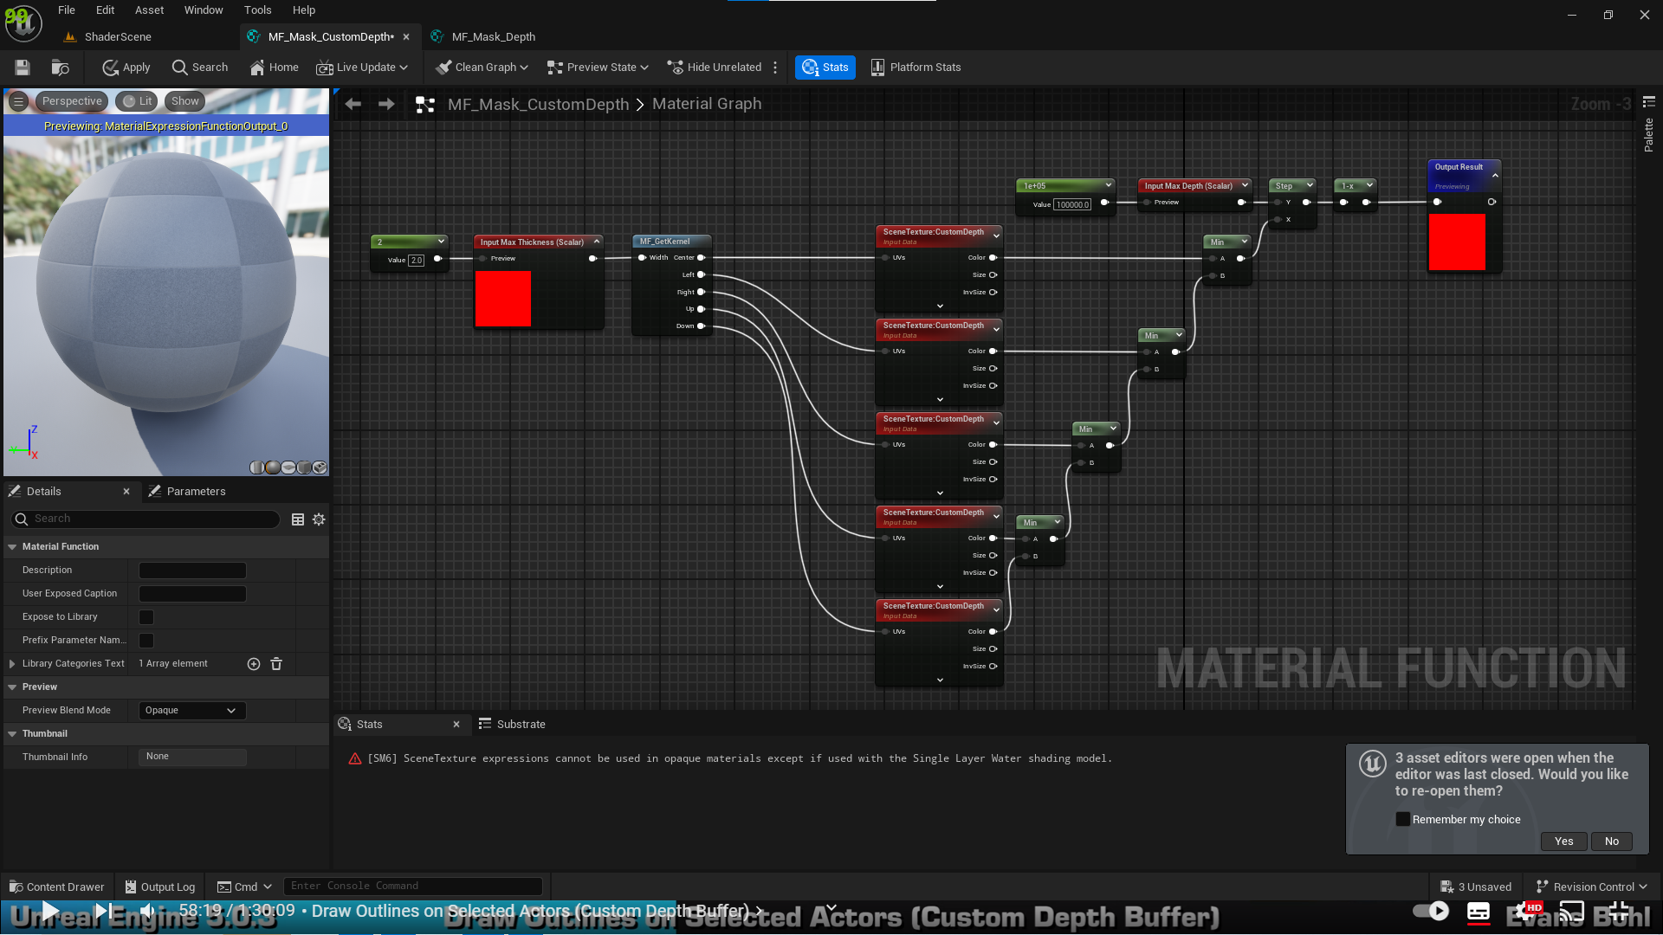

1. Add Custom depth mask material function to our shader

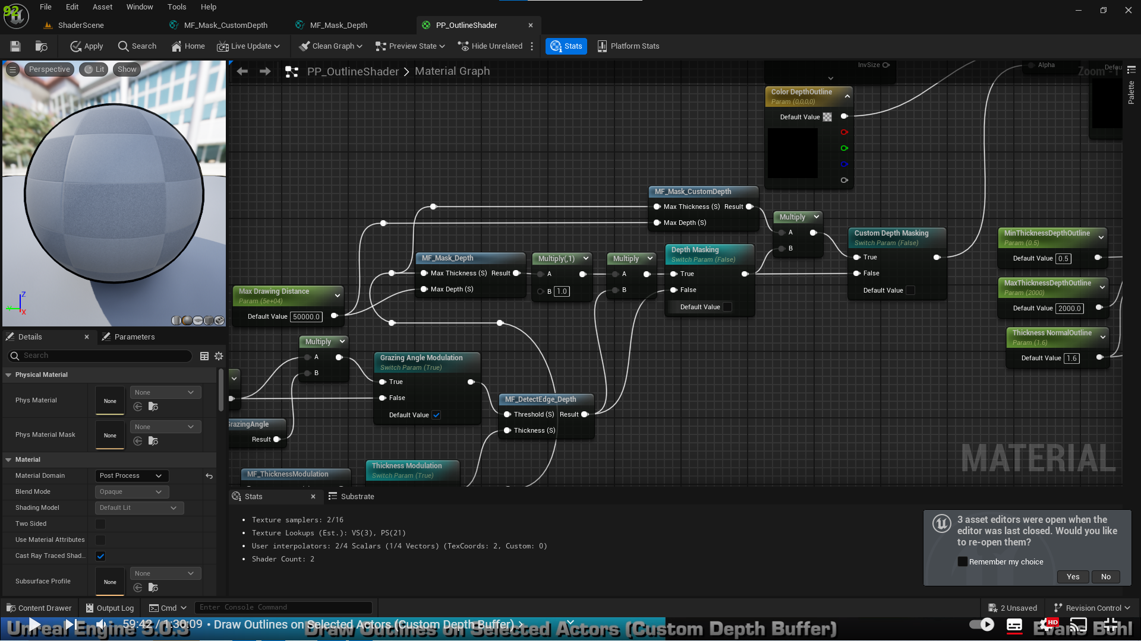

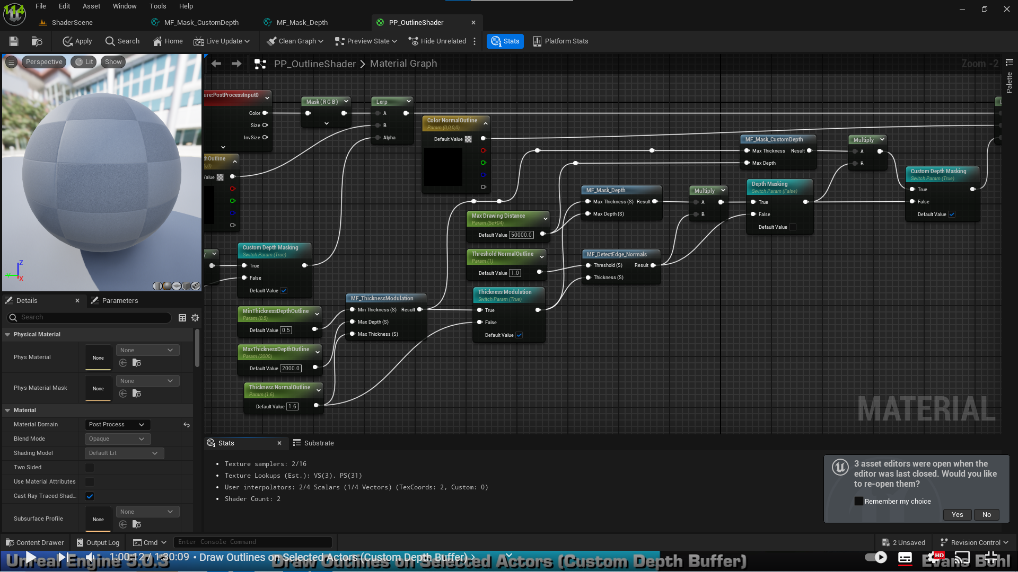

1. This produces a visual bug when an object that is not added to custom depth buffer to be somewhat outlined if it is standing in front of an object that is added to custom depth buffer. To solve this, we copy nodes in Material Function Mask Custom Depth and change scene texture nodes id to scene depth

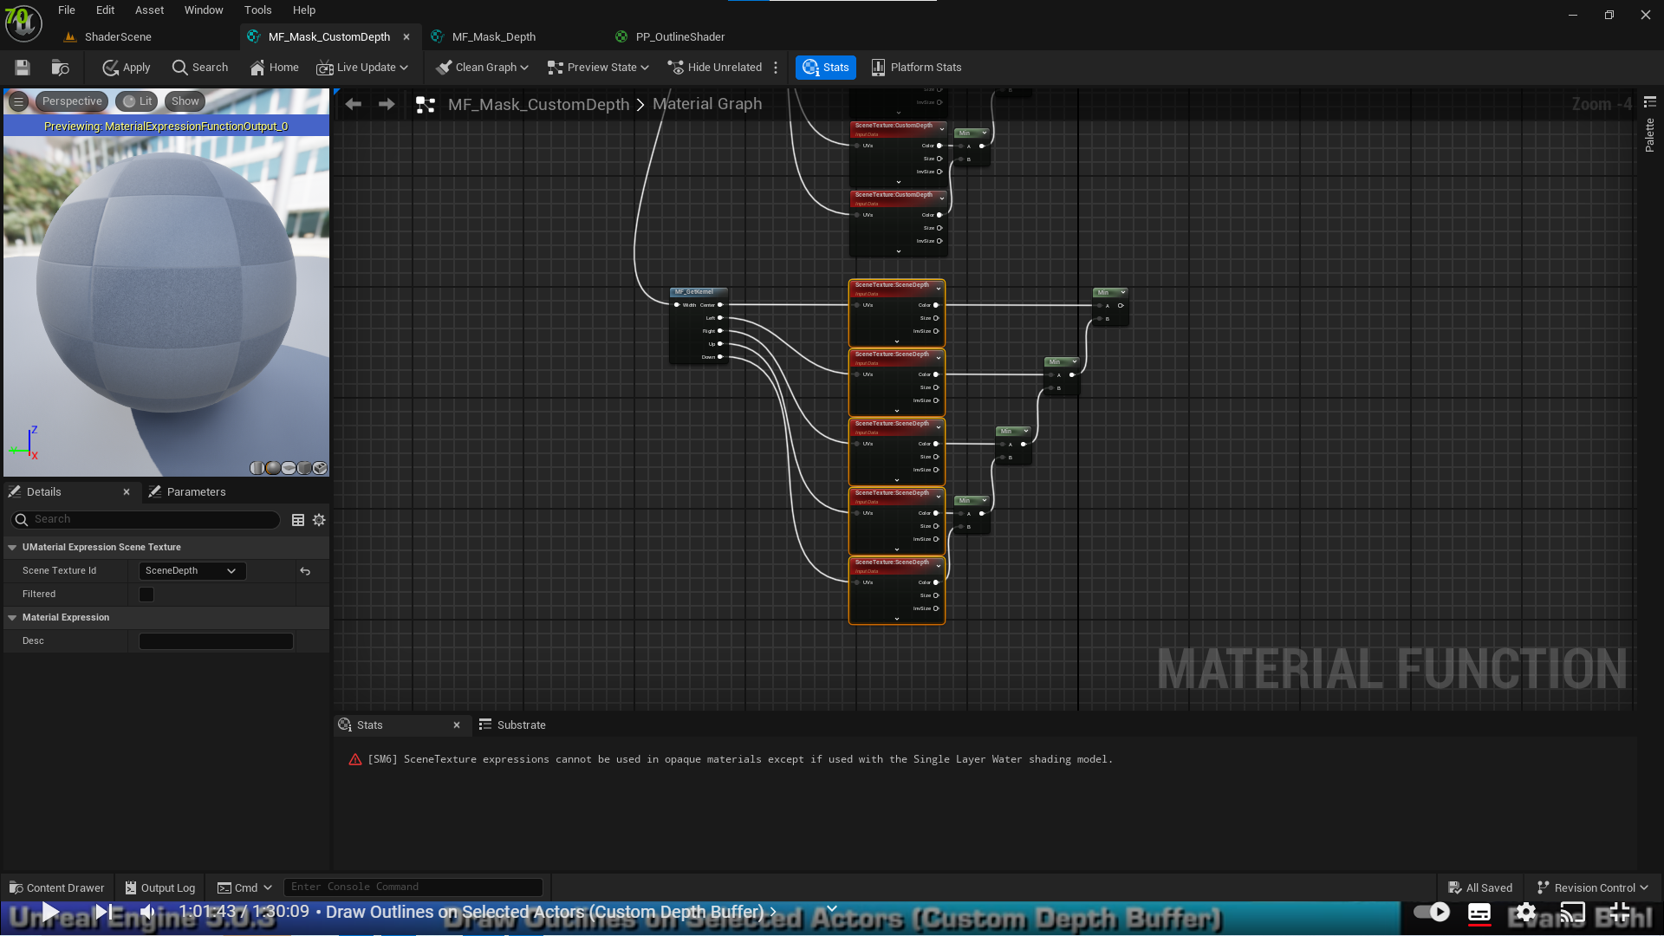

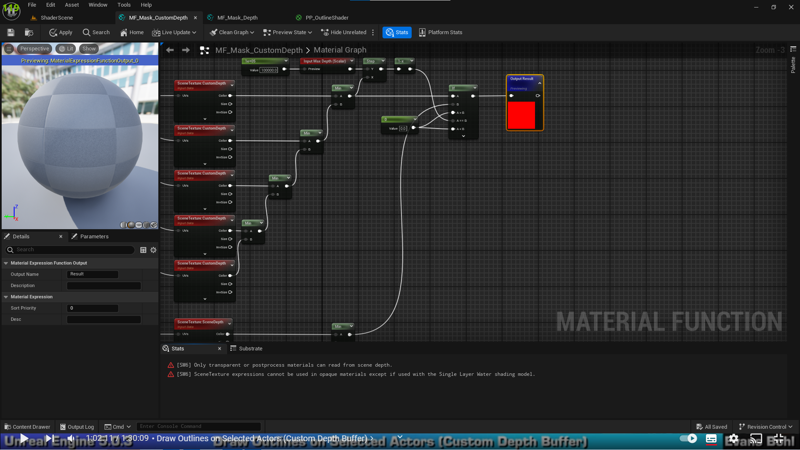

1. Multi colored outlines functionality

* Standard way of multi colored outlines is described in screenshot below, where we store actors with different outline colors in different indexes of custom stencil buffer

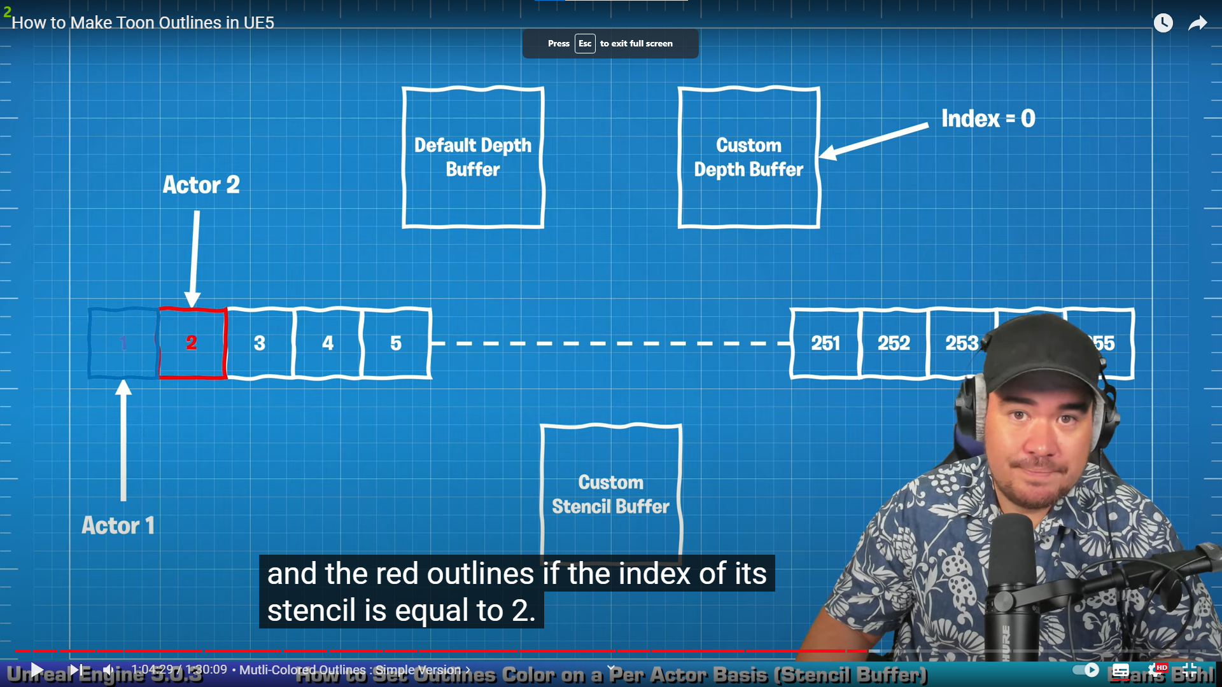

1. Make sure custom depth-stencil buffer pass is enabled with stencil in ue project settings

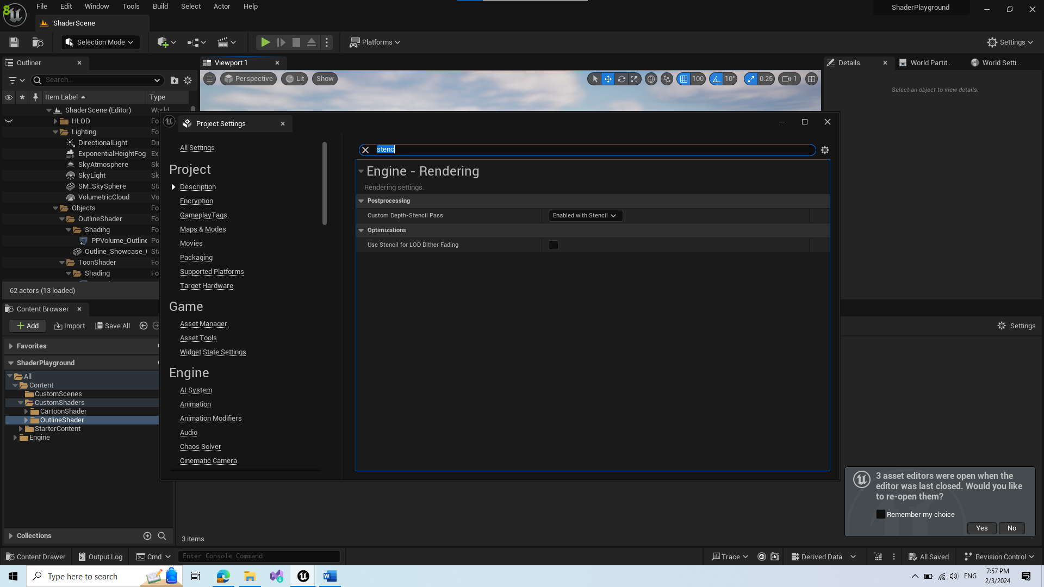

1. Similar to custom depth buffer, we can view which objects are enabled for custom stencil buffer by changing the view mode to custom stencil

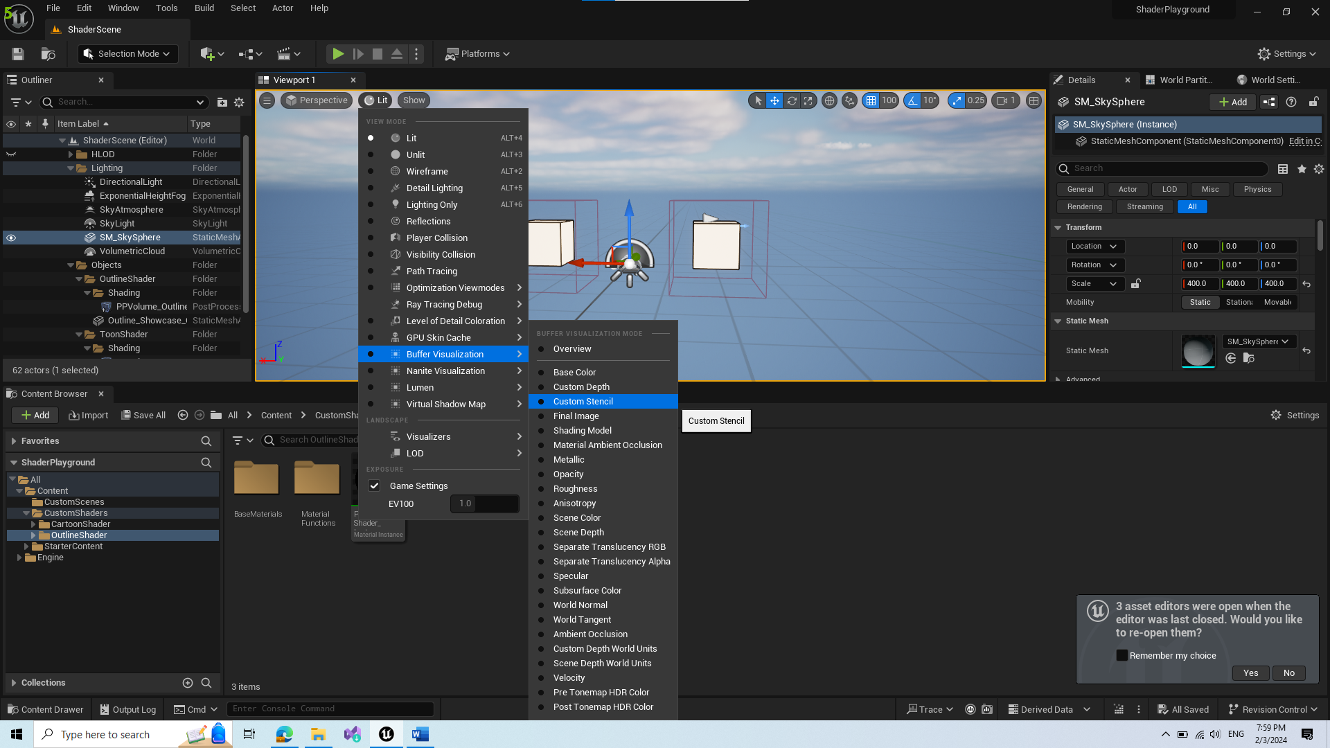

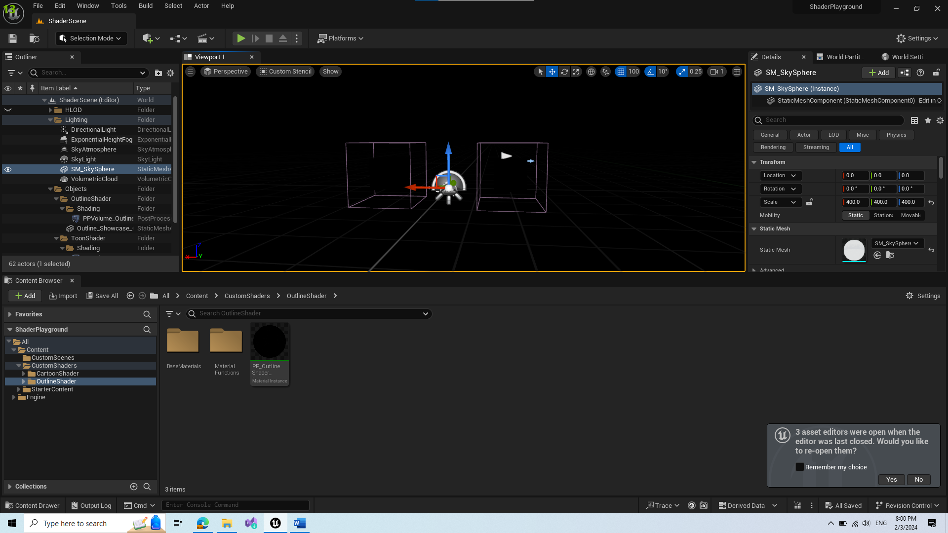

1. To enable custom stencil buffer on an object, set custom depth stencil buffer pass to a value greater than 0 (my logic is it should be less than 255 by the drawing in earlier screenshots but im not sure)

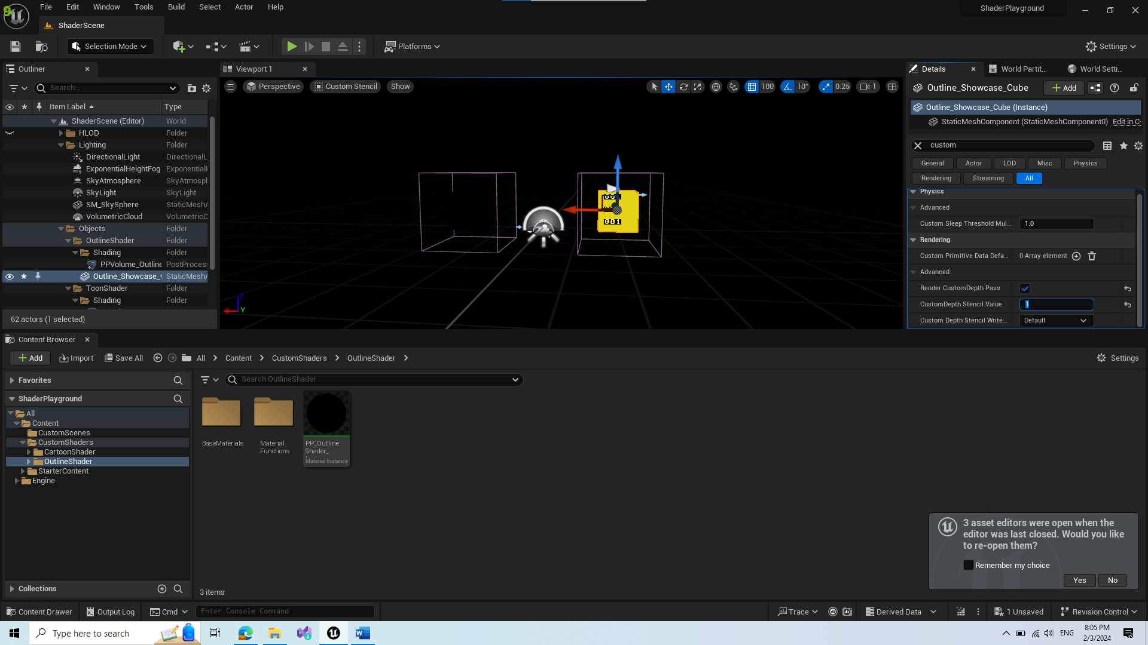

1. Create new Material Function GetStencilBasedColor

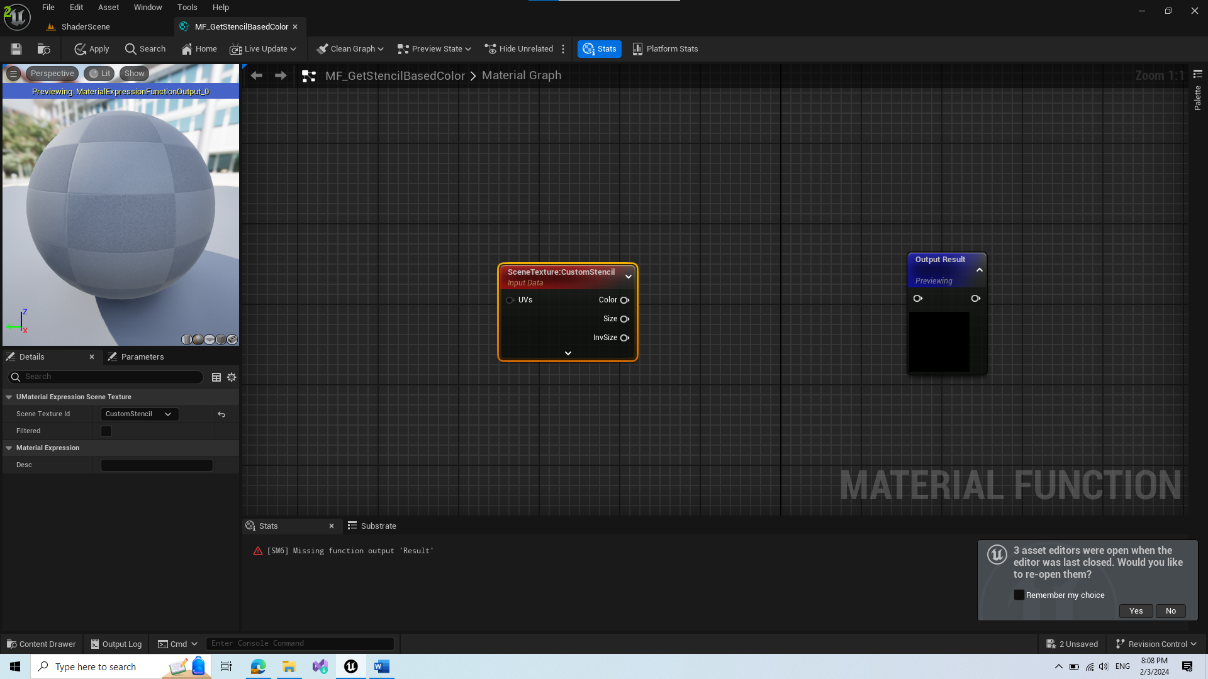

* In material function we add SceneTexture and change its id to Custom Stencil

1. Using if statements and multiple predefined colors, check if custom stencil shader texture is greater than certain defined values. Depending on result, forward the color that passed if statement.

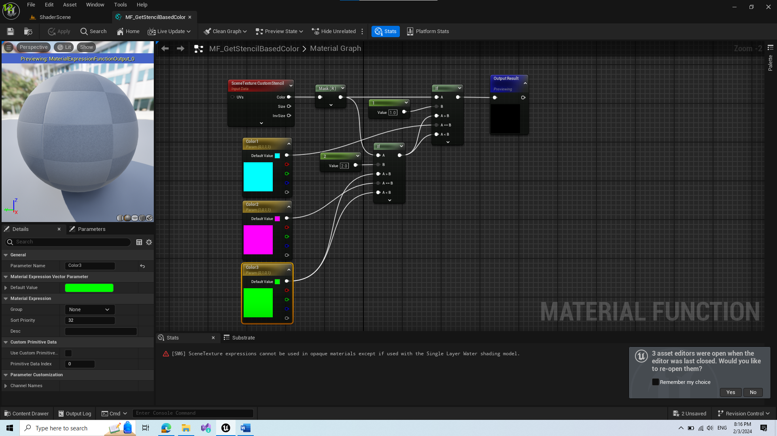

1. Add the Material Function into shader

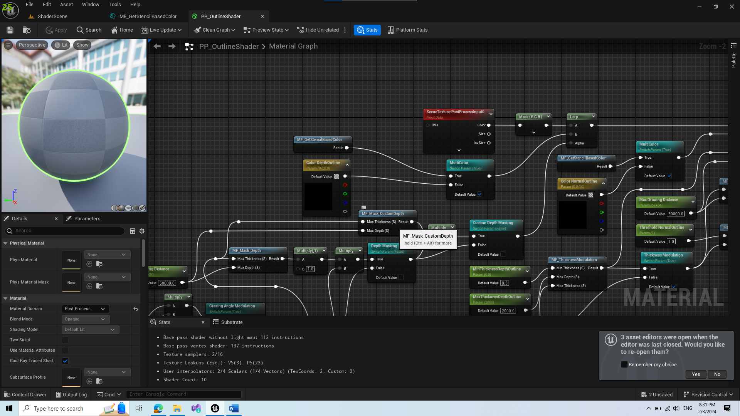

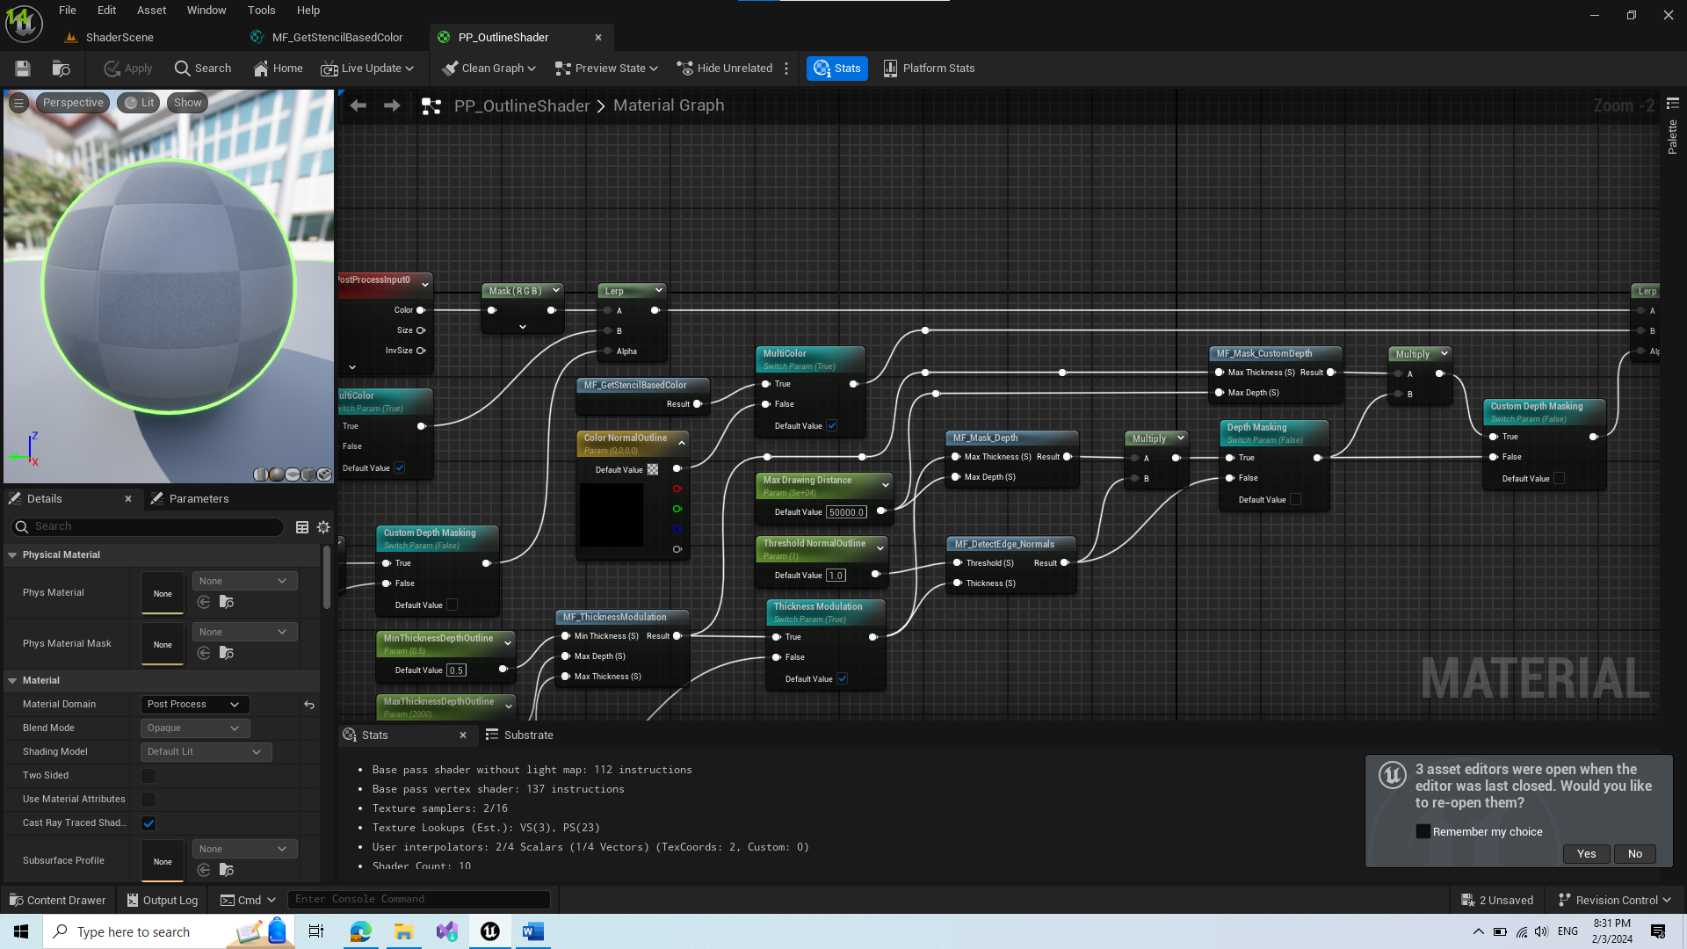

1. This produces a similar bug to before, when objects are in front of another

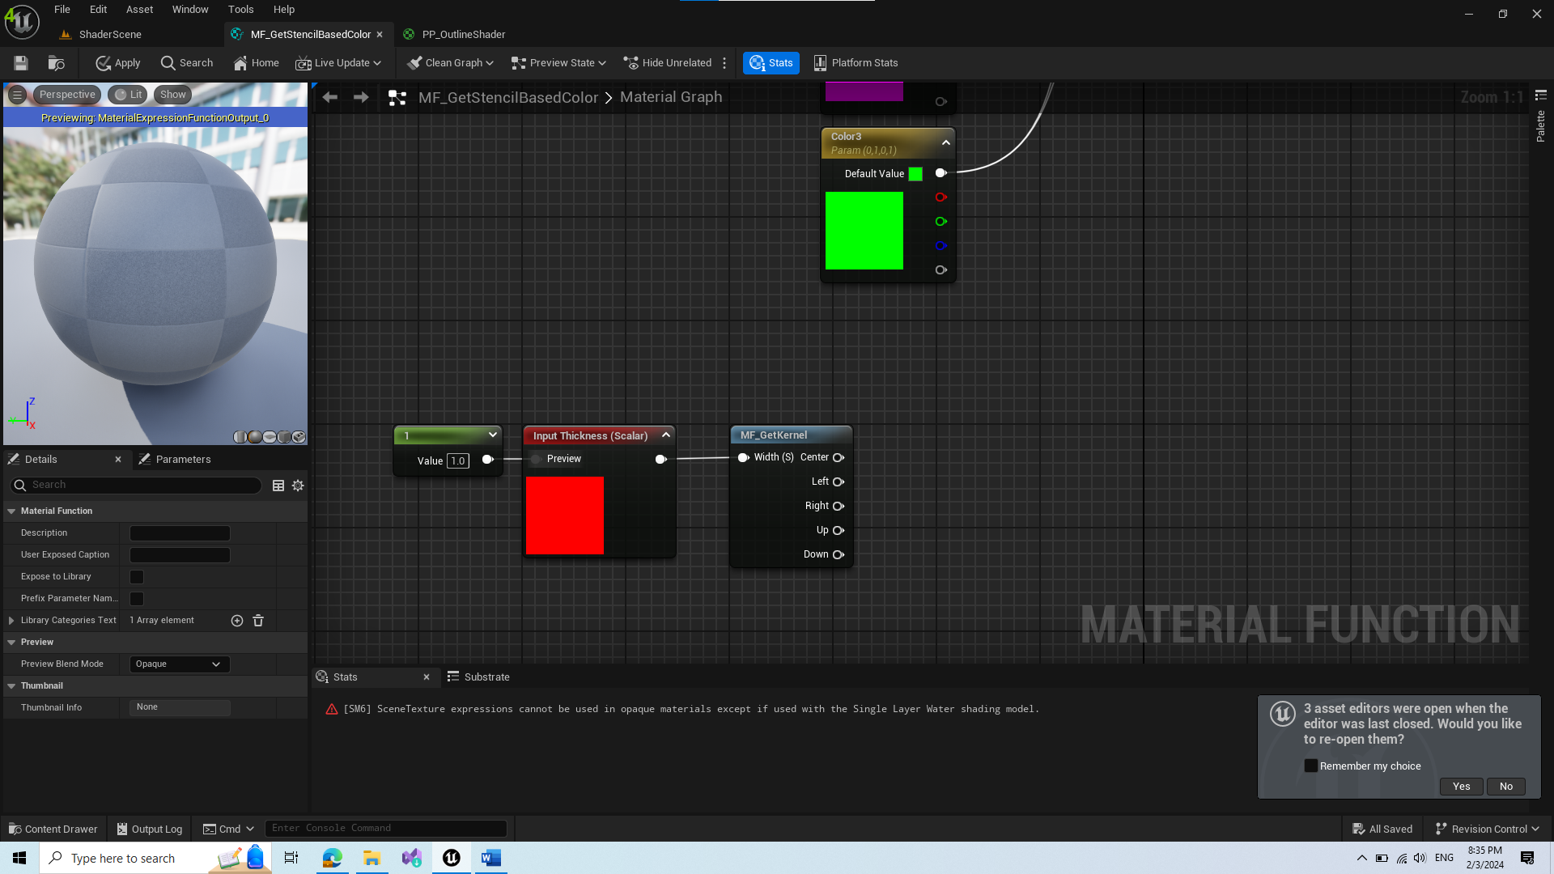

* Add GetKernel node similar to before

1. Create new helper Material Function Compare Custom Depth

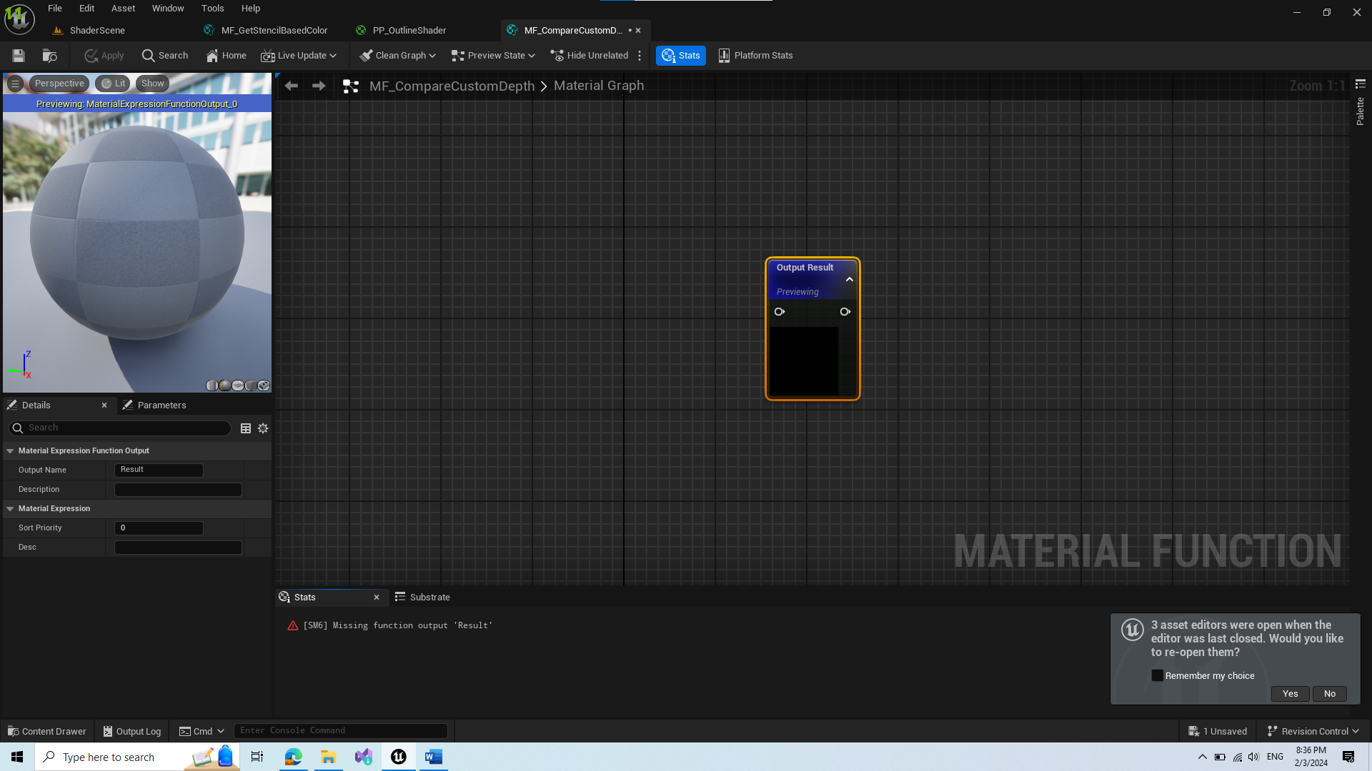

* Add 2 input functions and change thier input type to Function Input Vector2.
* Add SceneTexture nodes to the inputs and change their id to Custom Depth since if we want to use Custom Stencil the objects need to be enabled for custom depth pass.
* Use Mask on R channel for comparison.

1. Plug in the new material function in our stencil based color material function

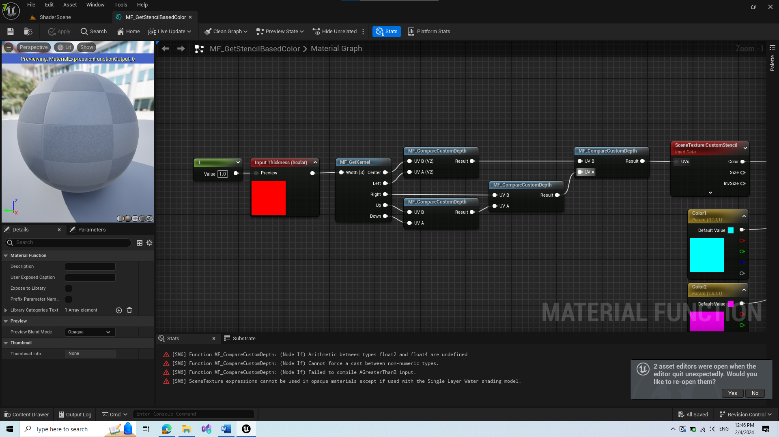

* Here we find the closest pixel and depending on it we do our shading

1. We created new input so we need to adjust our shader with forwarding thickness modulation parameter

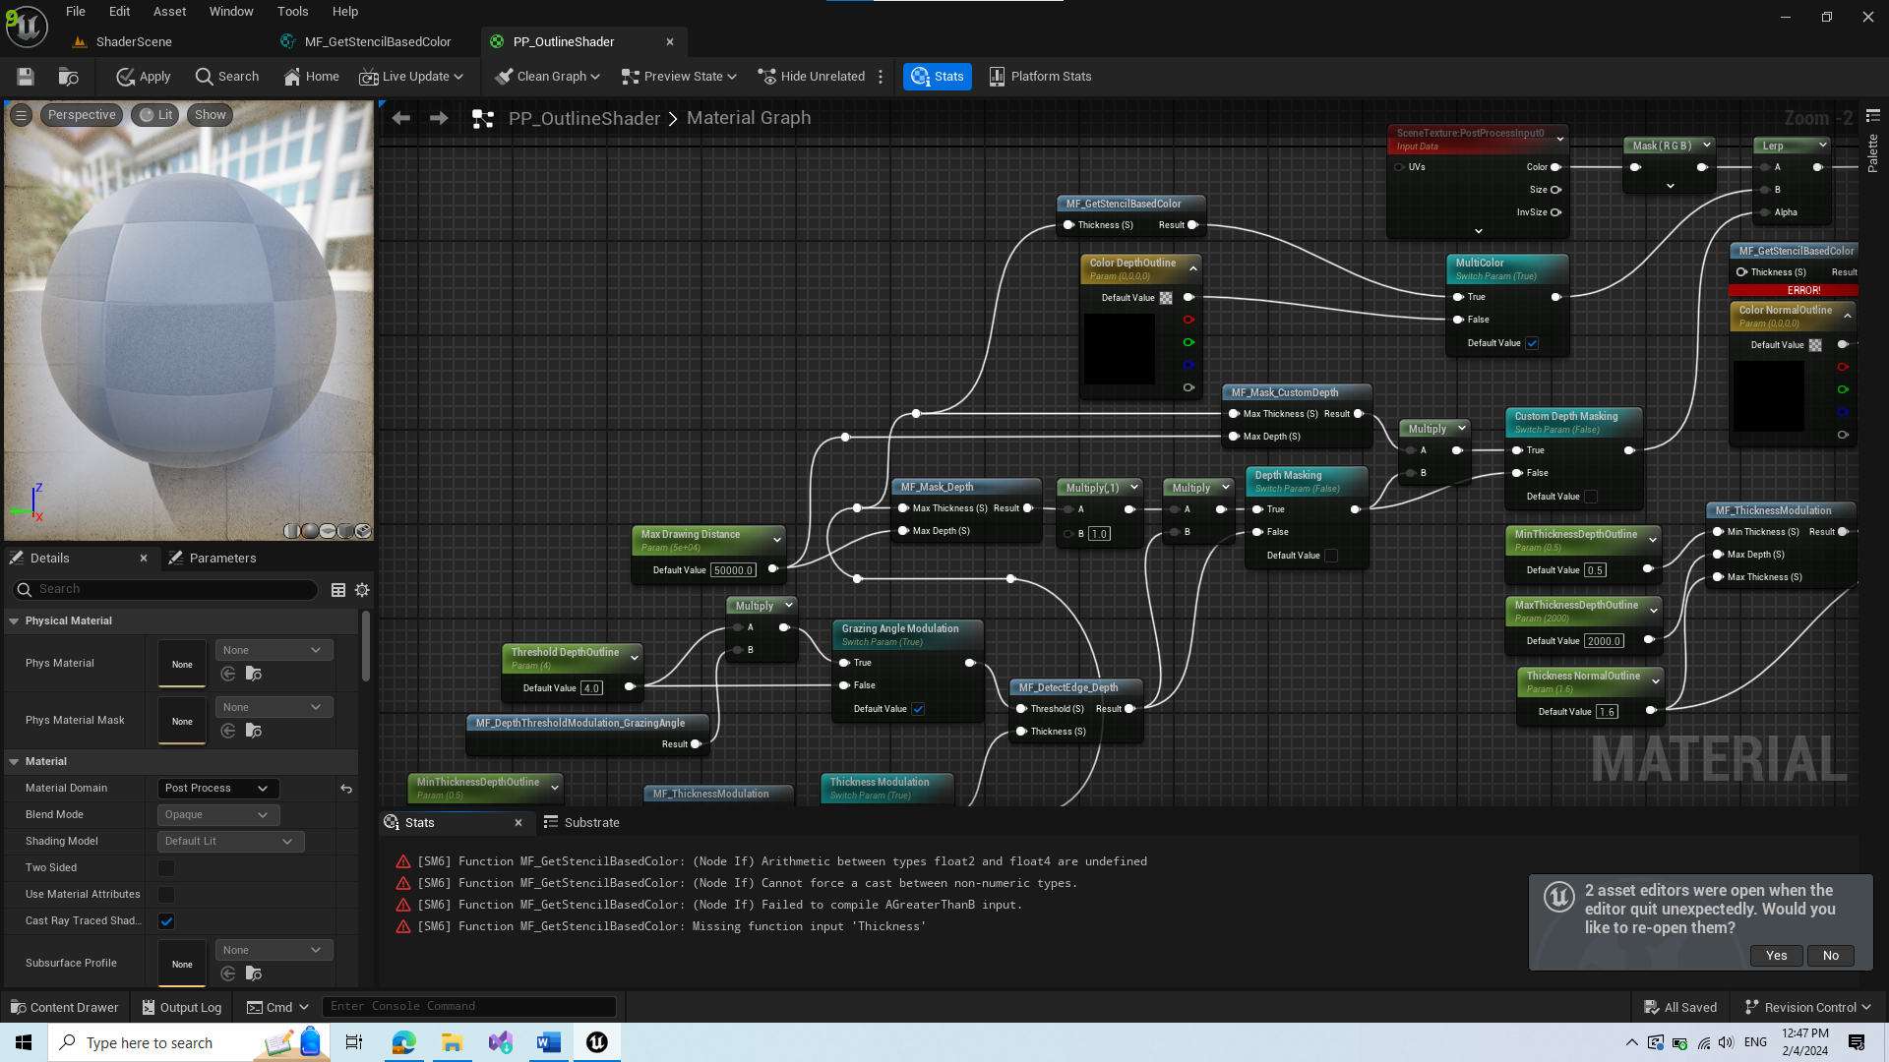

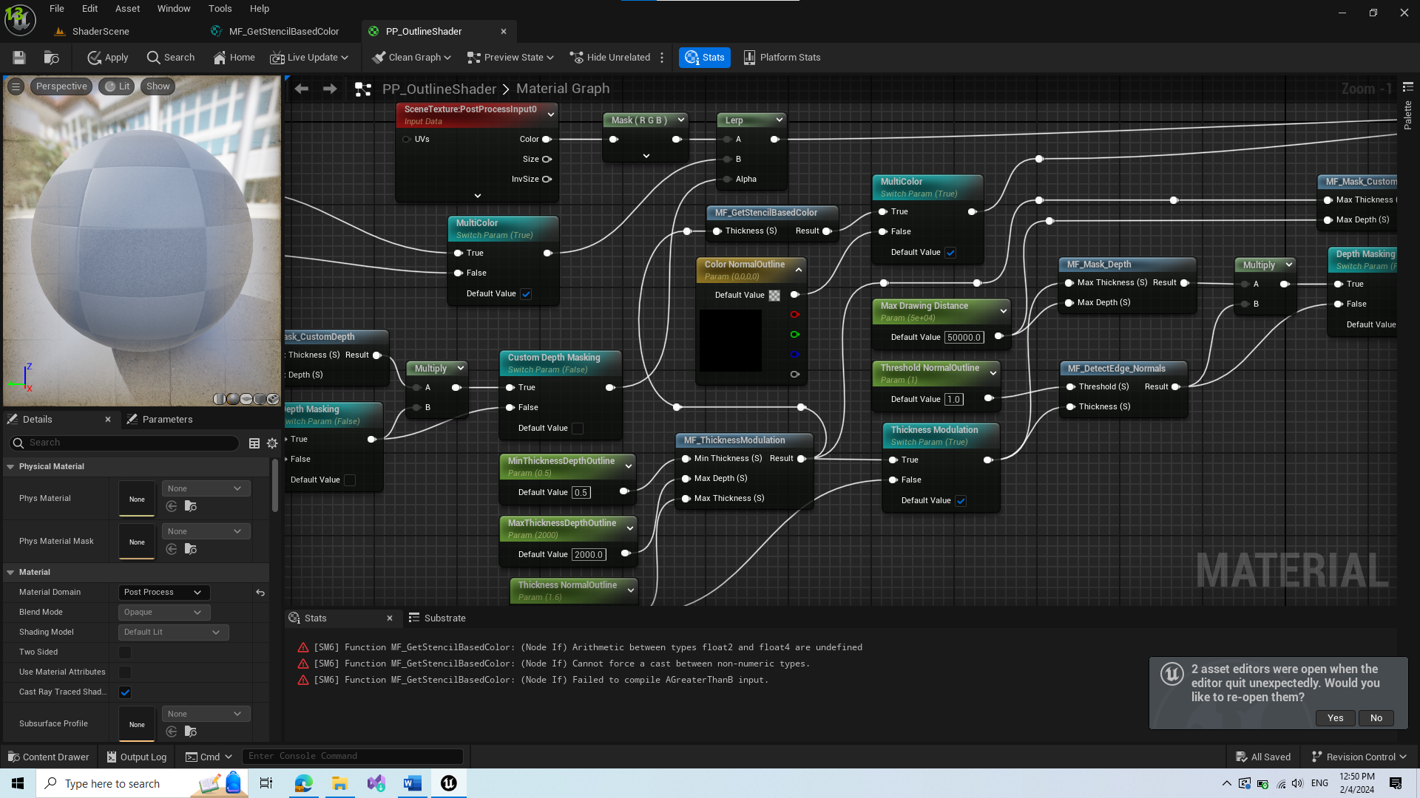

* However this creates a compilation error regarding SM6. I couldn’t find anything similar to this shader online with bug so I decided to press continue on next popup:

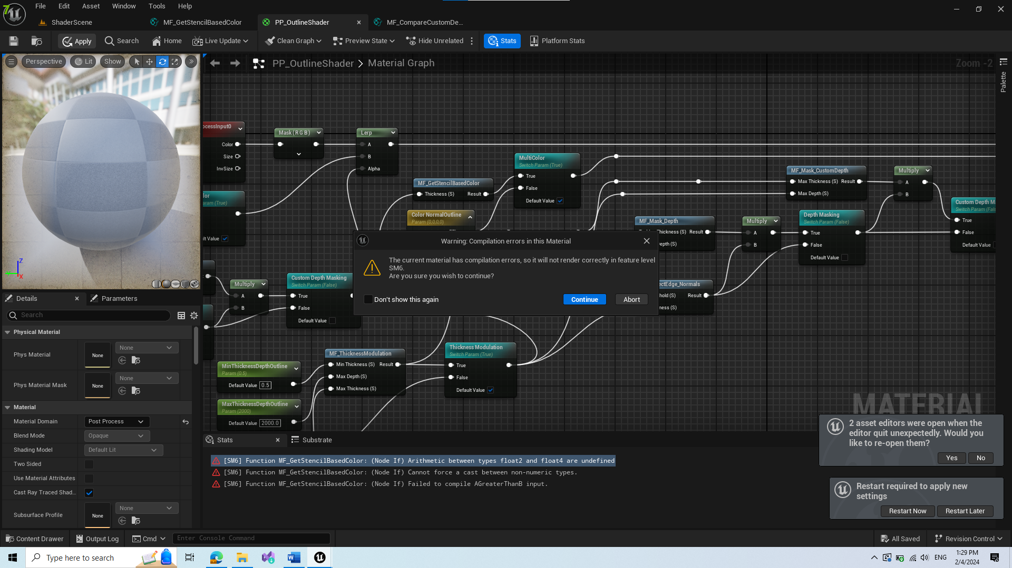

(My mistake, I connected wrong nodes in if statement, hope that continue didn’t mess things up)

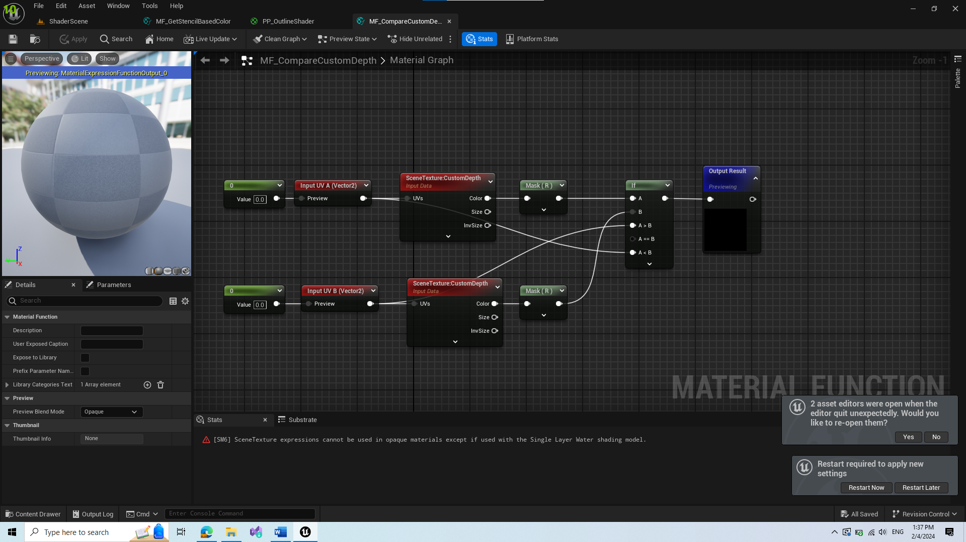

1. Modify Get Stencil Based Color Material Function to optimize if statement and to apply multiple colors for each index in stencil buffer

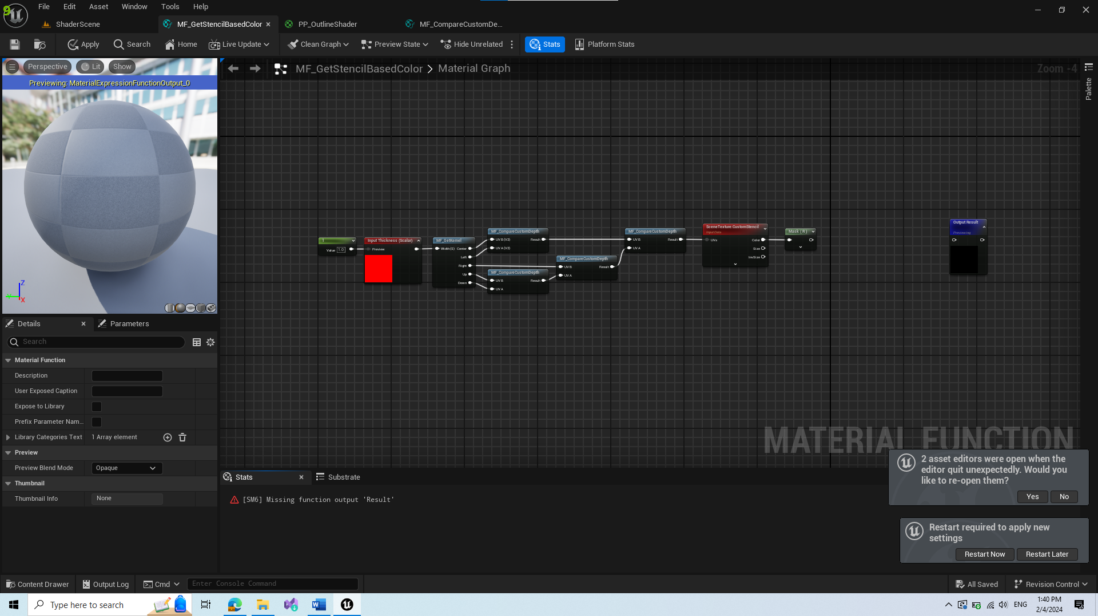

* Here we delete unnecessary nodes

1. Add Hue Shift node to adjust the texture colors

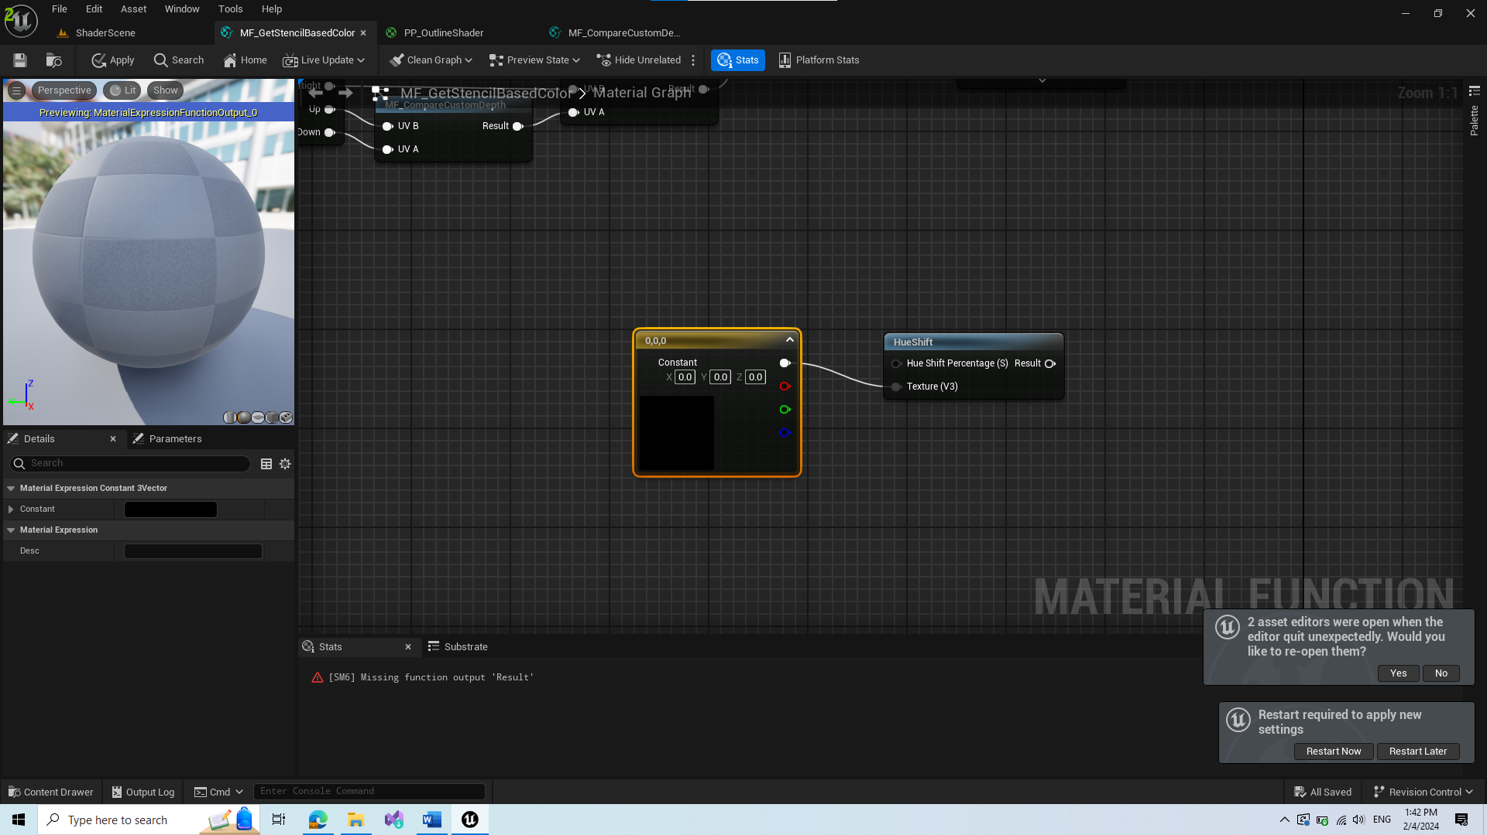

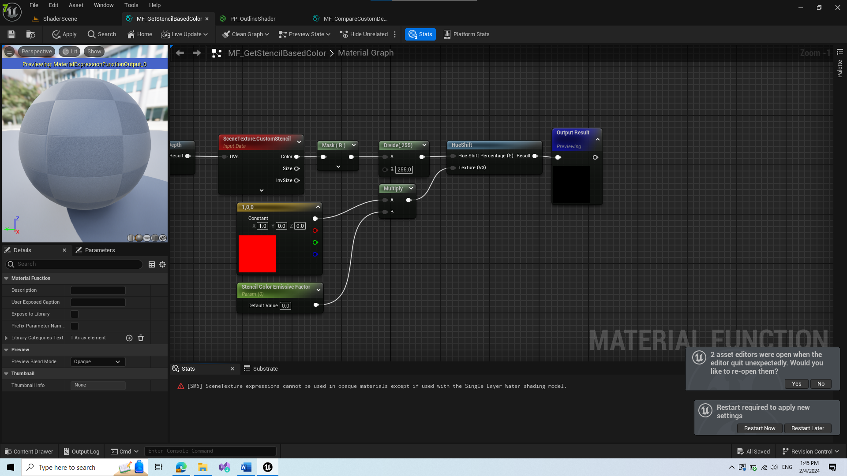

* Change Scene Color Emissive parameter to 1

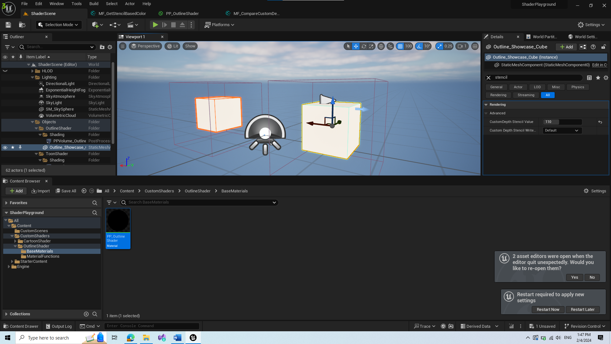

* Now you can change custom depth stencil pass value on object and the outline color changes accordingly